Higher pension for working with a CRT screen
Using a CRT screen at work has been qualified as work is special conditions, and those born after 1948 can apply for a special monetary compensation for the years of eye fatigue they experience working with this type of screens. Such decision has just been made by the Supreme Court (case no. III UK 150/18).
A compensation benefit for work in special conditions was awarded to an IT worker who had worked for 20 years with two CRT screens. She never worked with ‘paper’ documents, not did enter any HR & Payroll data into the system ‘by hand’. While in use, the screens produced a blinking effect as well as reflections and glaring, which contributed to eye fatigue.
The written grounds for the judgment state that the work performed by the IT worker qualifies as work in special conditions as set out under item 5 Division XIV of List A constituting an attachment to the regulation of the Council of Ministers on the pensionable age of employees working in special conditions or performing work of special nature of 7 February 1983 (Dz.U. of 1983 No. 8, item 43 as amended).
As a result, the IT worker has worked for over fifteen years in special conditions, which entitles her to the compensation benefit under Art. 2 (5) and Ar. 21 (1) of the act on bridge pensions.
The ruling of the Supreme Court will be also applicable in determining rights to early retirement or bridge pensions.
Is an employer required to provide its teleworkers with the equipment and Internet access?
Under the Labour Code, an employer is under an obligation to provide tele-workers with appropriate equipment and Internet access. However, this obligation can be limited or waived.
Art. 67¹¹ (1) of the Labour Code so regulate the issue - an employer is required to: provide its tele-workers with insured equipment necessary for the performance of work; cover the costs related to the installation, servicing, use and maintenance of the equipment as well as ensuring to the tele-worker technical assistance and necessary training in operation of the equipment.
It appears, however, that this obligation can be limited or even waived.
In order to do so, a separate agreement must be concluded setting out, e.g.:
- The scope of insurance and the rules for the tele-worker’s use of his/her own equipment necessary for the performance of tele-work;
- The rules for communication between the employer and the tele-worker, including the procedure for confirmation of the tele-worker’s presence at the workstation;
- The manner and forms of verification of the tele-worker’s actual work performance.
The parties to an employment contract can also agree that some of the equipment necessary for the tele-worker to perform his/her work will be provided by the employer with the employee being entitled to a cash equivalent for the remaining part owned by him or herself.
IPCC special report: The Earth is under man’s pressure
Climatic changes, desertification, soil degradation and environmental pollution – all these can lead to food shortages, amplify people’s migrations and incite conflict – the IPCC warns in its special report. Its recommendations include focussing on better land management and decreasing greenhouse gas emissions across all sectors of the economy.
On Thursday 8 August 2019 in Geneva, Switzerland, the International Panel for Climate Change presented a special report on climate change, desertification, soil degradation, sustainable land management, food security and flows of greenhouse gases in land ecosystems.
- The Earth already finds itself under an increasing pressure from man, and climate changes only deteriorate the situation. Maintaining the global warming at a rate of well under 2ºC can only be achieved by reducing greenhouse gas emissions across all sectors, including the food industry. The Earth plays an important role in the climatic system, hence the World’s attention should be focussed on sustainable development - the report says.
The Earth must continue to be productive; yet its capabilities are limited. This means that the entire attention of mankind should be concentrate prevention of climate changes, e.g. by growing energy crops and afforestation.
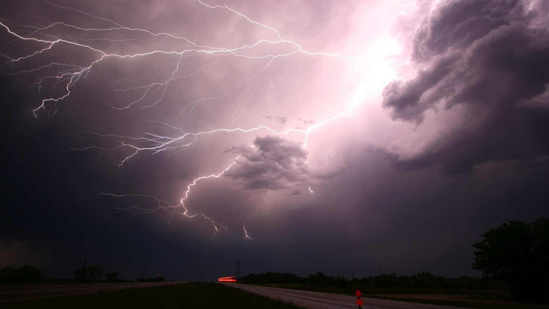
Being safe in a storm
The Government Safety Centre has published a guide for staying safe in a storm. The recent storm-related tragic events have made it clear that each adult and child alike should be familiar with the guidelines set out in that guide.
The safest place to stay in a storm is inside a building. Therefore, one should not leave it if possible.
However, when caught in a storm outdoors, one should:
- Find a safe shelter as soon as possible;
- Avoid hiding under trees;
- Avoid staying in open areas;
- When caught in an open area – find, if possible, a recess in the ground (avoid being a highest point) and squat down (do not sit or lie down) with legs joined under your body. The legs should be kept together as in case of a thunder strike electric current might pass between the feet as a result of the so-called step voltage;
- When swimming or on a boat – reach the shore and go away from the water as it is a perfect electric current conductor.
- Avoid touching metal objects or staying in their proximity – metal object can ‘attract’ lightning.
The Friendly Law package – further facilitations for businesses
In July of this year, the Council of Ministers adopted in over 60 statutes drafted by the Ministry of Entrepreneurship and Technology a Friendly Law Package, i.e. a collection of 70 measures to make business easier. The draft is comprehensive as it affects a number of different industries: from mail to telecommunications to aviation to energy to the hotel industry to payment services.
The FLP eliminates from the Polish legal system regulations that are obsolete, burdensome and no longer compatible with the modern social and economic reality.

The key elements of the Package include:
- A longer VAT settlement period for imports;
- A right to make an error;
- Consumer-type protection for sole traders registered with the CEIDG (Central Registration and Information on Business);
- A broader definition of craftsman;
- Extended possibilities for foreign scientists to start up and do business in Poland;
- Facilitations to those employed in the restaurant and catering industry;
- Exclusion from court enforcement of monies necessary for the sole trader and his family to maintain for two weeks.
The new regulations are to enter into force on 1 January 2020, with the exception of several provisions that will enter into force on other dates.
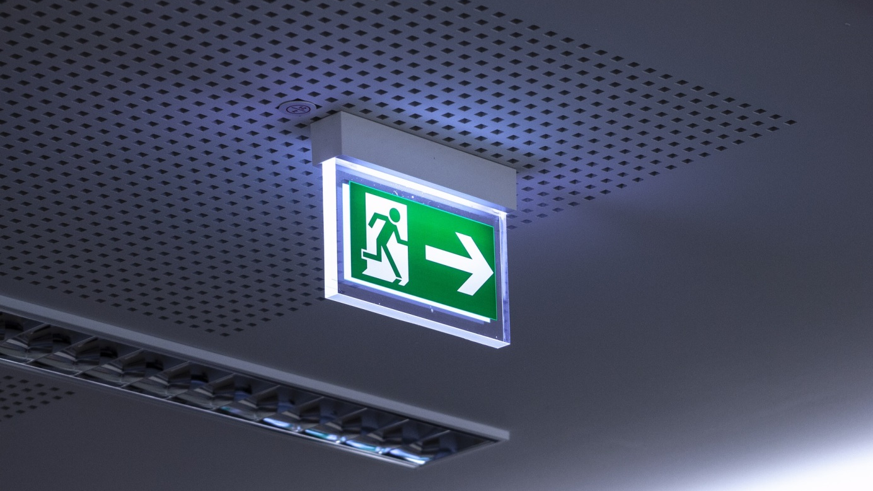
Evacuation lighting installation checks
Evacuation lighting installations must operate without fail. It is on it that the safety of those on the premises largely depends. In case of emergency it can make or break the entire evacuation or rescue action.
The obligation to carry out checks results from the regulation of the Minister of Internal Affairs and Administration on the fire protection of buildings, other building structures and areas of 7 June 2010 (Dz. U. No. 109, item 719 and Dz.U. 2019, item 67).
It also defines, in section 2(1)(9), fire-fighting equipment as equipment (fixed or semi-fixed, triggered manually or automatically) serving to prevent creation of fire, detect and fight fire or mitigate its impact.
Technical checks and maintenance activities in relation to evacuation lighting installations on the premises must be carried out at producer-determined intervals, not less frequently, however, that once in a year. The frequencies and methodologies for inspecting emergency lighting installation are set out in detail in the Polish Norm PN-EN 50172:2005 Emergency evacuation lighting systems.
It is important to bear in mind that such emergency lighting installation checks can only be performed by authorised individuals.
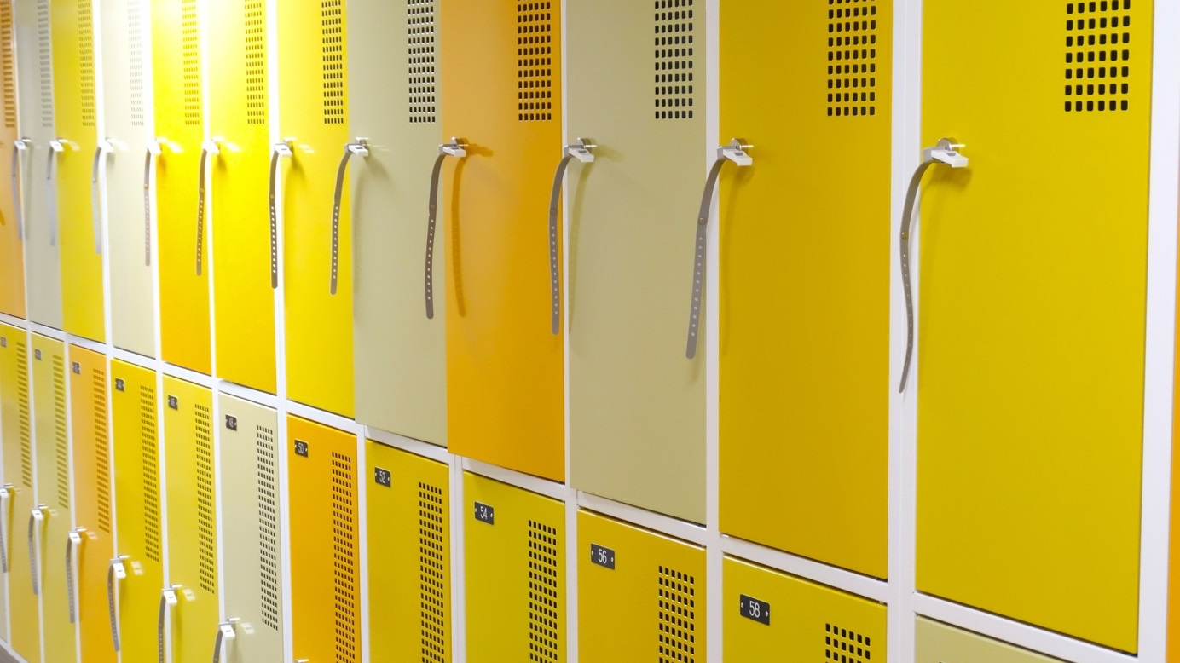
Can staff rotate their lockers?
Each employee should use their own, individually asigned locker. This means that en employer is required to ensure a number of lockers that matches the number of employees employed.
This duty stems from section 111 (1) of the regulation of the Minister of Labour and Social Policy on the general regulations on occupational health and safety, which provides:
“An employer is under an obligation to provide its staff with sanitary and hygienic rooms and equipment whose types, numbers and sizes should be adjusted the number of employees employed, technologies used as well as types of work and conditions in which such work is performed.”
On the other hand, under section 14 (3) of Appendix 3 to the above regulation, a locker room should be equipped with two single lockers or one double locker per each employee using the locker room with one locker being used for working clothes and personal protection measures and the other - for the employee’s own clothes.
Employers are under an obligation to ensure to all employees optimal hygienic conditions for the storage of work clothes, work footwear, personal protection measures and own clothes. This follows not only from the provision mentioned above, but also from Art. 207(2)(2) of the Labour Code, which imposes upon employers an obligation to comply with occupational health and safety rules.
Penalties for employees for failure to comply with OHS regulations
Under the Labour Code, each employee is required to comply with occupational health and safety rules as well as fire safety regulations. The employer can impose relevant penalties for failure to do so.
Under Art. 108 of the Labour Code, in the event of failure by an employee to comply with OHS or fire safety regulations, the employer can impose the following penalties: admonition, reprimand or fine.
The order of the penalties in the law seems to imply that it is in that order that they are to be applied, i.e. beginning from admonition, which is the lightest penalty, through reprimand, to the most severe penalty, namely fine. And they are indeed so applied in practice. However, it is worth noticing that there is no requirement that such penalties be imposed in exactly that order. It is always up to the employer to decide on the penalty to impose.

How much can a fine be?
The level of a fine is set out in the relevant regulations. Under the already mentioned Art. 108 of the Labour Code: “a fine per single violation, and for every day of unjustified absence, must not exceed a single-day wage of the employee in question, and the aggregate fines must not exceed a tenth of the remuneration payable to the employee, after relevant deductions under Art.87(1)(1)-(3) have been made”.
Subsidies for rooftop solar panels
‘My Energy’ is a programme addressed at home owners, who will be entitled to as much as PLN 5 thousand in non-returnable subsidies to the installation of solar panels. The government will allocate PLN 1 billion to the programme.
The National Environmental Protection and Water Management Fund will be responsible for administering the programme and paying out the subsidies. A maximum amount of subsidy per household will be PLN 5,000; however, not more than 50 per cent of the costs of the photovoltaic installation of 2-10 kW power.
It has only been said that the panels cannot be finally installed as at the date the programme is announced by the NEPWMF, but the installation must be complete on the date the application for the subsidy is being made. This means that subsidies cannot be applied for by those who already have PV installations in place.
The only condition for obtaining the financial support will be an official confirmation that a two-way meter has been installed by the operator of the distribution network, which will allow one to measure energy that is both collected and given up to the grid.
The order of applications is to be decisive before the limit of PLN 1 billion is exhausted.
OHS inspection, supervision and audit in the workplace
Each employer is under an obligation to ensure regular checks on the state of occupational health and safety. Such checks (inspections) are carried out by an appointed OHS Service member (either in-house or an outsourced specialist), whose duties include: monitoring work conditions and compliance with OHS principles and regulations as well as drawing up periodical reports on the state of occupational health and safety.
In practice, one can meet several terms referring to the activities involved in verifying the actual state of affairs with relevant regulations.
In the area of work conditions, three terms are commonly used: inspection, supervision and audit.
Audit focuses on identifying compliance of the reality with relevant regulations or requirements, whereas inspection seeks irregularities in the operations of a business in the area in question. Supervision utilises inspections supplementing it with certain repressive measures in the form of decisions, e.g.: administrative or financial ones.
The most efficient and effective gauge of working conditions is provided by an inspection that is independent from the employer, i.e. an audit. This allows one to avoid repressions in the form of penalties imposed by external controlling authorities (such as the PIP (State Labour Inspectorate), UDT (Technical Supervision Authority), PSP (State Fire Service) or IOŚ (Environmental Protection Inspectorate). Reports drawn up on completion of an audit procedure contain, in addition to any violations (omissions in inspections), recommendations on how such violations can be removed, which in turn allow business owners to precisely plan their expenses.

