Occupational diseases of the spine. Prevention
Research carried out in various industries has shown that nearly 80% workers report pains in the spinal area, which, as they claim, is directly related to their work. The condition affects primarily those doing hard manual work, work in a forced position and work exposed to vibration.
In Poland, backbone diseases fall into the category of the locomotor system diseases directly related to the work performed. This means that work conditions represent merely a single risk factor among many that contribute to the revelation, acceleration or deterioration of the illness. Thus, when identifying the disease it is necessary to document and demonstrate an adverse impact of the conditions or manner of work on the development or course of the illness.
Treatment of the diseases is time-consuming and requires the performance of adequate exercises, also outside the physiotherapist’s surgery. The worker in question must change his or her habits and daily lifestyle. One should above all:
- Incorporate into one’ weekly schedule physical activities - at least 2-3 times a week (this could include a long walk);
- Always walk upright;
- Avoid crossing one’s legs when sitting;
- Bend one’s knees and keep a straight back when leaning forward or lifting heavy objects;
- Keep a straight back and balance both hands when carrying heavy loads.
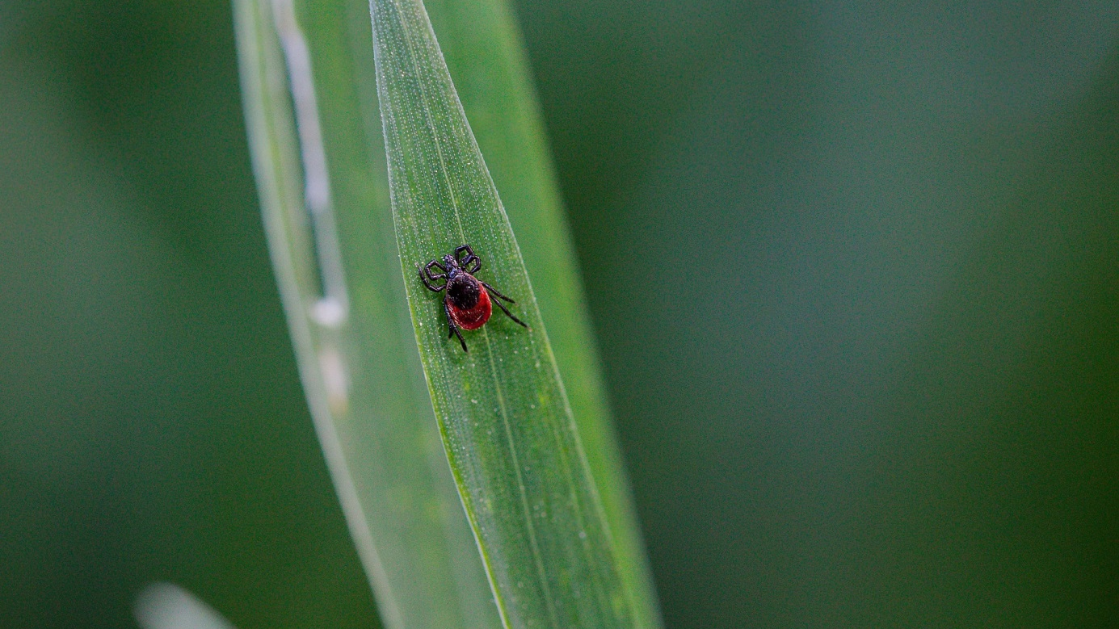
Can a tick bite be deemed an accident at work?
Yes, if the circumstances of the event answer the definition of accident at work under Art. 3(1) of the act on social security in relation to accidents at work and occupational diseases. In practice, however, finding a tick’s bite a primary cause of an injury could be ambiguous and questionable.
Where an employee was bit while performing one or more of the activities set out in the above regulation, this can be deemed an accident at work. However, what is questionable is the definition of injury, which under Art. 2 (13) of the above act is damage to the tissues of the human body or organs as a result of an external factor. Therefore, it should be remembered that injury includes a mere bite by a tick, but not possible complications in the form diseases (e.g. boreliosis).
Thus, a determination such an injury as an accident at work could be ambiguous as determining a tick as an essential cause of an injury requires specialist medical expertise and should be carried out by a doctor. Consequently, a post-accident team should seek medical consultation, and if necessary the opinion of other specialists, to the extent necessary for a proper evaluation of the nature and implications of the accident.
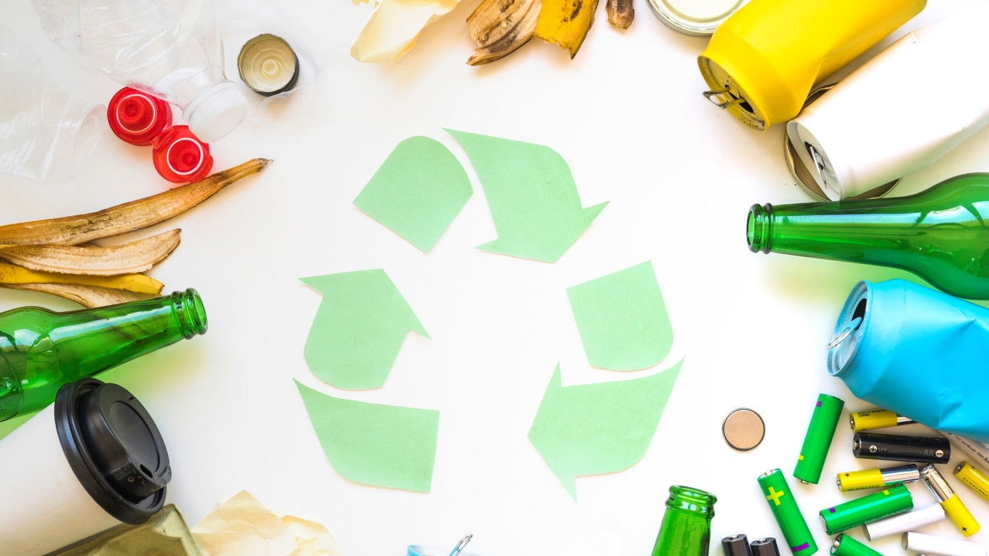
How to sort out rubbish properly?
Properly sorting out rubbish is easy although it still poses certain doubts. For instance: Should one wash up glass, plastic or metal bottles prior to disposing of them?
The main sorting principles states that mixed household waste should be separated from recyclable materials. Therefore one should separate: paper, glass, metals, plastics, biodegradable waste, especially bio-waste.
In order to make waste sorting easier, each waste category has been assigned a different colour. Thus:
- Yellow – METALS AND PLASTICS
- Blue – PAPER
- Green – GLASS
- Brown – BIODEGRADABLE WASTE
- Grey – UNSORTED WASTE
Users are sometimes uncertain about the treatment of packaging – should it be washed up prior to disposal? The answer is simple: NO. Bottles and other containers should only be emptied. They will be washed up later in the recycling process.
‘Enhancing Work Safety and Conditions’
In August of this year, the Council of Ministers adopted a resolution on the establishment of a multi-year ‘Enhancing Work Safety and Conditions’ programme to be implemented in the years 2020-2022. It represents a continuation of the programmes from the previous years and is intended to improve the level of occupational health and safety in Poland.
According to the Ministry, the state of occupational health and safety in Poland has improved over recent years. However, every year nearly 300 people die in accidents at work. On the other hand, the payments out of the ZUS Accident Benefit Fund amount to approx. PLN 5 billion per year. Thus, it is necessary to continue the Programme.
The 5th stage of the Programme will focus primarily on the challenges posed by dynamically changing work technologies and processes, which requires in-depth scientific research and development activities in order to identify threats in an intelligent work environment.
Małgorzata Kochańska, advisor to SEKA’S President, believes that new legal regulations should be created in order to improve work conditions.
- Although OHS in teleworking is regulated in the Labour Code, there are no regulations concerning remote jobs – the expert says. - Also the system of OHS Service staff education is in need of improvement as it is currently outside any control – she adds.
The Resolution came into force as of the time it was adopted.
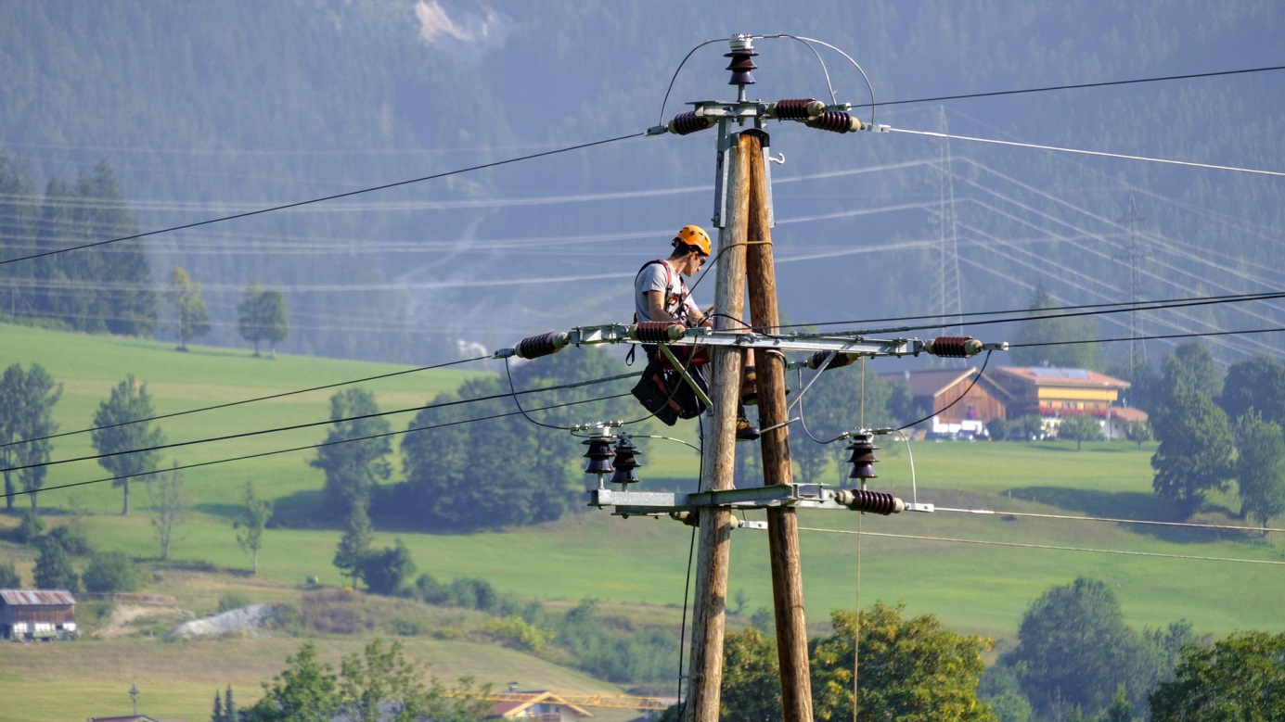
Training those responsible for electro-energy device maintenance and oversight – G1
Every person doing work involving maintenance of electro-energy equipment and installations is required to hold relevant certificate-proven qualifications. Specialist training allows one to acquire the necessary knowledge, take an examination and start working in a profession of choice.
The duty to obtain the necessary qualifications is laid down in the regulation of the Minister of Economy, Labour and Social Policy on detailed rules for verifying the qualifications held by those dealing with equipment, installation and grid maintenance (Dz.U. 2003.89.828; Dz.U. 2005.141.1189).
Dedicated training is organised in accordance with the above guidelines and are aimed to make participants familiar with current regulations and requirements relating to the organisation of the workstation taking into account safety rules for electro-energy equipment and installation maintenance and operation of up to and in excess of 1 kV.
Subjects taught during such training include the most important issues required when sitting an examination before the Qualification Board.
Upon a positive assessment, the trainee is given a qualification certificate for the operation, maintenance, repair and installation allowing him/her to perform work involving maintenance of equipment, installations and grids.
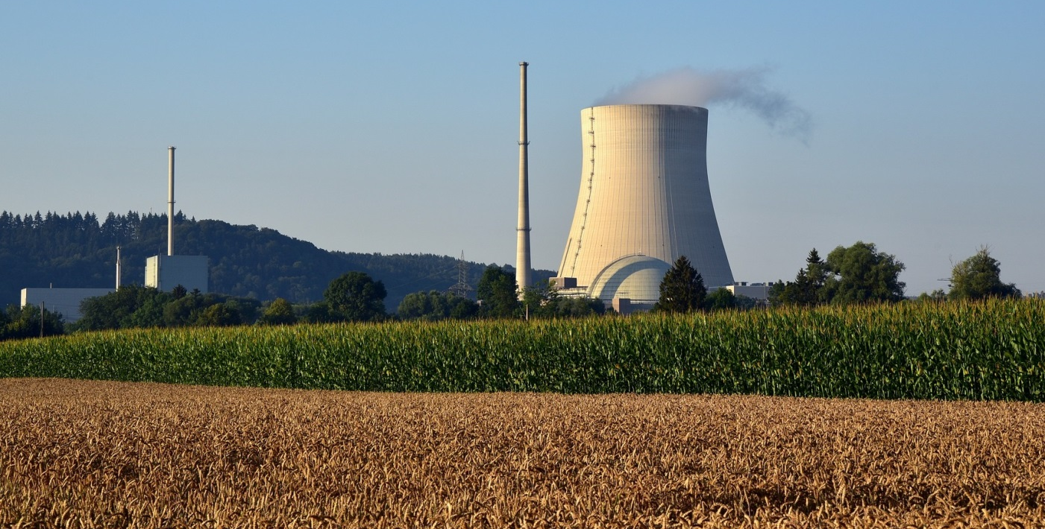
Operating rescue plan
An operating rescue plan is drawn up in case a serious industrial breakdown arises that threatens the environment and people's health. It must be drawn up at facilities of considerable or increased risk of an industrial breakdown.
A business operating a facility carrying a certain risk is also under an obligation to draw up a programme for the prevention of industrial breakdowns, which is implemented via a security management system ensuring a level of human and environmental protection that is adequate to the threats occurring, which in turn is constitutes an element of an overall facility management system (Art. 251 of the Environmental Protection Law).

Obligations of those operating a considerable risk facility:
- Draw up an internal operating rescue plane, and in the event of an imminent or actual industrial breakdown – immediately begin implementing it;
- Provide the Commander of the Voivodship State Fire Service with information necessary to draw up an external operating rescue plan taking into account trans-border implications of an industrial breakdown;
- Cover the costs of drawing up or amending an external operating rescue plan.
Periodical OHS training for OHS Service staff and those performing the duties of OHS Service
OHS Service staff or those performing the duties of that service support their employer who is responsible in the enterprise for the health and safety of their employees. Thus, they are required to hold relevant qualifications specified in Art. 4 of the regulation on OHS service and valid certificates of periodical OHS training attended.
The obligation results from the regulation of the Council of Ministers on OHS Service of 2 September 1997 (Dz.U. 109.704, as amended) and the regulation of the Minister of Economy and Labour on OHS training of 27 July 2004 (Dz.U.180.1860, as amended).

Periodical OHS training - aims
Periodical OHS training aims to update and supplement one's knowledge and skill in the area of: regulations, hazard analysis and assessment, methods of risk assessment for those hazards, as well as organisation and methods or shaping safe and hygienic work conditions. Moreover, its goal is to help resolve difficult problems in the field of OHS.
The specific content of the training is set out by “The Framework Syllabus for Periodical OHS training for OHS Service staff and those performing the duties of OHS Service”.
Who cannot be made redundant?
There is a wide group of employees that cannot be directly made redundant, or whose termination is very difficult and only possible under special cercumstances. Who does it concern?
Certain employee groups are protected by law against termination. This is affected by the following factors:
- Pre-retirement age – an employer cannot terminate an employment contract with an employee who has a maximum of four years left before attaining pensionable age and his/her length of service entitles him/her to acquire pension rights upon attainment of that age.
- Leave of absence or medical leave – a contract cannot be terminated in the case of an employee when on holiday or sick leave.
- Pregnancy and maternity leave – the employment of female employees that are pregnant or on maternity leave or child-care leave is protected against termination. The father is also protected while on paternity leave.
- The union activist – not all activists are protected, but those to be protected are selected and communicated to the employer by the board of the local (internal) union organisation. Then, the employer cannot, without their consent, terminate the employment contract with a member or another employee named by the board in a resolution.
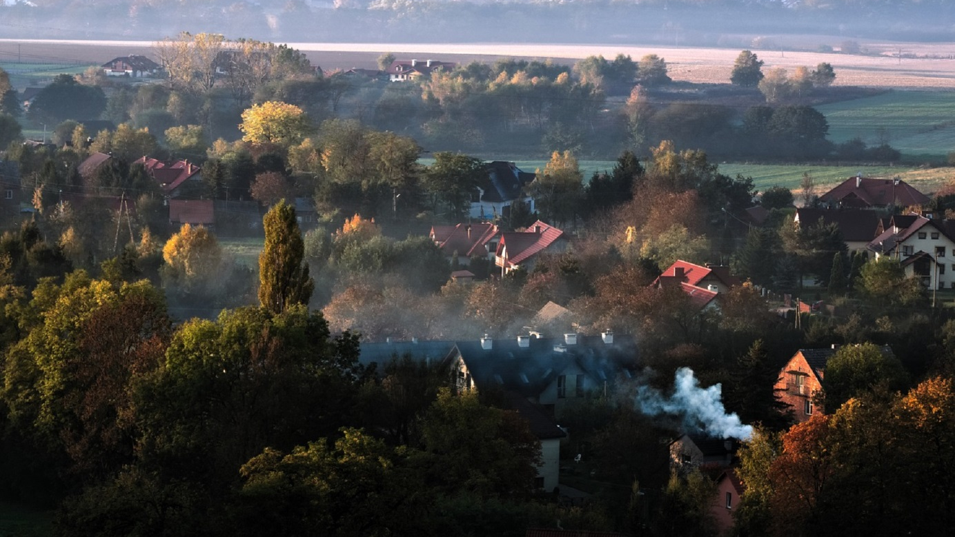
New smog alert norms
On 20 September of this year, Henryk Kowalczyk, the Environmental Minister, signed a draft regulation on new smog alert norms. The new law could come into force as early as the beginning of October.
Reports from the WHO and EU agendas show that 47 thousand people die in Poland as a result of smog and complications caused by the poor quality of air in Poland. The new proposal from the Environmental Minister states that smog alert should be announced whenever the average daily value exceeds 150 micrograms per cubic m for PM10, the information level would be 100 micrograms. Currently an alert is announced where the average daily value exceeds 300 micrograms per cubic metre with the reporting level at 200 micrograms.
Initially, the Environmental Ministry proposed amendments at the level of 250 and 150 micrograms per cubic metre for PM10 particles. However, they were challenged the Polish Smog Alert (PAS) which pointed out that they would still be the highest across the EU and three times higher than in France or Italy.
Nevertheless, the new levels will not match the recommendation of the WHO whereby admissible daily concentrations of PM10 should not exceed 50 micrograms, and in the case of PM 2.5 - 25 micrograms per cubic metre.
It is worth noting that in the event of smog it is recommended not to leave buildings unless absolutely necessary.
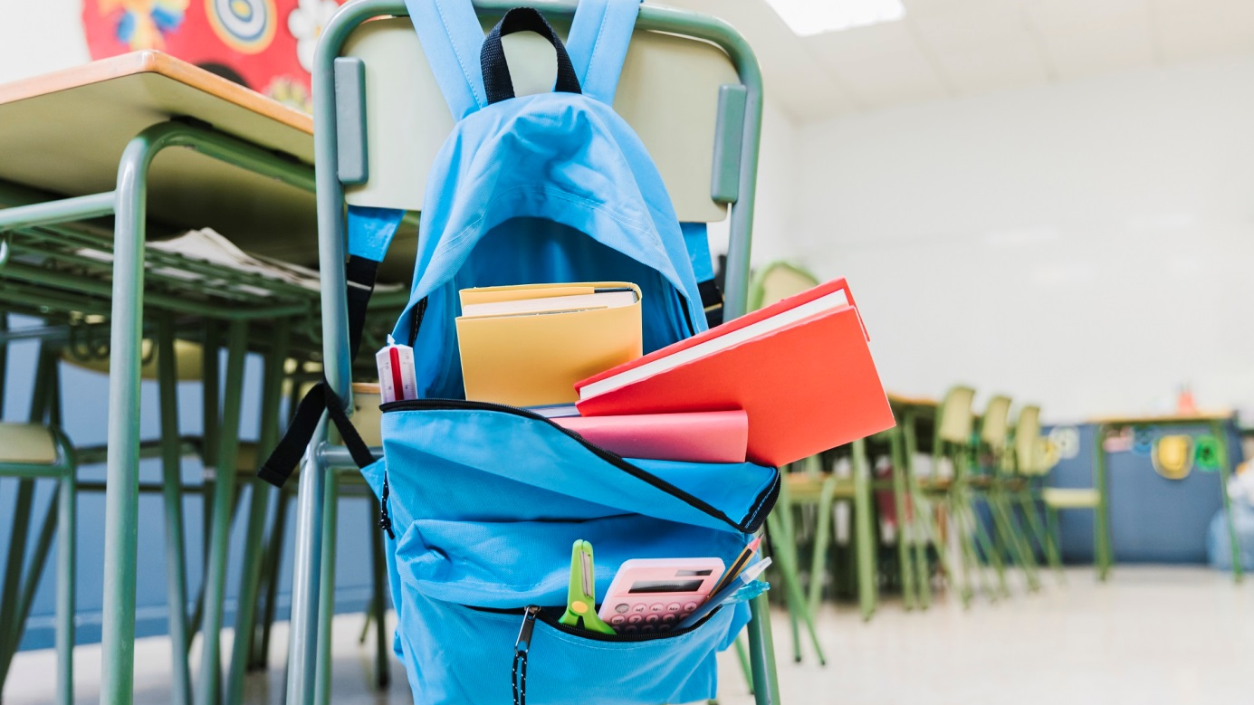
Education Ministry’s recommendations for schoolbags
The health and safety of children is our priority – this slogan has for over a year been the motto of the Ministry of National Education. In a special letter to teachers, the Minister addresses the issue of schoolbags. The Minister appealed to school headmasters and teachers to pay special attention to the fact that schoolchildren only carry the books and copybooks that are necessary on a given day.
The schoolbag is a basic component of each pupil’s school equipment. It is important that it be properly adjusted and not cause strain to the back. The Chief Sanitary Inspector reminds that a schoolbag must not exceed 10-15 % of the pupils’ weight. It plays an important role in keeping a proper posture and preventing spinal curvature.
The Minister also appeals to the parents to pay special attention to what their children carry in their schoolbags.
According to the Ministry’s recommendations, the teachers and headmasters should inter alia:
- Ensure safe and hygienic learning conditions to pupils;
- Required that pupils only carry the books and copybooks that are necessary on a given day;
- Impart solid knowledge on incorrect posture prevention;
- Talk to pupils and their parent on importance of the weight of the schoolbag and make them sensitive to the problem;
- Ensure a proper level of physical activity to pupils.

