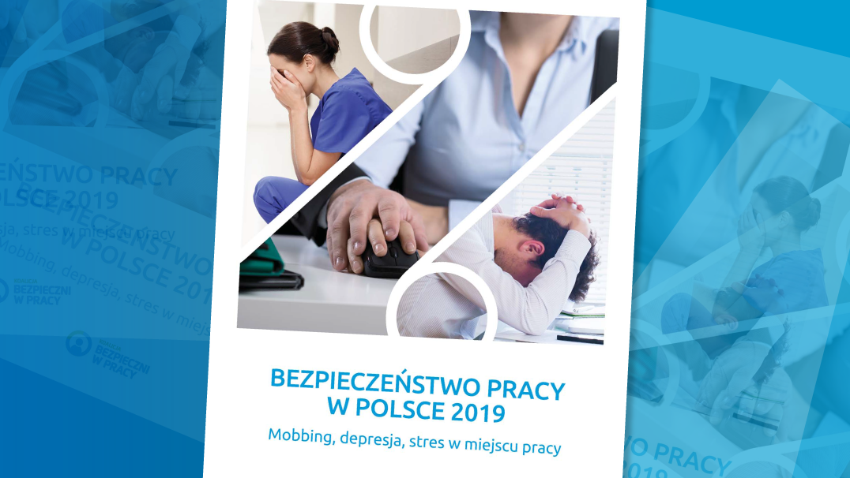

Mobbing, depression, stress in the workplace - OHS training provides an ideal opportunity to raise such issues
The Safe at Work Coalition has carried out for the sixth time a study into safety in the workplace. The findings of the report show that 85 per cent of office and grey-collar workers feel stressed at work, 63 per cent have been treated improperly by their respective bosses and 53 per cent have been subject of verbal abuse with 46 per cent being mobbed.
“Ignoring such phenomena can give rise to high costs in the future to be borne by employees and impose charges on the Social Security System through long-term sick leaves and employee absenteeism. In the long term, it can also result in some employees being excluded from the job market, which at a time of insufficient labour supply will deteriorate the situation of business undertakings in Poland” – reads the report.
OHS training is often the only opportunity to raise such issues. Jakub Nowak, Senior OHS Specialist and Fire Safety Inspector at SEKA, shares this opinion.
- Carrying out induction training is also key to maintaining a proper level of safety awareness across the entire organisation – says Jakub Nowak.

GDPR in HR
On 4 May 2019 the long-awaited amendments came into force adjusting Polish HR regulations to the GDPR requirements. The amendment to the Labour Code and certain other industry-related statutes identifies new risks and obligations in the work of HR departments.
The law as it stands at present requires employers to modify employee records and internal regulations, and to adopt a new approach to internal recruitment procedures. As those whose data are being processed, employees acquire new rights in such procedures. Given the new legal environment, it becomes imperative to implement proper procedures in each HR department.
The most important areas in which HR and personnel department staffs manipulate individuals’ personal data include:
- Recruitment - collecting CVs;
- Employee records - agreements, benefits, including sensitive data such as medical documentation and information on employees’ family members;
- Data sharing - sharing personal data of employees and associates with third parties.
Given the special obligations imposed upon such departments, knowledge and skilful application of the Regulation in practice can ensure secure business operations.
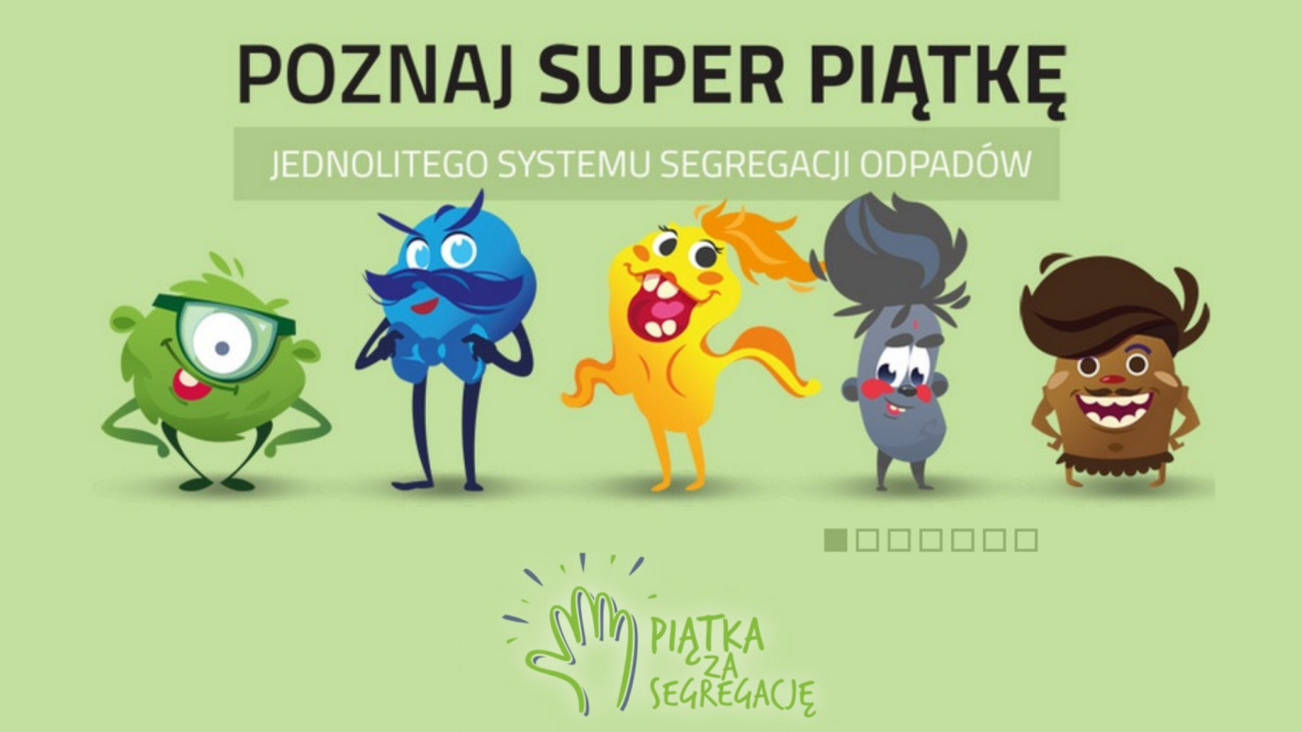
“High-five for sorting”
The Ministry of Environment has developed an information and education campaign aiming at educating the society on proper communal waste sorting. It targets both local authorities and household owners. The campaign is further supported by an educational programme for children. The motto of the campaign is “High-five for sorting”, which refers to symbolically ‘giving a high-five’.
Henryk Kowalczyk, the Minister of Environment, said during a press conference in Warsaw that the Ministry of Environment, in addition to enforcing legislative changes concerning waste sorting, attaches considerable weight to educating the society.

“High-five for sorting” Campaign
The leit motiff of the “High-five for Sorting” campaign is a group of five characters, each of whom being assigned to another sort of waste and colour of the waste bin:
- Wyszkłolony [a pun in Polish meaning ‘glass-educated’] – encourages glass sorting;
- Papa Pier [Papa Per] – teaches on paper sorting;
- Plastika Metalica – explains how to sort plastics and metals;
- El Bio – refers to bio-waste sorting,
- Zmieszko [a pun combining the Polish word for ‘mixed’ (zmieszane) and the name of an early Polish prince ‘Mieszko’] – shows what kinds of waste should find its way to the bins labelled ’mixed/unsorted’.
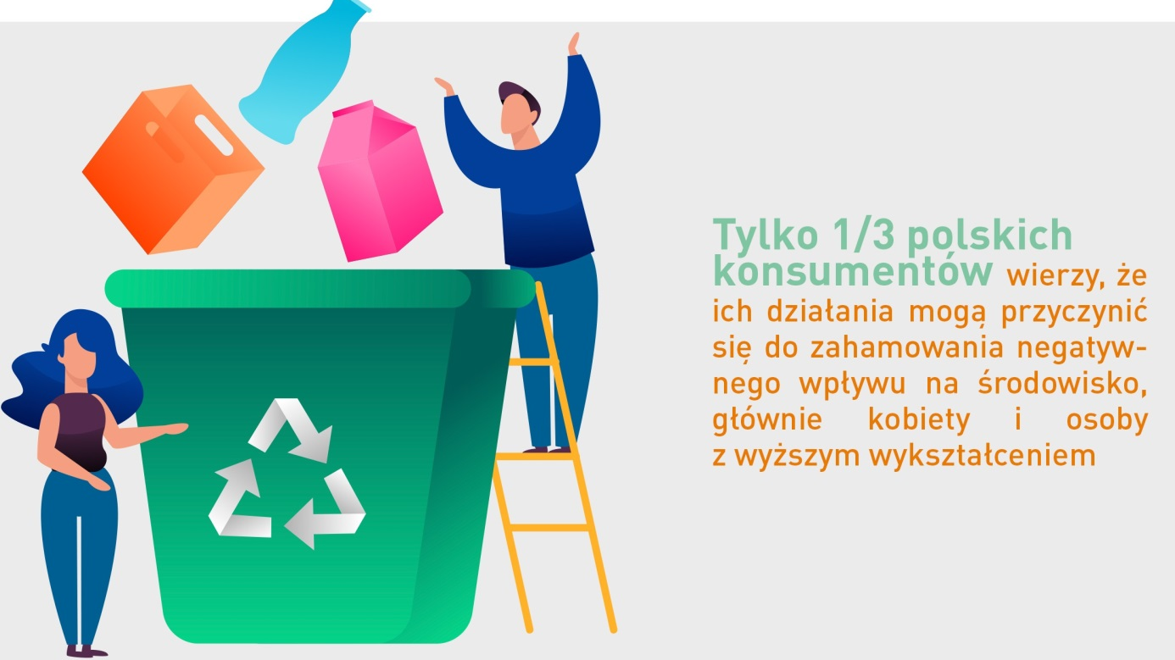

Poles do not know how to sort rubbish
A mere 66% of Poles sort their rubbish with only 15% doing it correctly – these are some of the findings of a survey carried out in October of this year by ARC Rynek i Opinia (ARC Market and Opinion) and Forum Odpowiedzialnego Biznesu (Forum for Responsible Business).
The findings also highlight a problem that concerns a majority of the society, namely Poles do not know how to sort their rubbish properly. As few as 15% of those surveyed gave correct answers to all the questions on waste sorting, e.g. which bin is for a used tissue, juice carton or greasy butter paper wrap. Further, a many as 75% of respondents did not know whether or not metal or plastic packaging must be washed up before disposal.
Another important conclusion of the research is the fact that a mere 58% of those surveyed think it reasonable to sort waste. Even fewer, namely a mere 1/3, Polish consumers believe that their conduct can contribute to mitigating the adverse impact on the environment. This opinion is particularly common among women an those with higher education.
- We are in need of activities that will raise environmental awareness among Poles. This is a vast are for educational campaigns and environmentally responsible business to propagate models for responsible consumption in the society, among other things - says Marzena Strzelczak, General Director of Forum Odpowiedzialnego Biznesu.
Over 80% of employees in Poland experience stress at work
Socio-psychological factors occurring in the work environment affect significantly employees’ health. An employee’s poor well-being, e.g. resulting from prolonged stress, is a frequent cause of accidents. Unfortunately, employers tend to play their role down, focusing primarily on ensuring physical safety to their subordinates.
The latest “Work Safety in Poland 2019” published by the Safe-at-Work Coalition indicates that over 80% of workers feel stressed at work. It is one of socio-psychological threats that deserves an equal amount of attention to that paid to ensuring safety in the workplace.
- Those who live under permanent stress can develop conditions of the circulatory system and the muscoskeletal system. Nearly half of the workers surveyed have reported backbone pains with nearly one in three reporting mood and sleep disorders as effects of stress at work - points out Jakub Nowak, Senior OHS Specialist at SEKA S.A.
Companies should notice the problem as it affects another factor that employers increasingly have to face up to – staff turnover.
- I am convinced that it is precisely the socio-psychological conditions in Polish enterprises that contribute to it – says Anna Jabłońska, President of the Safe at Work Coalition. She reminds us that 75 % of respondents have claimed that they would trade in a 15-20% higher salary for better conditions of work.
Fire safety audits in the workplace
A fire safety audit involves an analysis of the actual state of fire safety and compliance with current fire safety regulations. Carrying such audits on a periodical and regular basis gives one an opportunity to take action necessary to rectify potential irregularities.
Under the act on fire protection of 24 August 1991 (Dz.U. 2009.178.1380, as amended), the owner, administrator or user of a facility is directly responsible for fire safety. Current regulations impose on such persons a number of duties and obligations failure to comply wherewith may attract criminal sanctions and, in the event of fire or another threat, result in vast financial losses, loss of insurance and criminal liability.
A fire safety audit enables identification of any irregularities without any legal implications. It also helps remove any irregularities and thus avoid potential consequences from regulatory authorities.
The form and scope of an audit can be defined individually and can be carried out once or on a cyclical basis.
Workplace hazards
Workplace hazards occurring in the work environment adversely affect the worker's organism and can lead to serious medical conditions treated as occupational diseases.
Hazards can be divided, taking into account their occurrence and types, into:
- Physical factors – noise, ultrasound noise, mechanical vibration, microclimate, optical radiation, electromagnetic fields and radiation;
- Chemical factors – toxic, irritating, allergic, carcinogenic, mutagenic substances and those impairing reproductive functions.
- Biological factors – floral or faunal macro- and microorganisms (bacteria, viruses, fungi and protozoa).
Under Art. 227(1) Labour Code, in order to prevent occupational diseases and other work-related illnesses, each employer is required to:
- Maintain full efficiency of any equipment limiting or eliminating workplace hazards that are harmful to health as well as the equipment measuring such factors;
- Carry out, at own cost, the research into and measurements of factors harmful to health, register and keep records of the findings of such research and measurements and make them available to the employees.
Electronic waste records following 1 January 2020
From 1 January 2020 on, records will only be kept and reports made through an electronic Product, Packaging and Waste Management Database. To this end one must register with the BDO (Waste Database) Register.
Product, Packaging and Waste Management Database (DBO) was launched in January 2018 for the purposes of registration of entities introducing products, packaged products and managing waste. Following 1 January 2020 further system modules, i.e. record-keeping and reporting modules, are going to be implemented, which will provide the entities in question fully electronic registration, record-keeping and reporting functionalities.
Each business that:
- generates, collects, processes or transports waste,
- markets: products, packaging or packaged products, electric and electronic appliances, vehicles, batteries or rechargeable batteries,
should verify whether or not its business requires registration with the database. In order to do so, one should visit the following website www.bdo.mos.gov.pl and answer several questions.
In order to register with the database, an application must be downloaded from the website, completed and filed with the Marshal (Regional) Office relevant for the business's seat or individual's place of residence.

GDPR audit
Since the GDPR came into force, many businesses have been wondering whether or not the solutions they apply are compliant with the new regulations. An efficient test of these solutions can be provided by the so-called personal data protection audit carried out by independent third-party experts. It allows one to ensure that all requirements set out in the regulation have been met.
Some businesses and other organisations have been wondering how to carry out a personal data audit on their own. It should be remembered here that verification of any activities or of their compliance with the law requires a thorough knowledge of the law and also an ability to properly apply it in practice. For those who do not deal with legal regulations on an everyday basis carrying an audit can pose a considerable challenge. Moreover, there is no standard template for such an audit as each company or institution has different data processing procedures in operation.
Therefore, it is advisable to outsource such an audit to external experts who can your organisation in a reliable and professional manner.
A personal data protection audit comprises indication of potential breaches and guidelines on how to improve information and personal data security.
World Ergonomics Day
On 12 November we celebrate a World Ergonomics Day. It was added to calendars in 2005 in order to promote safe and health-conducive work conditions.
Ergonomics is an area dealing with safety and comfort in the workplace. Its application can minimise the risk of accidents at work and occupational diseases as well as improving the efficiency of the workforce.
When intending to ensure adequate conditions of work, an employer should also focus on implementing the principles of ergonomics at his or her business.

Does implementing ergonomics in the workplace pay off?
The answer to the above question is unambiguous – definitely yes! The benefits are obvious – staff’s better frames of mind, lower treatment or rehabilitation costs, and as a result – a better frame of mind and efficiency at work. For the employer, these include tangible, quantifiable profits and savings as a result of lower likelihood of accidents at work and occupational diseases.
Such activities are beneficial to everyone!

