One in six accidents at work attributable to low quality OHS training
The State Labour Inspectorate has presented figures concerning accidents at work at the latest meeting of the Work Protection Board (ROP) of the lower house of the Polish Parliament. They indicate that one in six accidents at work is a result of improper preparation of the employee and lack of instruction. This is caused by poor-quality OHS training.
The PIP’s data are as follows: 1,200 accidents at work were registered between 2016 and H1 2019 due to inter alia inadequate staff training and preparation for work. As a result 1,300 people were injured of whom 173 died and 484 sustained heavy bodily harm.
There are several reasons for this state of affairs: employers use poor–quality training services, and amendments to the Labour Code have led to some 5 million employees being deprived of an opportunity to refresh their OHS knowledge, including first aid.
The ROP has postulated amendments requiring that training providers hold adequate certificates.
SEKA S.A. is a certified training provider registered with CIOP-PIB and has for many years been committed to delivering top-quality training. Its experienced experts teach courses that are both interesting and engaging, and the implemented quality system compliant with ISO 9001:2015 serves to attest to its high standards of performance.
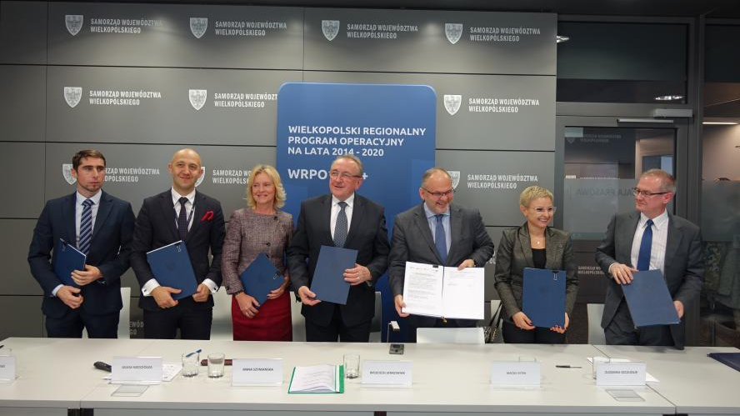
Two years of training subsidised in the Wielkopolskie Voivodship
SEKA S.A. has won a new EU-funded project entitled “Comprehensive Support to Adults in Occupational Training for the Subregion of the City of Poznań. On 28 November of this year the funding agreement was officially signed in the Marshal’s Office in Poznań. The Project covers the subregion of the city of Poznań and will be carried over two years.
As part of SEKA S.A.’s project, 1190 adults will be supported (including 714 women):
- those in active-employment age, specifically between 25 and 64 (primarily those of low competences and qualifications and or 50+);
- those still learning/studying;
- those working or living in the area of the subregion of the city of Poznań.
Depending on their situation in the job market (being in work or unemployed), they will be entitled to support of up to 93% of the costs of training.
The project will comprise the following activities: promotion, recruitment, occupational counselling, development services provided through the BUR (Developmental Services Base) and development services monitoring.
Those participating in the project will choose the services that best meet their development needs. Then they will contact the operator themselves (rather than their employers).
Smog causing allergy and lung diseases
Since the beginning of the heating season, smog has been ever increasing. Polluted air we breathe results in greater proneness to infections as well as being the cause of serious diseases, such as asthma or lung cancer.
Situation in Poland looks bad, or even dramatically bad, as far as air quality is concerned. Such is the conclusion presented by Piotr Dąbrowiecki, MD, of the Military Medical Institute.
Breathing polluted air has direct impact upon people’s lives and health. Nearly 50,000 premature deaths are reported in a year, an epidemic of asthma and various allergy types (there are already over 12 million allergic people in Poland).
Piotr Dąbrowiecki exemplifies the situation with January 2017. Then, the air pollution lasted for very long, nearly a month. As a result, 17% more patients reporting symptoms of asthma visited medical care institutions, 30% more reporting breathing problems and 60% more having cough. Quoting the statistics provided by the Main Statistical Office, he says that 11,000 more Poles died in January 2017 than in January a year before or two years before.
These alarming data show that the situation of the inhabitants of polluted Polish cities is really serious. The conclusion is unambiguous: the phenomenon of smog should be a priority for the government.
OHS and Fire-Safety requirements hard to comply with in overpopulated schools
In our current, overpopulated schools and educational institutions, compliance with OHS and fire-safety obligations poses a considerable challenge to every headmaster.
The regulation of the Minister of National Education and Sport on health and safety in state and non-state schools and institutions of 31 December 2002 and section 17 of the regulation of the Minister of Interior Affairs and Administration on the fire safety of buildings, other building structures and areas of 7 June 2010 (Dz. U. No. 109 of 2010, item 719) set out unambiguously what guidelines must be followed in order to ensure safety to the students and staff present in a building.
Under the current regulations, a headmaster is to ensure that the students of the school or institution have a space for keeping schoolbooks and school things. This, given a large number of students, is often difficult to provide. Another problem is an insufficient number of toilets.
Alert drills carried out at schools have shown another problem – buildings are not adjusted to such large numbers of people. Corridors were blocked, bottlenecks created.
The problems are really serious, particularly as what is at stake is the health and safety of children. Headmasters face a difficult task – compliance with OHS and fire-safety obligations. Under these circumstances it may be helpful to draw on the experience of independent external experts, who may come up with a good solution.
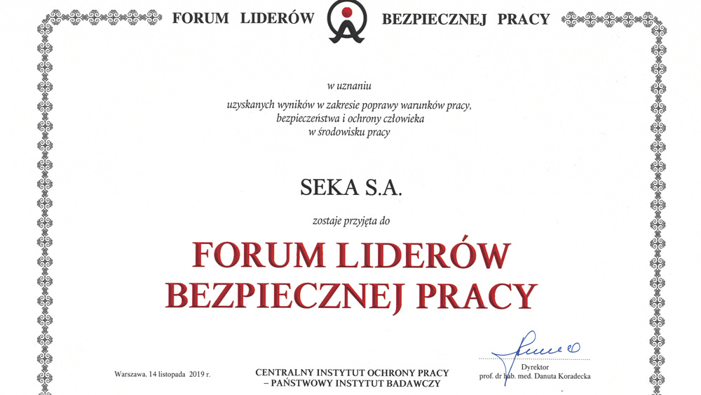
SEKA S.A. has become a member of the Safe Work Leaders’ Forum
On 14 November, SEKA S.A. was admitted to the Safe Work Leaders' Forum. Thus, our efforts have been recognised aiming at improving work conditions and health and safety in the workplace.
The Safe Work Leaders’ Forum was created in 1998 by the Central Work Protection Institute – State Research Institute. Its overall aim is to create healthy and safe workplaces through implementation, propagation and promotion of the latest achievements in science and technology in the area of safety, health and life protection in the work environment.
Moreover, the Forum serves to build partner relationships among its members, employers and employees, who use the advances in science and technology in shaping work conditions, in particular those developed by CIOP-PIB.
Currently, the organisation has 146 businesses (primarily large ones) as its members, which can be set as an example in matters relating to the culture of safe work.
CIP-PIB’s recognition provides evidence of our full commitment in matters that are important and critical to ensuring and compliance with the most important principles – those of OHS.
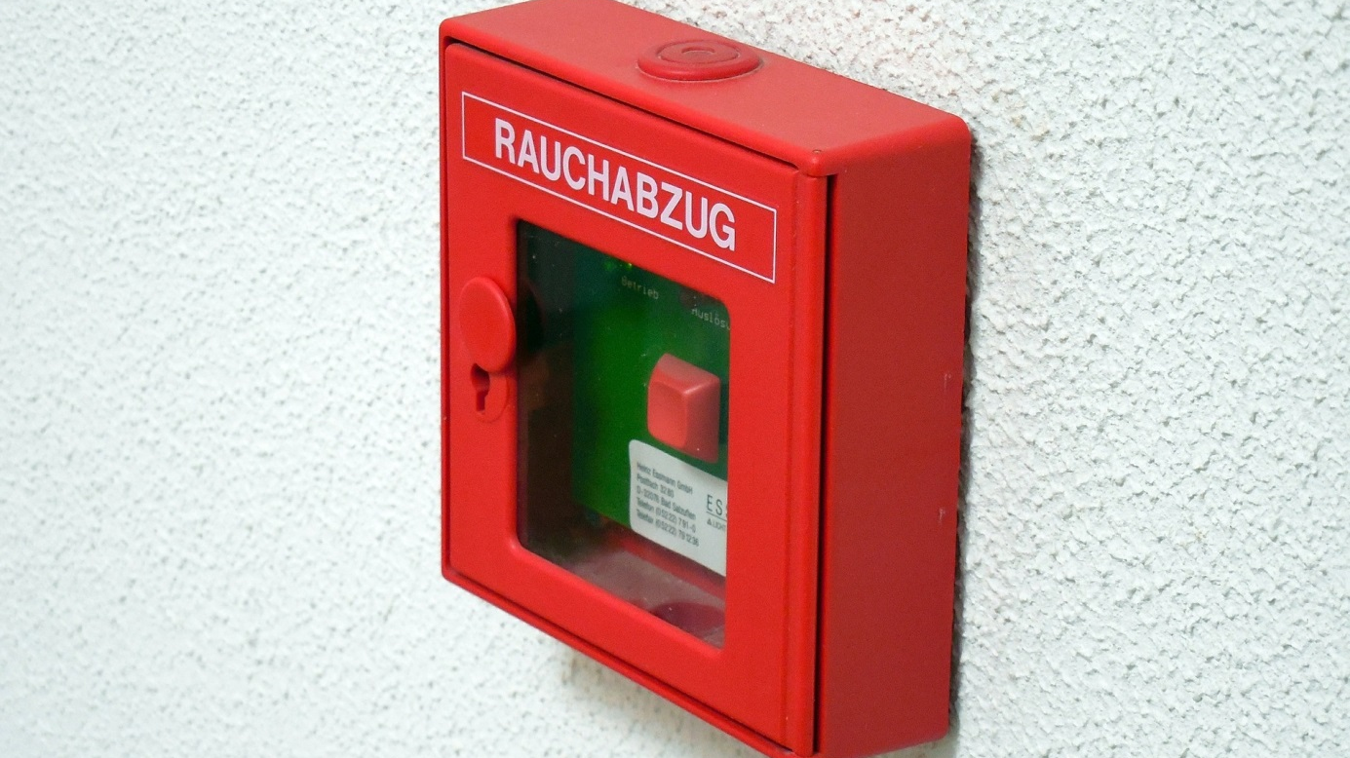
Fire protection systems in industrial and warehousing facilities
Industrial and warehousing facilities are buildings of high fire loads and a high degree of fire spread. The owner or administrator of such facilities should install adequate systems that will efficiently prevent fire, and should fire start - immediately detect, signal and extinguish it.
Production and warehousing facilities commonly use the following fire-protection systems:
- Hand-held systems: portable extinguishers and an internal and external hydrant network. These are first-response measures to the source of fire.
- Automated fire detection and signalling systems: detectors, commonly known as flame, smoke or heat sensors, and manual warning buttons.
- Automated fire control and extinguishing equipment: sprinkling or spraying installation; in the event of server rooms or electronic technological process control systems, the installation utilises neutral extinguishing gas, e.g. nitrogen.
- Smoke removal systems (smoke flaps). Smoke can be removed in a natural way – through gravitational ventilation systems or by automatically opening smoke flaps in the roof, which allow the smoke to be removed from the building.
Who is required to report an occupational disease?
Occupational disease is a medical condition which is a result of exposure to agents that are harmful to health occurring in the workplace or in relation to the manner in which work is performed, referred to as occupational exposure. Occupational diseases are listed in an appendix to the regulation of the Council of Ministers on occupational diseases of 30 June 2009.
Employer obligations and conduct with respect to occupational diseases are set out in Art. 235 of the Labour Code. Thus, a suspected occupational disease in an employee must be reported:
- by the employer;
- by the physician who has suspected an occupational disease in an employee while performing his/her professional activities;
- by an employee/former employee who suspects that the symptoms occurring in him could be indicative of such an illness; a current employee must report his/her suspicions through their medical practitioner exercising medical care;
- by a dentist who has suspected an occupational disease in an employee while performing his/her professional activities.
A suspected occupational disease should be reported by an employer on a relevant form filed with the State Sanitary Inspector or Regional Labour Inspector. Their competence is established taking into account the place where work is or was performed by the employee, or the national seat of the employer.
Employees have gained greater rights in disputes with employers
Since 7 November 2019, a court will be in a position to reinstate a dismissed employee even prior to the conclusion of the relevant proceedings. Such rights have been conferred upon employees under an amendment to the Civil Procedure Code of 17 November 1964 (consolidated text: Dz.U.2019.1460).
The reform aims at making civil proceedings more efficient and faster. The amendment introduces multiple new solutions allowing a large number of cases to be resolved as early as at the first hearing. It reduces the citizens’ way to the court – cases will normally be heard near their place of residence.
As the Rzeczpospolita daily reports, “employees have gained a powerful right in disputes with employers. Upon unfair dismissal, they can seek reinstatement even by the court of the first instance. Employment-related cases can last for years, so employees will be allowed to return to work prior to their final resolutions.
Sławomir Paruch, partner at Raczkowski Paruch, a law firm, tells the Rzeczpospolita that so far a majority of dismissed employees only sought damages as reinstatement after the many years the case had lasted was pointless. Now reinstatement claims will certainly be back on track. Such employee conduct means a greater risk to employers of reinstatement of those dismissed and the related organisational complications as well as additional costs. On the other hand, an employer will have to pay more in the event of an amicable solution.
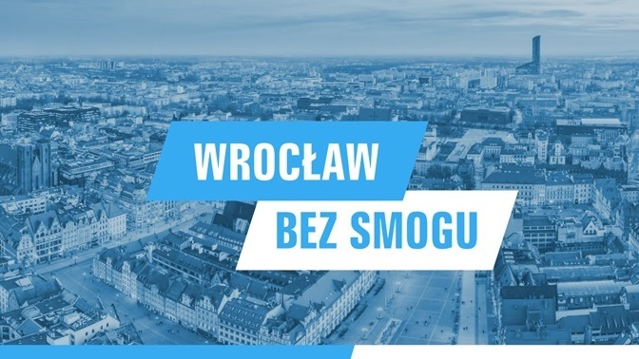
Wrocław fights against smog

PLN 330 million by 2024 - this is how much Wrocław intends to earmark for activities involved in liquidating outdated stoves.

Inhabitants can receive up to PLN 20 thousand for liquidating an old furnace and replacing old windows while council flats in which the tenants have liquidated a stove will be exempt from rent. These activities aim at implementing the anti-smog ordinance.
According to the data provided by the NIK (Supreme Audit Chamber) and the WIOŚ (Voivodship Environmental Protection Inspectorate), the number of days in which the admissible air pollution norms are exceeded has been falling year by year. Under the anti-smog ordinance, by 2024 there should be no non-class stoves or stoves of the lower classes (i.e. first and second class); whereas by 2028, solid fuel stoves (with few exceptions) will have been removed.
- Wrocław free of smog is one of the two most important challenges we are facing. Its achievement requires interdisciplinary action - stresses Jacek Sutryk, Mayor of Wrocław, presenting a wide programme for improvement of air quality in the capital of Lower Silesia.
In view of estimating the funds required to perform these tasks and discovering the details of the structure of Wrocław’s low emissions, the city council signed a comprehensive research agreement with Wrocław University of Technology. After 10 months it was established that there were 20,035 sites in which old furnaces ought to be removed.
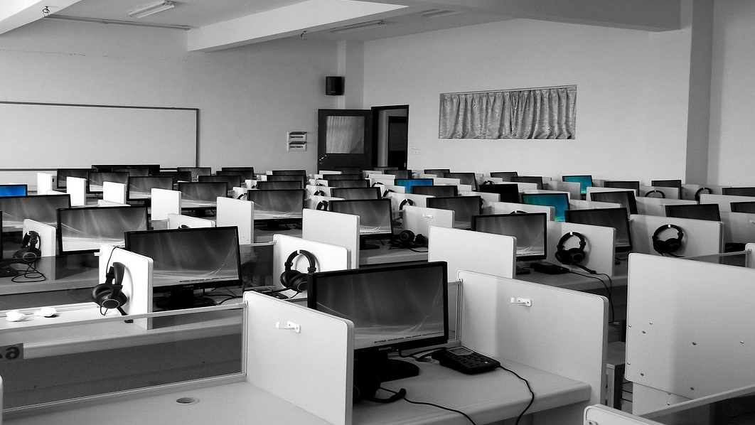
World Ergonomics Day
Celebrated since 2005, Ergonomics Day has aimed to promote ergonomic work conditions as fundamental to preventing ailments caused e.g. by the muscoskeletal system. According to the European Agency for Occupational Health and Safety, medical conditions concern primarily the back, neck, shoulders and arms, but can also concern legs.
The conditions can be caused by:
- Carrying heavy objects in an improper posture;
- Repetitive energetic movements;
- Awkward, static position;
- Vibration;
- Maintaining the same position (whether standing or sitting) for a prolonged periods of time.
Factors such as poor lighting or low temperature in the working environment can further contribute to the development of such conditions. There is an ever-growing body of evidence that the disorders in the muscoskeletal system may be due to psychophysical factors.
Prophylactics are the basic method of preventing such ailments. Above all, the workstation must be adjusted to one’s needs. It is also essential that a proper posture be adopted and exercises be done involving stretching and loosening one’s muscles.

