Promoting health among your staff
20% employees declare they would quit their jobs if their employer failed to care better and better for their health with 40% admitting that pro-health activities in their companies would have a considerable impact upon their work motivation.
Prof. J. Nofer National Centre for the Promotion of Health and Work Medicine Institute, in performance of their contract with the Ministry of Health, have published a report on how mid-size and large company staff in Poland behave and what they think in relation to healthy eating habits and physical exercise.
Sponsoring healthcare is not enough. The research shows that a mere one in five employees have named availability of doctors among top three important matters for their health. What employees expect from their companies is health-supporting activities, and these do not merely include gym or sport-centre passes or pro-health events. Nearly half of those employed claim that when changing jobs they would be looking for a company that will take a better care for their health, than what is required under OHS regulations.
The published findings clearly show that employees’ expectations outlive what firms are offering. Nearly 60% want their employers to collect information from them concerning their expectations from the employer on how to pursue a healthy lifestyle. Only 8% of respondents said their companies were interested in that issue.
Only one in four companies attempt to prevent mobbing
The research carried out last year by the Safe-at-Work Coalition shoed that 60% employees in Polish firms have experienced improper treatment from a superior, and 46% have fallen victim of mobbing. Unfortunately, only one in four employers have taken any steps to prevent the phenomenon.
Jan Obojski, Logistics Management Representative at ILS Grupa Inter Cars and an expert of the Safe-at-Work Coalition, said in an interview with the Newseria Biznes agency that mobbing concerns the entire organisation. Poor atmosphere at work affects work efficiency, the firm’s reputation deteriorates as well as the entire atmosphere surrounding it. The essence of mobbing is the lasting and persistent nature of the activities taken.
- Where the pressure on an employee is exerted repeatedly over a long period of time, then we face mobbing. Such actions are taken by employers as well as line managers, but few employees realise that they can be mobbed by other colleagues - says Jan Obojski.
80% of respondents said they preferred less-paid work at a company with good reputation. Not only does mobbing affect employee decisions on changing employers, but it can also have serious legal implications for the company itself – the employee has a right to enforce his or her claims, “if, as a result of persistent harassment, he or she terminated his or her agreement or suffered harm”.

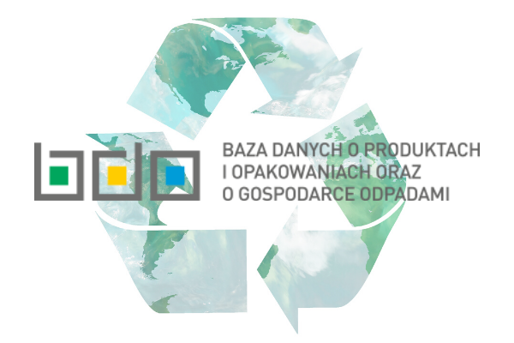
BDO: waste-management reports until 30 June 2020
The amended act on waste allows keeping parallel records of waste in the Waste Database (BDO) and in printed form until 30 June 2020. It is also by that date that businesses are required to file their waste management reports for 2019.
On 31 January 2020, an amendment to the act on waste and certain other acts in respect of records and reports to be filed with the Database of products and packaging, and waste management (BDO) came into force.
Due to the amendment, businesses have gained additional time for filing their waste management reports, i.e. by 30 June. So far, the documents were filed by 31 March of the year following the reporting year.
The deadline for registration with the BDO has also been extended until the end of June. Until 30 June 2020, companies can keep parallel records with the BDO and in printed form, provided that they issue a Waste Disposal Sheet (KPO) or Communal Wate Disposal Sheet (KPOK) in that form. However, business owners must bear in mind that the documents issued in the printed form must be entered into the BDO by 31 July 2020.
Coronavirus – symptoms and proper conduct
The recent weeks have seen instances of illness occurring in South-East Asia involving high body temperatures of over 38°C, cough, dyspnoea and breathing disorders. The epidemiology of infections with the 2019-nCoV, or the Coronavirus, is not yet well established.
In an announcement of 25 January 2020, the Chief Sanitary Inspector said that the preliminary case definitions and principal rules of conduct for those suspect of the virus infection had been developed.
According to the guidelines, a suspected infection include cases occurring following 9 January 2020, related to travel to the virus-occurring areas or close contact with a person who had travelled to those areas, over the 14 days prior to the symptoms occurring and features:
- Body temperature exceeding 38°C,
- Symptoms of the respiratory system diseases, e.g. cough, dyspnoea, breathing difficulty, radiological symptoms of pneumonia or ARDS.
The GIS informs that on noticing such symptoms, one must immediately report to a hospital emergency ward, where further treatment will be determined.
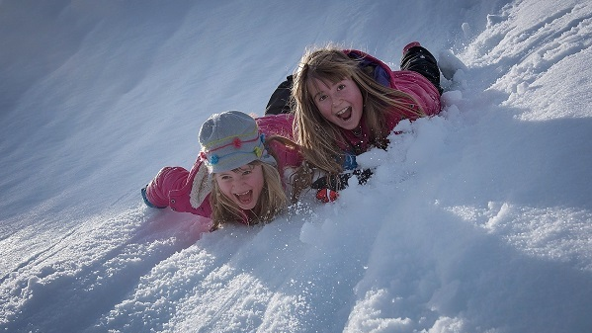
Safe winter holidays
On 13 January the first round of winter holidays started. Parents should make sure that they are carefree, happy and, above all, safe; and they are supported by the State Sanitary Inspectorate. Its role is to exercise sanitary and hygienic supervision over the locations where children and teenagers rest in the winter that are registered with the Education Board.
The GIS (Chief Sanitary Inspector) assures that the inspectors will audit the locations. Assessed will be the accommodation conditions for children and teenagers, such as:
- Cleanliness of the rooms;
- Access to hygiene facilities (hot water, soap, towels, etc.);
- Ensuring healthcare;
- The sanitary conditions of the kitchen and canteen, conditions of food storage and food health quality;
- Cleanliness of the surroundings of the holiday location.
Each parent having doubts about their children’s holiday locations can obtain detailed information on the organiser and location on the website of the Ministry of National Education https://wypoczynek.men.gov.pl.0} Moreover, problems relating to improper sanitary or hygienic conditions at holiday locations can be reported to the relevant local Poviat Sanitary and Epidemiological Stations.
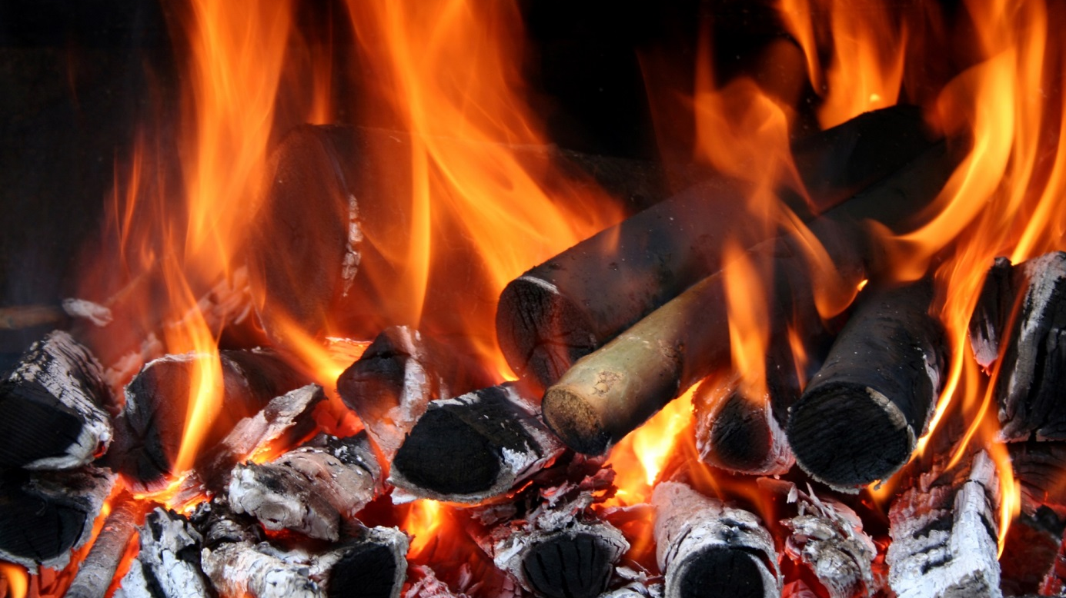
Fire safety rules for the winter
Surprisingly enough, there is an increased risk of fire in the winter, as fire usually breaks out inside buildings. The single most frequent cause of fire is reckless open fire handling.
Safety at home depends primarily on ourselves and our behaviour. So, remember these important rules:
- Never apply fuses of capacity greater than the recommended values.
- Only use as many electrical appliances as the installation capacity allows.
- Never make quick-fixes of the electrical connections or refurbish old installations or extension cables.
- Never place electric heaters directly on combustible surfaces or near easilty combustible materials (such as furniture, net curtains, etc.) – ensure a minimum distance of 50 cm,
- Never block ventilation ways,
- Never heat your rooms with a gas cooker – such practices, particularly in buildings with central gasometers, where one can heat one’s flat at the cost of others, often end up in serious poisoning of the body.
If you notice fire, notify the Fire Service immediately. On arrival of the fire-fighters you should strictly follow the orders from the rescue action leader.
Is occupational burnout a disease?
Occupational burnout is not a disease as yet, and doctors will not issue medical certificates on its grounds. The World Health Organisation (WHO) provided a more precise definition of a burnout, which was entered into the Disease and Health Issue Classification. According to it, burnout is currently a syndrome resulting from prolonged stress at work that an individual cannot efficiently handle.
According to the latest disease classification – i.e. ICD-11(2019) – burnout is still not classified as an illness, but its definition has been made more precise and it was categorised as work-related health issues.
Currently, burnout is characterised by three dimensions: 1 – exhaustion or lack of energy, 2 – cynicism, negativism and distancing oneself from one’s work, 3 - reduced sense of one’s efficiency.
Quite importantly, the current definition of burnout only refers to professional context and should not be applied to experiences from other areas of life.
Can doctors issue sick-leave certificates based on occupational burnout? Polish regulations only allow for a medical certificate in the case of an illness that prevents one from working. Occupation burnout is not a disease according to the ICD-11 classification.
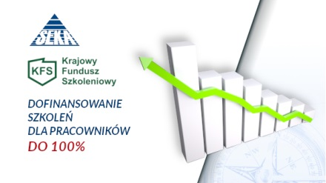

Filing funding applications – the National Training Fund
Similarly to the previous years, one will be entitled to apply for the funds from the National Training Fund for permanent education. SEKA S.A. can help you go through all the application stages and take through the training that will best suit your staff’s needs. The first deadlines have been announced.
Who can apply for the financing? The following entities can apply for the financing: businesses, institutions, offices, foundations employing staff on employment contracts and sole traders employing at least 1 member of staff on employment contract (full-time or part-time). The programme is addressed to those who belong to groups threatened with redundancies for lack of qualifications necessary on the job market, those requiring requalification or improving their knowledge.
Funds under the KFS can be utilised for:
- Courses and postgraduate courses and examinations taken by employees at the employer’s initiative or consent,
- Medical or psychological examinations should they prove necessary,
- Insurance against accidents occurring in relation to long-term education.
The financing can cover up to 80% of the cost of training, but not more than 300% of the average salary in a given year per trainee.
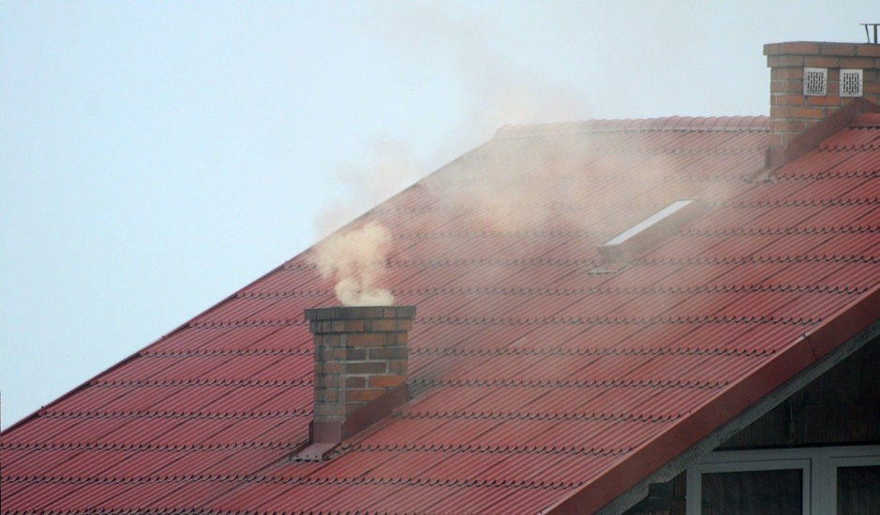
Stove is not a rubbish bin!
When burning rubbish in our household stoves we emit toxic substances that can cause serious lung or respiratory system diseases. Moreover, they pollute the neighbourhood, and the tar and soot can lead to a fire in chimney.
The Ministry of Environment has reported that Poles burn an average of 2 million tonnes of waste in their stoves a year. Such activities are not only harmful to the environment and health, but they can also attract severe penalties of up to PLN 5,000.
Pursuant to Art. 96 of Environmental Protection Law of 27 April 2001 (Dz.U.2018.799), many municipalities and voivodships have adopted ordinances aiming at preventing the adverse impact of smog on people’s health and the environment.
The ordinances specify inter alia the types of fuel and installations (furnaces, stoves, fireplaces) that can be used and types of entities affected by them.
Failure to comply with the regulations can attract a fine of up to PLN 5,000. It is worth noting, that obstructing audits is also punishable with up to 3 years’ imprisonment.
Every citizen witnessing waste burning can report the same to the Municipal Police, to the relevant City Council department or the Voivodship Environmental Protection Inspectorate – where waste is being burnt by a business.
Work hazards facing nurses
A nurse’s job ranks among the most stressful jobs. No wonder, it is shift work, covering nights, and is performance involves a high degree of risk.
The State Labour Inspectorate has drawn up an Information Sheet concerning hazards at this position and setting out rules of safe work in the profession.
Biological hazards. Direct contact with patients carrying dangerous diseases and patient-derived infectious material – these are some of the agents increasing the risk of falling ill.
Chemical hazards. Poisons, disinfecting preparations and cytostatic medicines can result in health conditions of various degrees, from skin and mucous membrane damage, through perspiratory system damage, to cancer or even death.
Hazards involved in a force position Work in a standing position, prolonged seated position, adopting a forced position (e.g. when lifting patients) can result in diseases of the muscoskeletal system, shoulders and wrists.
Other hazards. Stress and the occupational burnout syndrome as a result of shift work, night work, high levels of responsibility and other factors of psychological and organisational nature.

