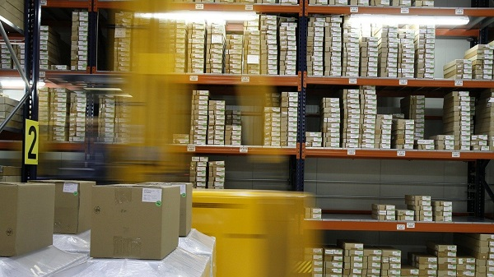

Do parcels from China carry coronovirus?
“Those receiving parcels from China are not at risk of contracting the new coronavirus” – one reads in a communication published on 21 February of this year by the Chief Sanitary Inspector.
Based on the research available so far, one can only state that infection with coronavirus only takes places through man-to-man contact.
The virus is airborne, but it cannot be excluded that infections through the faecal-oral route. COVID-19 can be carried from one individual to another by:
- Direct physical contact;
- Direct contact with air droplets when an infected person sneezes, coughs or exhales;
- Direct contact involving touching infected areas, on which the virus can survive for a very short period of time.
According to WHO assurances, coronavirus will not survive long in letters or parcels. That is why one cannot contract the virus from a parcel from China.
Time to adjust the regulations on breathalyser tests by employers.
New amendments to the labour law will confer a right on employers to carry out breathalyser tests on their employees. Employers also want to have the right to carry out tests for various other intoxicants.
Under the Labour Code, an employer must not admit an Employee to work where such employee is reasonably suspected of reporting to work under the influence of alcohol or of having consumed alcohol at work. However, the implementation of the GDPR gave employees the right to deny such tests on the grounds that certain sensitive data – including those relating to one's state of health - may only be shared with the employer at the employee's own initiative.
The Personal Data Protection Office has issued an opinion whereby breathalysing is only admissible in justified cases where the employer suspects that an employee is intoxicated, and should be carried out in the presence of the police. This is contrary to Art. 211 Labour Code expressly stipulating that an employee is required to cooperate with his/her employer in relation to OHS in the workplace.
Hence, employers have a dual problem: on the one hand, they are legally (criminally) liability for health and safety in the workplace and the compliance with the work rules, including an obligation to pay compensation in the event of an accident; on the other hand, however, they are not in a position to detect all events of intoxication, even more so if they employ some several hundred, or even thousand, people.
Can ‘Green Economy’ be profitable?
An increasing number of companies realise that an efficient environment management system can help them build trust, enhance the corporate image and reach new customers. What is more, adopting pro-environmental attitudes can bring tangible financial results to many Polish companies.
Such conclusions can be drawn from a survey carried out by DNB and PwC. Nearly 45% respondents – representatives of Polish businesses – have admitted that pro-environmental actions could bring tangible financial benefits to their companies. As many as 47% of those surveyed thought that such activities could be of short-term character and primarily result in an improved corporate image. The research has also shown that the positive impact of pro-environmental initiatives is not granted, but must be paired with thoughtful planning of actions ant proper enterprise management. Regulations should also have considerable impact serving as an important stimulus for companies undertaking pro-eco action.
According to Jacek Socha, Vice-President of PwC Polska, 67 of the largest Polish companies have already implemented pro-environmental initiatives with another 14% planning to do so. Currently:
- 76% of Polish enterprises sort their waste;
- 73% use energy-saving light bulbs;
- over 50% carry out educational activities among their respective staffs.
Recycling waste or switching off devices that are no longer in use requires few resources and brings tangible benefits soon.
Professional burnout – what is it caused by?
Professional burnout mainly occurs in jobs involving close contact with other people or emotional engagement in their problems, e.g.: nurses, doctors, teachers and psychologists. Burnout is a syndrome resulting from chronic, work-related stress.
Last year, WHO made more precise the definition of professional burnout. According to ICD-11, it is the effect of experiencing chronic, work-related stress, defined by across three dimensions:
- Exhaustion and lack of energy, resulting in reduced efficiency at work;
- Increased mental distance towards one’s work;
- Cynical or negative attitude to work.
The reasons for this phenomenon can be sought along three lines: its individual, interpersonal and organisational aspects.
- Individual factors. Features conducive to professional burnout include: passivity, low self-esteem, defensiveness and insecurity.
- Interpersonal factors. These include primarily relationships between employee-customer, with burnout developing in jobs involving emotional engagement in the problems of others.
- Organisational factors. These include primarily orders and prohibitions that create a set of expectations from the employee. The employee’s well-being is also affected by the physical environment, including noise, crowds, poor choice of office equipment, etc.
The happiest workers are those in IT, Marketing and Advertising.
Low-stress work is worth its weight in gold as happy employees are better motivated to perform their duties, more efficient and there is less risk that they will want to change employers. According Devire’s report for Kodilla.com, the happiest employees in Poland are programmers, engineers as well as marketing and advertising specialists.
The findings of the report show that the employees’ well-being is primarily fostered by a stable business and ideal employer, which according to the respondents gives one a lot of autonomy (48%) and is open to initiative and feedback (40%).
Magdalena Rogóż, an IT market expert of the Kodilla.com programming school, states that the greater the satisfaction from work, the higher its value. Besides, a happy employee is more committed and comes up with more initiative.
- Such a person is loyal and less liable to think of changing employers. In industries, such as IT, where specialists are scarce and which do not tolerate error at work, requiring precision and accuracy, it is of paramount importance that employees be appreciated, and as a result - happy – adds Magdalena Rogóż.
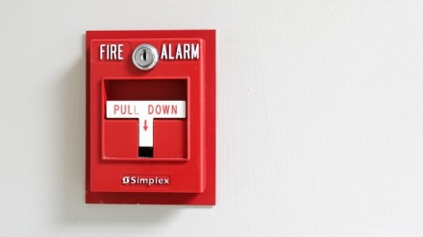
Annual fire safety assessment at your business
Employers have multiple obligations under fire-safety regulations. One is a requirement to carry out periodical audits of the state of fire safety in the workplace. The findings of such audits are necessary to manage the business in a safe manner in compliance with the law. What then should be checked?

What is checked during an environmental fire-safety assessment?
- How fire safety is organised – This concerns primarily the state of the staff’s awareness of the problem, i.e. knowledge of fire-safety regulations and the fire safety manual in operation on the site.
- Evacuation conditions – the vertical and horizontal evacuation passageways are checked for width, length, accessibility and passability, and for the way in which they are marked.
- Hand-held extinguishing equipment – extinguishers are particularly checked here for their choice (type and number), placement and marking.
- The technical state of electric, lightning and gas installations – for each installation its technical state must be analysed separately and proper documentation must be drawn up. Above all, the installation should be visually inspected for such aspects as: defects, abrasion and charring.
Data Controllers’ Handbook
Late December 2019, the Personal Data Protection Office published the first Polish version of the Data Controllers’ Handbook. The publication contains practical hints and guidelines on the application of the GDPR dedicated above all to data controllers.
The Handbook presents practical, robustly documented guidelines and hints that are to be adjusted and expanded due to the national promotional and training activities. It is addressed to data controllers, particularly data controllers acting in the public sector.
The publication consists of three parts:
- The first part concerns the history of the law. It covers inter alia “The first regulations, principles and international instruments for data protection” and “The European law on data protection in the 1990s and early 21st century” as well as such notions as: ‘confidentiality’, ‘privacy/private life’ or ‘data protection’.
- The second part addresses the GDPR-related issues: introduction, status and approach, accountability rules and functions, tasks, qualifications and experience of a data controller.
- Part III contains practical matters. It contains guidelines on the tasks of a data controller or tasks requiring a data controller’s involvement in practice.
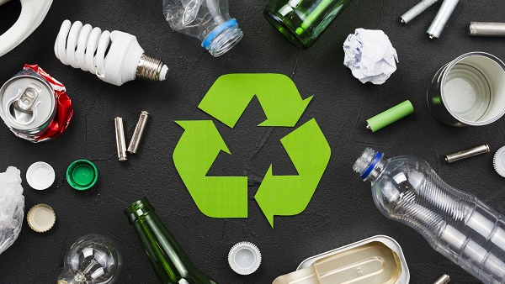
The most frequent mistakes in waste sorting
We all know that waste should be sorted. It is necessary as it will be later processed and converted into everyday items of other or similar characteristics. Yet, it is worth doing it correctly since sorting waste is not so unambiguous as one might think.
The following examples prove the point.
- Jars and cans are thrown away together with mixed waste. This is a serious mistake since there are separate containers for glass and metal. Important! One need not clean glass containers or food cans prior to disposing of them – they only need to be emptied. They will be washed in the sorting plant.
- Not everything is glass that looks glass. It turns out that not every type of glass can be thrown into the same container. One should only throw drink and food jars and bottles as well as cosmetics glass containers to the glass container.
- Animal waste is not biodegradable. One must not throw meat, bones or meat containing food leftovers into the biodegradable waste. Hair, fur, excrements, cat litter or sawdust containing excrements should not be thrown there either.
- ‘Carton’ is not paper. Milk or juice cartons, or the so-called tetra-pack containers, should be thrown into the yellow container for plastics.
- Receipts are not paper, either. Receipts are printed on thermal paper. Hence they should be thrown into the black containers for mixed waste.
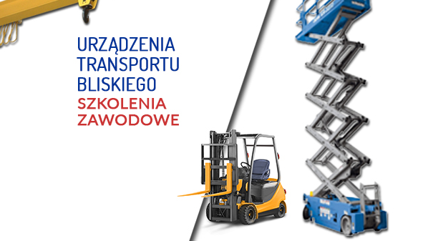
How to obtain UTB qualifications?

Handling equipment (UTB) comprises diesel, electric and hybrid forklifts used in in-store transport which require for their operation a necessary qualification from the Office of Technical Supervision (UDT).
The rules for obtaining the qualifications are set out in the regulation of the Minister of Entrepreneurship and Technology on the manner of and procedure for verifying the qualifications required in operation and maintenance of technical equipment and the manner of and procedure for extending the validity of the qualification certificates of 21 May 2019.
An examination before the qualification board verifies:
- Theoretical knowledge of the technical conditions required by the technical supervision authority, norms and legal regulations concerning the activities performed;
- Practical skills in operation of technical equipment.
Given the requirements, the relevant training is delivered in two stages: the theoretical part where trainees acquire the knowledge required, and the practical part where they acquire the skills of handling equipment operation.
The training and courses in forklift operation offered by SEKA S.A. are compliant with the UDT guidelines and provide the trainees with comprehensive preparation for examination before the qualification board.
The authorities exercising supervision over work conditions
The supervision over work conditions in Poland is exercised by the institutions appointed and authorised by the Polish Parliament. The basic duty of these bodies is overseeing the compliance by enterprises with employment law, and health and safety and fire safety regulations.
The supervision authorities can be divided into external ones - established by the state, and internal ones - established by the employer and employees. Their organisation and scope of activities are set out in separate provisions of law.

External – state – authorities
- State Labour Inspectorate
- State Sanitary Inspectorate
- Office for Technical Supervision
- State Fire Service
- State Mining Authority
- Polish Atomic Agency.

Internal – social – bodies
- Social Labour Inspectorate
- OHS Service.

