WHO: Tap water is safe
The World Health Organisation (WHO) reports that coronaviruses are killed during the water treatment process, which means that coronavirus is not spreading across the water supply system.
In a recent WHO publication entitles “Water, sanitation, hygiene and waste management for the COVID-19 virus”, experts explain that there is no evidence for the COVID-19 virus being able to survive in drinking water; consequently, there is no need for additional disinfectants.
The research shows that the viruses are prone to UV and disinfectants, such as chloride, sodium hypochlorite or chlorine dioxide. And these, as Polish water treatment plants are announcing in their official communications, are commonly used by them. It follows, then, that viruses are removed from the water at an early stage of the technological water treatment process.
The City Water Supply and Sewage Plant in Wrocław reports that viruses, similarly to other suspended particles of that size, “are removed from water during the process of coagulation combined with polyelectrolyte-supported flocculation and sand, sand-anthracite and/or carbon filters”. It is not possible for the viruses to find their way into the communal water supply system as it is entirely tight.
Such information has also been posted by other water supply and treatment plants.
Not only work can be done remotely – learning at the times of coronavirus
For most of us, moving our entire lives into the confines of our homes and staying there for (initially) two weeks seemed like an apocalyptic vision of science fiction writers. Some, however, have jumped at an opportunity of catching up with their arrears.
There are a plethora of e-learning courses that you can do in the quiet of your home. Wearing slippers, tracksuit, with a cup of coffee/tea/cocoa (if still available...) – whatever you like. One advantage of the solution is that the training can be interrupted at any time and resumed after we have solved our household problems.
You may be wondering who and what for is all this e-learning. The answer is simple: given the current situation, with all of us having to stay at home, it could be the only way to attend statutory training, such as that in occupational health and safety. On returning to the ‘normal’ state, we will be able to focus entirely on our work duties, of which there will probably be a lot.
Employers and those in charge of HR management can, on the other hand, improve their managerial skills and knowledge in such areas as mobbing prevention, efficient instruction-giving, salary management or the GDPR. There is plenty to choose from.

Remote video teaching guide
The possibility of online video courses opens new opportunities for training institutions. How to develop a professional and interesting course of this kind? We are presenting a few guidelines for those who would like to follow the idea in these difficult quarantine times.
Be an expert. The first and foremost requirement is professionalism. Individuals and institutions who only want to gain media presence rather than delivering genuine knowledge to their audiences will easily discourage their customers. Therefore, one should above all base one’s efforts on experience-supported and consolidated expertise.
Plan. Draw up a detailed plan before you even start creating training videos. Develop all materials. Courses should be delivered in an optimal way, i.e. they should deliver a sufficient amount of knowledge in a proper amount of time.
Reach your audience. Prior to delivering the training, it is necessary to research the demand and size of the target audience. One can use one's own social media channels. It makes sense to not only allow prospective clients to give their opinions, but also to let them ask questions.
Technical issues. Audiences find nothing else as off-putting as a lack of professional training form. Even training that offers genuine content will fail to arouse people's interest if it lacks flow and pace, and occasional technical glitches.
In the case of ‘live’ courses, it is essential to practice all training elements beforehand.

Are your working or learning remotely? Remember about several principles important to your health
Proper body posture, sufficient desk size and screen position, regular breaks from work and muscle loosening exercises - all these contribute to mitigating the conditions resulting from long computer-based work or learning sessions. We would like to remind you of the basic principles of safe work using computers.
Place of work. A properly arranged working area can help eliminate or reduce potential aches and pains. Take into account the correct and recommended placement of the hardware: screen – at a distance of 40-75 cm from your eyes; chair – with adjustable seat, backrest and armrests; table - ankles bent at right angles; room - well lit and ventilated.
Organisation of work. It is worth adopting certain principles that will increase your efficiency: make a plan of work involving your computer – draw up a list of tasks starting the most urgent ones and put your priorities first, focus on that single task; eliminate harmful influence of any external factors; ensure peace and quiet.
Breaks and exercise. After every hour of work take a minimum of five minutes’ break. You can spend it e.g. by doing breathing exercises, massaging your fingers as well as loosening your trunk muscles.

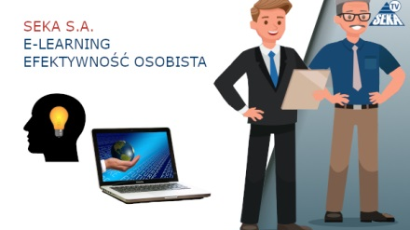

E-learning: Personal Efficiency
SEKA S.A. offers a wide range of online courses. You can extend your knowledge without leaving your home. E-Learning – Personal Efficiency is a course that will allow teach you different ways of developing your personal efficiency by managing your personal intellectual and emotional assets properly. Our training is designed to improve both hard and soft skills. Take advantage of our offer!

Availability
Modern solutions allow you to attend the training online using your PC/laptop, tablet or smartphone. No additional installations are required, what you need is a standard web browser and sound card. The courses are designed in a manner allowing you to interrupt your learning sessions and resume at any time. An attractive graphical form, accessible language and reliable content ensure the efficiency of the training process.

For whom?
The training is addressed at a wide range of audiences. Whatever your position in the company, you want to improve your efficiency and effectiveness of your actions as well as developing your personal potential. With such an attitude plus our training your success is guaranteed!
Find out about online courses offered by SEKA S.A., the country’s e-learning leader.
Questions at the time of coronavirus
The most frequently asked questions at the Patient Hotline concern the symptoms, conduct and prevention, as well as teleworking and the special law adopted in order to prevent and fight infections with the SARS-CoV-2 virus.
According to the current state of our knowledge, the course of a coronavirus infection can vary significantly - from symptom-free, through mild respiratory system conditions, to acute pneumonia, or even multi-organ failure and septic shock. One can contact the virus through contact with another person as it is airborne. This happens when someone coughs or sneezes near you (at a distance below 1.5 metres). The virus can also be spread by direct touch. For this reason, it is so important to wash your hands frequently.
When can an employer order so-called remote work and will your salary change? Under Art. 3 of the special law on preventing coronavirus, employers can instruct their employees to perform their work outside the usual place of work, i.e. remotely. The decision on remote work is at employers’ absolute discretion.
One is entitled to regular remuneration for the work performed remotely; hence it will not be reduced.
State of epidemic threat vs. state of epidemic - the notions explained
On account of a growing number of SARS-CoV-2 virus infections, the state of epidemic threat was introduced on the territory of Poland on 14 March 2020 while the state of epidemic was already announced a week later, on 20 March.
An epidemic threat is a legal situation introduced in a certain area in relation to a risk of epidemic in order to undertake preventative action (Art. 2 (23) of the act on combating infectious diseases).
A state of epidemic, on the other hand, entails taking anti-epidemic and preventative action in order to minimise the effects of an already existing epidemic (Art. 2 (22) of the act on combating infectious diseases).
Thus, the state of epidemic threat is introduced in order to prevent an epidemic, whereas the state of epidemic is announced where an epidemic has occurred in a given area and its effects ought to be mitigated.
The regulation on the introduction of the state of epidemic on the territory of the Republic of Poland of 20 March 2020 vest relevant governmental authorities with new powers, imposes a number of bans as well as several new obligations. Time in force – until revoked.

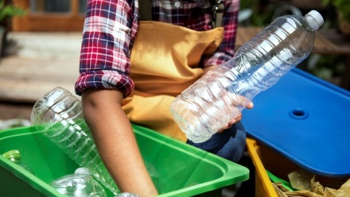
Communal waste not to be sorted?
The Cluster for Waste Management and Recycling has sent a letter with its postulates to the Ministry of Climate requesting a possibility of waste disposal without sorting or of direct incineration or co-incineration of waste. In this way, the Cluster wants to protect the staff of the sorting plant against coronavirus.
Associating more than 100 members Cluster of Waste Management and Recycling – the National Key Cluster states that the current situation requires precautions to be taken also in the waste management industry.
In a letter sent to the Ministry, the Cluster's members appeal for a temporary non-sorting period with respect to communal waste (regardless of its caloricity). This would require suspending the prohibition on the storage of the combustible fraction under the regulation of the Minister of Economy on the admissibility of storage of waste in landfill sites of 16 July 2015 (Dz.U.2017.1277).
They also request that the mixed communal waste collected from households, including the high-caloricity fraction, could be directly incinerated or co-incinerated in adequately prepared installations.
The postulates aim at protecting the sorting plants’ staff against becoming infected by the waste deriving from infected persons’ homes.
New fire safety regulations for landfill sites
On 4 March of this year, a new regulation entered into force of the Minister of Internal Affairs and Administration on fire safety in waste collection, storage and processing. The new regulations are as a result of an increasing number of fires in such sites and over the past years and the resulting adverse environmental impact.
Under the regulation, a separate fire PM zone should be created for the purposes of collecting, storing or processing solid combustible waste, separated with stripes of empty land or with fire-safety elements. This is applicable where the total volume or mass of the solid combustible waste at a site or in an area exceeds 200 m3 or 50 Mg respectively. The regulations also specify the requirements concerning:
- Storage of whole or shredded tyres,
- An obligation to equip fire zones containing solid waste with fire-signalling system and alarm,
- Building structures or their parts and other places designated for the storage of gaseous or liquid gas waste,
- Smoke-removing equipment for fire zones containing solid waste with the fire-load density exceeding 500 MJ/m2 and area larger than 1000 m2,
- Terms of fires safety for combustible waste which can pose a risk of fire as a result of spontaneous heating.
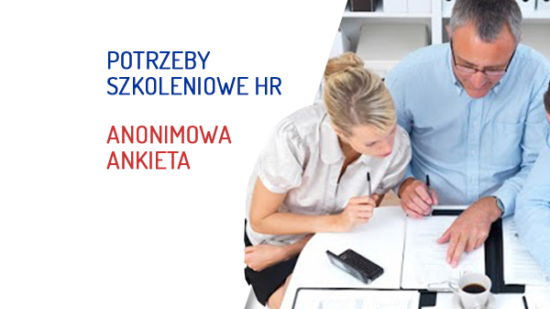
HR training needs
SEKA S.A. invites:
- Representatives of HR departments,
- Representatives of Personnel departments,
- Representatives of Payroll departments,
- All those who are interested in matters relating to human resource management,
to complete an anonymous questionnaire to help us determine your current training needs in the fields soft and hard HR skills.
The findings of the survey will enable us to prepare a package of courses that will provide a genuine response to the needs of potential Trainees.
Thank you for your time devoted to completing the survey.
You can complete the questioannaire HERE -> https://tiny.pl/7htlr

