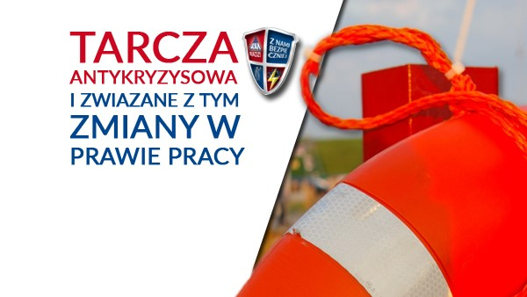
Anti-Crisis Shield and consequent amendments to labour law
On 31 March 2020, a legislation package incorporated in the so-called Anti-Crisis Shield was signed by the President and came into force already on the next day, i.e. on 1 April. Since then, businesses have been able to make relevant applications.
Sole traders, micro-businesses, as well as small, medium-sized and large companies, affected by the economic implications of the pandemic (including falling turnover), can apply for various forms of aid and legal instruments set out in the Anti-Crisis Shield.
The Shields provides inter alia the following solutions for businesses:
- Aid for micro-businesses (with up to 9 employees) and self-employed in the form of ZUS (Social Security) contribution release for 3 months (March-May);
- Business stoppage benefit of up to PLN 2000 – for self-employed with revenue of less than 3 times the average salary;
- Aid in the form of subsidy of up to 40% of average monthly salary to employees, where the working hours have been reduced to 80%, or subsidises salaries during the economic stoppage;
- Flexible working hours – for companies in difficulties.

However, firms must meet a number of economic and legal conditions, set out in the statute, before they can apply for the aid. And, according to lawyers, the regulations are very long and complicated, sometimes unclear, thus generating interpretation disputes even among experienced practitioners.

So, if you need state aid and have doubts about the regulations, draw on the knowledge of lawyers. Sign up for a training course offered by SEKA S.A.
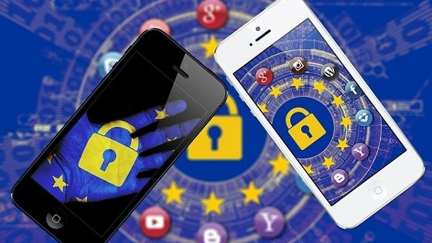
How to carry out a data protection risk assessment for remote work?
The activities undertaken by the state authorities in order to prevent the virus from spreading have resulted in many businesses organising their work remotely. The practice has shown, however, that not all are prepared to do business in this form.
According to odo24.pl portal, in most cases organisations have neglected the technological aspects of personal data protection. It has been widely assumed that an employee’s home is as safe a place as the company servers for the storage, processing and collecting of personal data. Consequently, the organisation of remote work should be preceded by an assessment of the risk to the personal data provided.

Risk assessment – step by step
- Define the data processing operations to be performed remotely. Review all processing registers maintained by your organisation.
- Review the resources to be used by your staff (hardware, software, network, locations, etc.). Specify which assets are owned by the organisation and which by the employee. Indicate that using private equipment can generate additional risks.
- Specify the safeguards to be applied to those resources.
- Identify potential threats to personal data processed remotely. The GDPR has identified inter alia the following threats: accidental or unlawful destruction of personal data, loss or modification, and unauthorised disclosure or access.
- Define the vulnerability of data to potential threats. For instance, leaving agreements or notes on a client in a generally accessible place.
- Set out a list of risks with threat levels assigned.
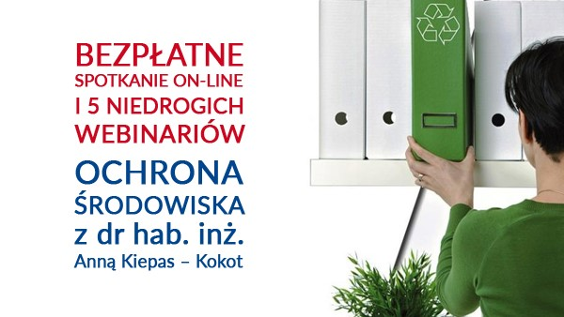
- Develop a risk-handling procedure on the grounds of the above list. Start with priorities. Implement procedures in accordance with the predefined schedule.

Free meeting and webinars in environmental protection
One can teach oneself the skills required in ensuring compliance with environmental protection regulations. However, it requires considerable amount of work and, besides, entails uncertainty as to whether the findings made are correct. Topical environmental webinars enable participants to acquire the necessary skills and implement them in their organisation in a short time.

In an era of constant changes and threats, managing environmental protection in a company requires a specific approach:
- Identify accurately the obligations of a business in relation to its use of the environment;
- Move freely in the jungle of the ever-changing regulations;
- Be able to prepare properly the documentation necessary for the obtaining of relevant decisions;
- Draft the documentation, records and reports accurately and on time;
- Prepare your organisation professionally for audits from authorised bodies;
- Take decisions bearing in mind potential penalties and other sanctions.

The webinars offered by SEKA S.A. enable case studies based on the individual needs of each participant. After the training, the participants can obtain free-of-charge answers to any questions they were not able to ask during the online session.

On 8 May 2020, from 17.00 to 18.00, we invite you all to a free-of-charge online meeting with Ms. Anna Kiepas – Kokot, Ph. Sc. – an academic lecturer with many years’ experience, author and co-author of many academic publications in the field of environmental protection, particularly issues relating to waste management.
During the webinar, Ms Kiepas – Kokot will address the questions you have always wanted answers for or will prepare individual answers in the case of more complex issues.
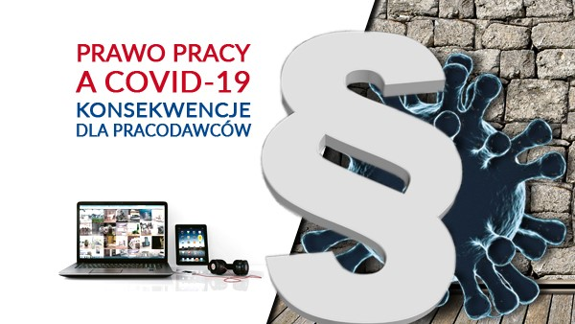
Labour Law and COVID-19 – implications for employers
Under the current legislation, employers are responsible for the health and lives of those they employ and are required to minimise the risk of their employees falling ill with the coronavirus.
As employer, you should remember that the state of epidemic does not release you from the obligation to comply with labour law!

One of the tools that employers can use is instructing employees to work outside the normal work premises, i.e. remotely. Many companies have introduced it as an obligatory principle. Another obligation is for employers to provide employees with personal protection equipment: disinfectants and disposable gloves, or even a complete set of protective clothing where is justified by the nature and place of work, e.g. hospital.

The so-called Anti-Crisis Shield developed by the Government sets out to support businesses. However, the regulations are often lengthy and not always clear.

What support can a business receive? Do the new regulations provide for help in respect of job protection?

Such questions are often being asked in many industry-related fora. Business owners are confused and seek answers that are accurate and specific. Alas, the answers that can be found in the Internet are not always reliable. Therefore, we have developed substantive and legislation-compliant online training covering the most important issues relating to labour law and its implications for employers.

Introduction and settlement of remote work
The situation, both in this country and worldwide, has forced many employers to implement radical changes to how their businesses operate.

The actions are taken as a result to the so-called special act, which regulates the rules for and manner in which COVID-19 is prevented, counteracted and combated. One of the solutions is working remotely.
Under Art. 3 of the special law on preventing COVID-19, employers can instruct their employees to perform their work, as specified in their respective employment agreements, outside their usual place of work for a determinate period of time (remote work).
One will not find a definition of the term ‘remote work’ in the Labour Code, as the concept has been missing from Polish law so far. Work performed remotely is referred to in the regulations as ‘teleworking’. Thus, under Art. 675 of the Labour Code, teleworking means working on a regular basis outside the workplace by means of electronic communications for the purposes of regulations on the provision of services by electronic means.
Other provision regulate among other things: the terms of application of telework by employers, as well as the respective obligations of employers and employees, including supervision and ensuring occupational health and safety.

A lack of specific regulations results in many employers having often doubts about whether or not they should instruct their employees to work outside the normal work premises. Nevertheless, many companies (wherever practicable) are operating in exactly this way at the moment.

One of SEKA S.A.’s proposals for dispelling the doubts surrounding the instructing, performing and settling remote work involves dedicated online training. It has been developed with employers as well as HR and payroll staff in mind. The matters discussed during the course make up a set of answers to the questions our lawyers are most frequently asked.

Remote training – capabilities matching our times
One can acquire knowledge without ever leaving one’s home not only in the area of soft skills, but one can also learn to operate an excavator or pilot a plane. This is possible through remote learning courses, available in different forms: videoconferencing, webinars, e-learning, podcasts, ebooks, mobile games or even virtual reality.
Remote learning has entered our private spaces and has settled there for sure. At the same time, it makes it possible to improve competences and acquired new skills at a time when traditional educational forms are unavailable. Such restrictions are imposed by the regulations on preventing the epidemic and combating the virus in our country.
- Hence the first argument FOR remote learning -> AVAILABILITY.
There are currently restrictions on people moving around and gathering in public places. As a result, a possibility of doing training without direct contact with other people or even instructors creates another advantage of such learning -> SAFETY.
Naturally, one cannot omit other arguments which influence the choice of this form of training even in ‘normal’ times. These include:
- Comfort – remote training can be delivered at a place of our choice. Be it a desk in your bedroom, kitchen table or living room couch, or a garden hammock or armchair on the terrace.
- Comfort also means time. You can choose the time of day (or night) and the amount of knowledge to be absorbed in line with your capabilities. A learning session can be interrupted at any time and resumed at a time you’re ready again.
Where to throw away used disposable gloves and face masks?
You might think it’s easy: both disposable gloves and masks are made of plastics, so they should be put into the yellow container.
Yet, this is not the case. Used protective equipment should be thrown into mixed waste, i.e. to black containers.
Due to the epidemic, since 2 April all open shops have been required to provide their customers with disposable gloves or hand disinfectants. On the other hand, since 16 April all citizens have been required to cover their nose and mouth in public places.
Unfortunately, the requirement has resulted in gloves and masks being scattered on the streets, at bus stops or in parks. This is dangerous as communal cleaners may be exposed to coronavirus.
Also, another problem arose: Which containers should used protective equipment be put in?
The Warsaw City Council has made a statement in this respect whereby according to the guidelines of the Chief Sanitary Inspector for handling waste generated during coronavirus infections.
“Used hygienic materials, including paper towels, paper face masks or rubber gloves, should be thrown into mixed waste. Cardboard tissue boxes, on the other hand, should be thrown into paper containers.”
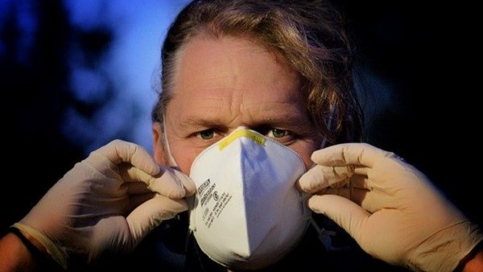
Whenever in doubt in sorting out waste, you can always make use of the search engine available at segregujna5.um.warszawa.pl.

Which masks do actually protect you against the virus?
Since 16 April, we have all been required to cover our noses and mouths in public places. This is yet another restriction imposed by the Government in response to the coronavirus epidemic. What mask to choose in order to really protect oneself against the infection?
Basically, masks can be divided into medical and protective ones. What are their features and uses?

Protective masks
Masks of this kind protect us, specifically our airways, against external conditions: smog, dust, particulate matter, aerosols or viruses.
They must be made in accordance with the EN149 standard. Depending on the protection class, they can be divided into three categories: FFP1, FFP2, FFP3. The higher the class, the greater the efficiency in protecting our airways against external particles.

Medical masks
The main function of medical masks is protecting others against the air exhaled by us, e.g. against droplets of cough.

Home-made masks
Unfortunately, no home-made masks have been tested and their efficiency cannot be confirmed. The most important element of a protective mask is a filter responsible for ‘passability’, i.e. the size of pores through which contaminants can get inside. Thus, if a home-made mask is fitted with a proper certified filter, then it will also be able to serve as efficient virus protection.
Psycho-sociological hazards in banking
Employees experiencing stress related to the conditions of work or psycho-sociological threats occurring in the workplace are unhappy, their motivation goes down and they declare more often the will to change the workplace. Such factors also occur in the banking sector. Psycho-sociological threats have considerable impact on the work safety in an organisation.
The particularly troublesome threat categories in banking include: lack of control and career development. On the other hand, the most frequent and most stress-inducing sources of hazards include:
- Staff evaluation systems;
- Obligation to strictly follow the prescribed procedures;
- Risk of redundancy;
- Bureaucracy.
The following are often quoted as specific stress-inducting factors:
- Work overload;
- Difficulties in dealing with customers/clients;
- Technological problems;
- Long working hours;
- Low remuneration;
- Home-work life conflicts;
- Necessity of using cash.
It is worth noting here that those employees who experience work stress as a result of work duties and interpersonal relations report lower assessment of their physical health. Moreover, they more frequently declare willingness to change jobs.
WWF: Epidemics are a result of our actions
Undoubtedly, humans are responsible for at least half of zoonotic diseases. Human interference with the ecosystem, i.e. changing the use of soil or destroying animals’ natural habitat has disturbed the ecological equilibrium in nature. The global coronavirus pandemic caused by the SARS-CoV-2 coronavirus is just a result of such actions.
The report published by the WWF entitled “Ecosystem destruction and rise of the pandemics. Protect human health by preserving biodiversity” says that many newly-occurring diseases, such as: Ebola, AIDS, SARS, bird and swine flu and COVID-19 are not accidental catastrophic events, but rather a consequence of our impact on the natural ecosystems.
People have considerably changed both land and the ocean. Currently, a million species of animals and plants face extinction, and greenhouse gas emissions have resulted in average global temperatures rising by 1º C compared to the pre-industrial era.

75 per cent of infectious diseases derive from animals.
An uncontrolled trade in wild animals in Asian and African metropolitan markets creates a danger of people contacting diseases present in such animals and developing old and new zoonotic diseases. 75 per cent of human infectious diseases known so far derive from animals. Zoonotic diseases cause about a billion infections and millions of deaths every year.

