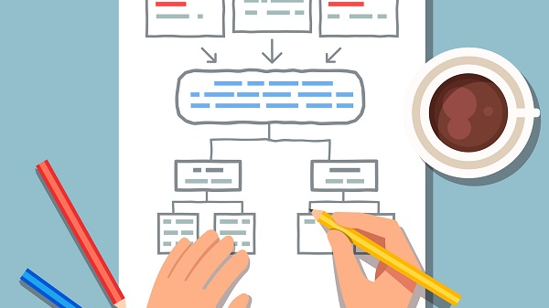
COVID-19: Workplace Safety Precautions Plan
At this time of epidemic, a new threat has arisen in the workplace caused by the corona virus SARS-CoV-2. Hence, employers or business owners are required to undertake actions mitigating the risk involved in exposure to this biological factor. One of such tools consists in developing a preventative action plan.
A Safety Precautions Plan is one of the solutions recommended by the CIOP-PIB (Central Institute for Labour Protection - National Research Institute). It should be drawn up by the management in consultation with employee representatives and in collaboration with occupational medicine doctors and OHS specialists. In creating such a plan, the following points must above all be taken into consideration:
- The legal requirements and recommendations from the state administration effective during the epidemic;
- Types of work performed in the workplace and the associated probability of contracting the SARS-CoV-2 virus in the workplace;
- Number of employees, divided into teams performing specified tasks;
- The workplace infrastructure (including the size and condition of the premises);
- Technical solutions preventing harmful biological factors from spreading.
The plan should cover comprehensively all factors contributing to the increase risk of SARS-CoV-2 infections and specify all possible precautions.
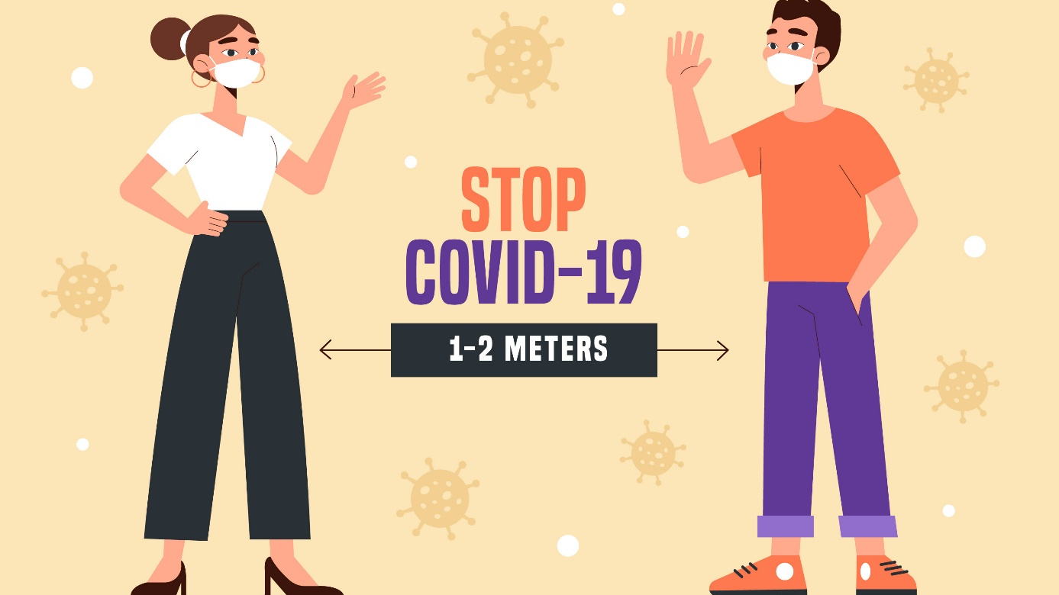
How to mitigate the risk of SARS-CoV-2 exposure in the workplace?
Under the current regulations (i.e. Art. 207 § 2 and Art. 304 of the Labour Code), employers have a duty of care in respect of the safety and health of those employed by them. One basic precaution is occupational risk assessment and application of necessary precautions mitigating such risk (Art. 226 (1) of the Labour Code).

Precautions mitigating the risk of corona virus infections
- Ensure social distancing.
- Work remotely. If the nature of the work allows it, it should be performed remotely.
- Limit direct contact with external visitors.
It is recommended to keep to a necessary minimum any business travel and meetings requiring direct contact between the staff and third parties.
- Compliance with the hygienic procedures in the workplace. It is imperative to implement and strictly comply with hygienic procedures in the workplace.
- Personal protective equipment and work clothes. Where the nature of the work performed makes it impossible to keep a proper distance of a minimum of 1.5m and the time of contact exceeds 15 minutes and there is high probability of contact with SARS-CoV-2 or a person infected with COVID-19, the employees should be provided with adequate personal protective equipment.
Bodies of water are not dustbins!
Recent times have seen a considerable rise in river contamination. This includes both household rubbish dumped directly into the water and waste water leaking from water treatment plants. Chemical substances which enter waters and the contaminants released from solid waste pose a threat to both human health and the environment.
Wody Polskie (the Polish Waters Company) in collaboration with local authorities are undertaking actions aiming at maintaining the cleanliness and order at hydro-technical sites, riverside areas and the areas surroundings bodies of water. Despite the efforts, the problem of waste dumping in the proximity of rivers and other bodies of water is so common that the staff regularly engage in riverbank cleaning campaigns.
For instance, an average of 1.5 tonnes of waste is collected from a 1-kilometre segment of riverbank in Wrocław after a typical spring or summer weekend. The problem, unfortunately, concerns the whole Poland.

#SzanujWodę – reaguj! (#RespectWater – React!)
If you have witnessed water being contaminated or seen anyone disposing waste or releasing waste water into the river, react! Call the emergency number 112 to inform the operator about the problem providing the exact location and brief description of the event.

Good practices in the enterprise not only during the pandemic
The state of emergency and the precautions undertaken are affecting employees’ states of mind. Therefore, employers should take one more task into consideration: mitigating the psychological strain as well as implementing or expanding the existing communications inside the organisation.
In developing an action plan and identifying the threats, an employer should also take into account aspects contributing to the psychological strain on the employees. With the threats in mind, one ought to determine specific precautions. Thus, an employer can:
- Assign individual working hours to the employees;
- Set up a regular Internet forum;
- Ensure individual psychological assistance to the employees;
- Prevent exposure to stigmatisation, isolation from the team and exclusion from social life of those who have recovered from COVID-19.
Proper communication with the staff is an extremely important aspect. Such actions are not only relevant at the time of the pandemic, but they are worth implementing as permanent procedures in the company as they greatly affect the morale of the employees.
The precautions taken allow efficient business and staff management, not only in times of crisis, but also on a daily basis. So, they are worth including in a business’s organisational planning.
How to manage stress at work?
Stress is one of psycho-sociological hazards in the workplace. It greatly affect workers’ moods and hence their health and safety levels in the organisation. Preventing stress in the workplace is not only an employer’s obligation, but it is also legal requirement under the framework directive 89/391/EEC.

What actions can be taken by employers?
Psycho-sociological hazards in the workplace can be prevented and effectively managed. First of all, one ought to change the approach to the problem and realise that stress represents a risk comparable e.g. to a fall or another OHS hazard. Thus, an employer should:
- Raise the employees’ awareness of psycho-sociological threats. To this end, a stress-management policy should be drawn up, communicated to all staff, who should then be engaged in a joint conversation on the subject.
- Manage the risk. The procedures for risk management in the workplace should be drawn up based on the existing guidelines in the areas of OHS and fire safety. Hence, the first step will be to identify the threats.
- Build up strength. A high level of emotional immunity helps employees manage their time well, solve problems quickly, control their emotions as well as contributing to a high level of confidence and good relations with others.
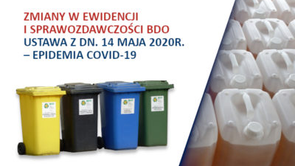
Changes to the waste (BDO) records and reporting requirements - COVID-19 epidemic
The entering into force of the act amending certain acts with regard to protective measures in response to the spreading of the SARS-CoV-2 virus of 14 May 2020 (Dz. U. 2020.875) has resulted in: resumption of the terms of administrative proceedings, changes to the manner of the BDO (Waste Database) record-keeping, extension of reporting deadlines and decision-binding terms.
The act sets out changes in record-keeping. Companies which have not yet obtained a register number will be able to keep the records in the printed form leaving the space for the BDO number blank.
The act has modified the report-filing deadlines. Annual reports on waste generation and waste management can be filed by 31 October 2020. Exceptions include vehicle disassembly stations – by 11 September 2020. The deadlines for reports on the communal waste collected have been extended until 31 August 2020. Annual reports on products, packaging and waste management can be filed by 11 September 2020.
The legislator has also extended the validity terms of already granted decisions concerning waste management. This applies to decisions issued for a fixed term whose validity expires during the state of epidemic and motions for amendments to decisions filed on or before 5 March 2020.
Plants in the office? Certainly
Not only do plants present in the office absorb harmful substances and increase humidity, but they also contribute to workers’ health, particularly their mental well-being. They contribute to the feeling of security, calm down, provide relaxation to the strained eyes as well as dampening noise.
In the workplace, we are surrounded by office equipment which release acetone and trichloroethylene, coupled with chemical substances exuded by paints, varnishes and other chemicals used for cleaning purposes. In the summer, the air is dried by air-conditioning, while in the winter – by the heating system. All these contribute to our health and well-being. A good solutions to these workplace problems are plants, which increase humidity and act as fitoremediants, i.e. natural absorbents of harmful substances.
The research carried out in three academic centres over the last decade has demonstrated that plants exert psychological influence as well increasing productivity by 10-15% compared to ‘plantless’ offices.
The best species of plants for offices are those which are the most resistant and durable. Examples include: Aloe vera, Sansevieria trifasciata, Nefrolepis, Anturium (Andrego Anthurium andreanum), Spathiphyllum, Epipremnum aureum, Philodendron and Chlorophytum comosum.
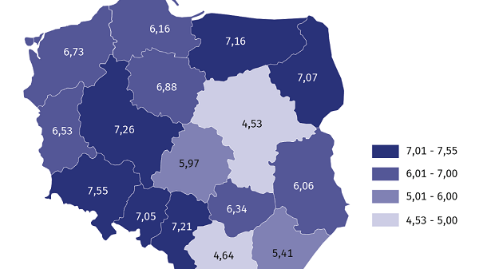
The numbers of those injured in accidents at work are going down
The numbers of accidents at work in Poland have been falling over the years. According to the Main Statistical Office (GUS), 83,205 persons injured in such accidents were reported, which amounts to 1.3% less than in the same period in 2018. Undoubtedly, this has been caused by an increased care for worker safety as well as proper training.
Towards the end of March of this year, the GUS published the preliminary data for accidents at work in 2019. Compared to the previous year (2018), they number of accidents is clearly decreasing year by year. The accident rate (i.e. number of injured per 1000 workers) fell from 6.37 to 6.15.
Also, the number of workers injured in serious accidents dropped by 24.6% whereas in the case of accidents with other outcomes – by 1.1%. On the other hand, the number of fatal accidents did not change and stood at 0.2% of all injured.
Still, the greatest number of accidents occur in mining and extraction (unfortunately in this case the rate rose from 14.73 in 2018 to 15.68 in 2019).
The most frequent cause of accidents at work is worker misconduct. Such improper behaviour causes 60.8% of all accidents at work!
Safe work in the country
The race against the weather, hurry, getting around safety precautions and failing to comply with instructions – all these factors increase the risk of accidents in farming. The Main Labour Inspector has issued an appeal requesting farmers to exercise extreme care for their health and safety (including other persons around them) while performing their daily duties.
Current farming is supported by a large number of modern agricultural machines and means of transport. Hurry, and hence carelessness, only too often bring about tragic accidents.
“Please follow the rules of safe machine and equipment operation. Try to plane the several activities so that that, thanks to good organisation of work, you will not have to hurry in order to do things on time” – the appeal reads. - Despite an overwhelming amount of workload, never forget about regular rest. Stress and fatigue increase the risk of harm to your life and health”.
In his appeal, Wiesław Łyszczek brought up a very important subject – children on the farm.
“At the same time, remember that children have summer holiday at the time of harvest. The youngest children often do not realise the dangers involved in playing on the farm. Provide them with care and a safe playing ground away from operating agricultural machines. Do not risk the health and lives of your children”.

Free of charge business support!

SEKA S.A. would like to invite micro, small and medium-size businesses to take part in a project co-financed by the EFS involving training and training-related consultancy activities.

The project is dedicated to business owners (and their employees) who jointly satisfy the following conditions:
- They are micro, small or small businesses;
- The suspended their business in the period of 24 months prior to joining the project;
- Within 6 months prior to joining the project they resumed their business as sole traders or members of a partnership or company.
The support comprises training activities and training-related consultancy:
- 3-day, 8-hour long training sessions, specifically in techniques to analyse the cause of previous business failure, business development planning, competency gap analysis and consultancy activities directly related to the above training areas;
- 3-day, 8-hour long training sessions in support of ongoing business operations and consultancy activities directly related to the above training areas.

Information and enrolment: www.efs.seka.pl

