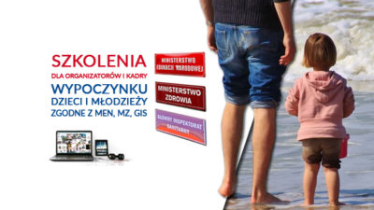
Guidelines for the organisers of summer rest for children and youth

Chief Sanitary Inspectorate, Ministry of National Education and Ministry of Health have published guidelines for the organisation of summer rest for children and youth. The aim of the procedures is to introduce additional safeguards, minimise the infection risk, limit the number of contacts on the site and ensure compliance with safety requirements.
The organiser is required to train the staff in respect of the COVID19 procedures. Wherever possible, such training can be delivered by OHS specialists. While resting, on should follow the following principles:
- Both the staff and participants must regularly wash their hands with soap and water;
- Surfaces that are often touched, such as handrails, door handles, table tops and switches, should be disinfected on a daily basis;
- Toilets should be disinfected on a regular basis;
- When disinfecting, one ought to strictly follow the recommendations of the disinfectant's producer.
In the event of any alarming symptoms suggesting a coronavirus infection, the manager or a person appointed by him should immediately isolate the person in question in a separate room and contact a physician, epidemiological or sanitary station, an infectious hospital ward, or, if the health of the person is deteriorating, call the emergency number 999 or 112 and report a possible coronavirus infection.
Silvers in the company. How to adapt the workplace?
The society is aging with the pool of young work candidates shrinking. Before long, employers will be forced to compete fiercely for young employees or reach for the so-called ‘silvers’. Whatever employees are chosen, the employer has to ensure ergonomic workstations to them.
Despite a common misconception, it is the middle-aged employees that may prove to be more profitable to the employer. They are characterised by such features as: broad experience, loyalty, responsibility, accuracy, respect for work and corporate allegiance. Moreover, the costs incurred by the employer in the event of a 50+ employee’s sick leave are lower.
An important factor for the employer to be taken into account when employing a silver is proper adjustment of the workstation to the employee’s physical and psychological capabilities and needs. What is aimed for is easier, less strenuous on the body, while at the same time efficient, performance of one’s work duties
In adapting a workstation among other things one should: adjust the machines, tools and equipment to the individual size of the employee; minimise the need for twisting and leaning forward as well as the strain upon the wrists; ensure increased light intensity; increase the contrast as well as the letters and symbols on any screens, monitors or printed materials.
Employing and retaining elderly employees in the company requires understanding of the changes people undergo with age and adjusting accordingly both corporate culture and pro-health prophylactics.
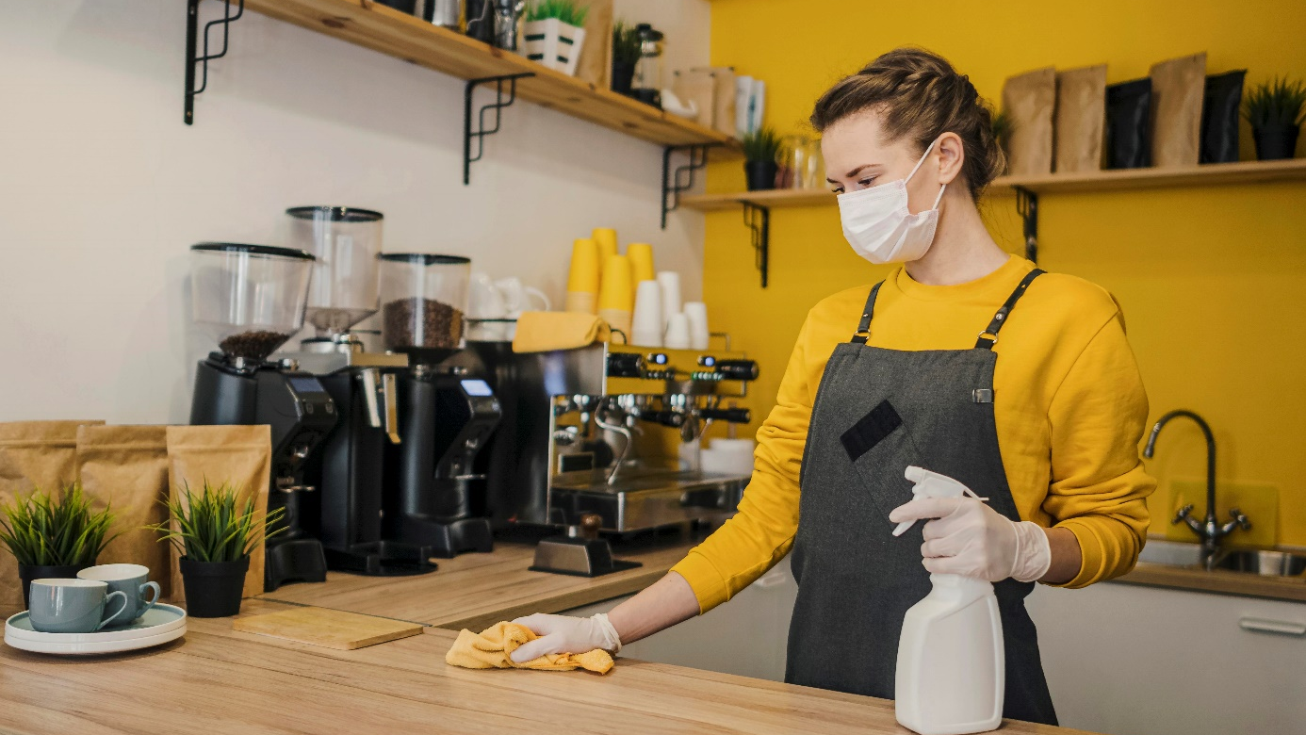
Returning to work - recommendations for employers

Employees slowly begin to return to their offices, factories and other places of stationary work. However, SARS-CoV-2 is still there; nobody has turned it off or instructed to leave Poland. Hence, on return to work, one must continue to comply with the basic recommendations of the Health Ministry and Chief Sanitary Inspectorate.
Before the employees return to their stationary work premises, the employer should assess the risk of coronavirus infections and adjust the office accordingly. Guidelines for work in time of pandemic should be incorporated in new terms and conditions and then communicated to all employees.
The State Labour Inspectorate recommends that the basic hygienic procedures be still observed. In this way not only coronavirus can be prevented, but also other viruses or bacteria.
In the workplace, one should among other things:
- Ensure daily disinfection of frequently touched surfaces, such as door handles, worktops, desks, keyboards, washbasins, toilets, soap dispensers, etc.;
- Ensure access to places where employees, clients and contractors can wash their hands with soap and water and then disinfect them with proper substances.
Waste management – report and permit deadlines

The situations brought about by the BDO (Waste Database) implementation and then the coronavirus pandemic has causes serious trouble to businesses engaged in waste management. The deadlines for filing reports and permits, as well as the manner of record-keeping, were specified in Shield 3.0.
By 31 August 2020, the annual reports for 2019 on communal waste should be filed by means of the BDO.
By 11 September 2020, also through the BDO, annual waste reports for 2019 should be filed with the Voivodship Marshal.
By 30 September 2020, an external audit for 2019 should be carried out. The obligation concerns organisations engaged in recycling electrical and electronic appliances and those operating recycling plants.
By 31 October 2020, entities required to maintain waste records (except those operating shredders and disassembly plants) must submit to their respective Voivodship Marshals annual reports on the waste generated and waste management.
Until 31 December 2020, documents concerning waste record can be made in printed form. Specimens of such records are set out in Schedules 5a-5g of the act on waste. By the end of the year, the entities which have applied for registration with the BDO, but have not obtained a registry number yet can operate legally.
Laptop is also a computer - ergonomics
Laptops and tablets are mobile devices and do not full under the definition of a workstation involving a computer screen. Nevertheless, it is reasonable to qualify such devices as computer systems and organise the workstations at which they are used in accordance with OHS and ergonomics rules.
Neither laptops nor tablets contain elements that could allow them to be treated as a computer system consisting of a separate screen, keyboard and central unit. Thus, such devices to not meet the definition set out the applicable regulation. However, it ought to be remembered that many years have lapsed since the provisions were first adopted, with considerable technological developments on the way. Nowadays, laptops are commonly used at typical office workstations. Work involving a laptop or tablet should also be organised in a manner conforming to the principles of OHS and ergonomics.
The Central Institute for Work Protection – National Research Institute recommends bearing in mind several fundamental rules when working with a mobile device:
- A tablet or laptop should be placed on a stand on the desk with the screen set at 30-45° (this prevents excessive leaning forward).
- In case of longer work involving a laptop or tablet, one should use a separate keyboard and mouse.
- The screen should be placed so as to avoid reflections from windows or lights.
- The font size should be adjusted so as not to put too much strain on the eyes.
New healthy nutrition and physical activity pyramid
Physical activity and proper diet are fundamental to well-being. The healthy nutrition pyramid shows in a graphical, and at the same time concise, manner the rules for a healthy life style. The current Pyramid represents an answer to WHO's recommendations and incorporates the idea “Less sugar, salt and fat, more fibre”.
The nutrition pyramid is an element of the social information campaign carried out by CIOP-PIB entitled “Active at Work” promoting physical activity among workers.
- Physical activity – we should spend a minimum of 30-45 minutes a day doing sport. This need not be typical sport as physical activity includes: walking up and down the stairs, walking, nordic walking, cycling, swimming, etc.
- Fruits and vegetables – fruits and vegetables should provide a basis for one's diet - they should amount for at least a half of what we eat. One should also remember about proper proportions: ¾ vegetables and ¼ fruit.
- Cereals – they still represent an important ingredient of our nutrition. It is recommended to eat wholegrain products as well as groats and brown rice.
- Milk and dairy products – it is recommended to drink at least 2 large glasses of milk, which can be substituted with e.g. kefir, yoghurt and - partly - cheese.
- Meat and fish – it is recommended to cut the consumption of meat, particularly red meat, down to 0.5 kg per week, and to replace it with fish, pulses and eggs.
- Fats – specialists recommend cutting down on animal fats and replacing them with vegetable oils and nuts.
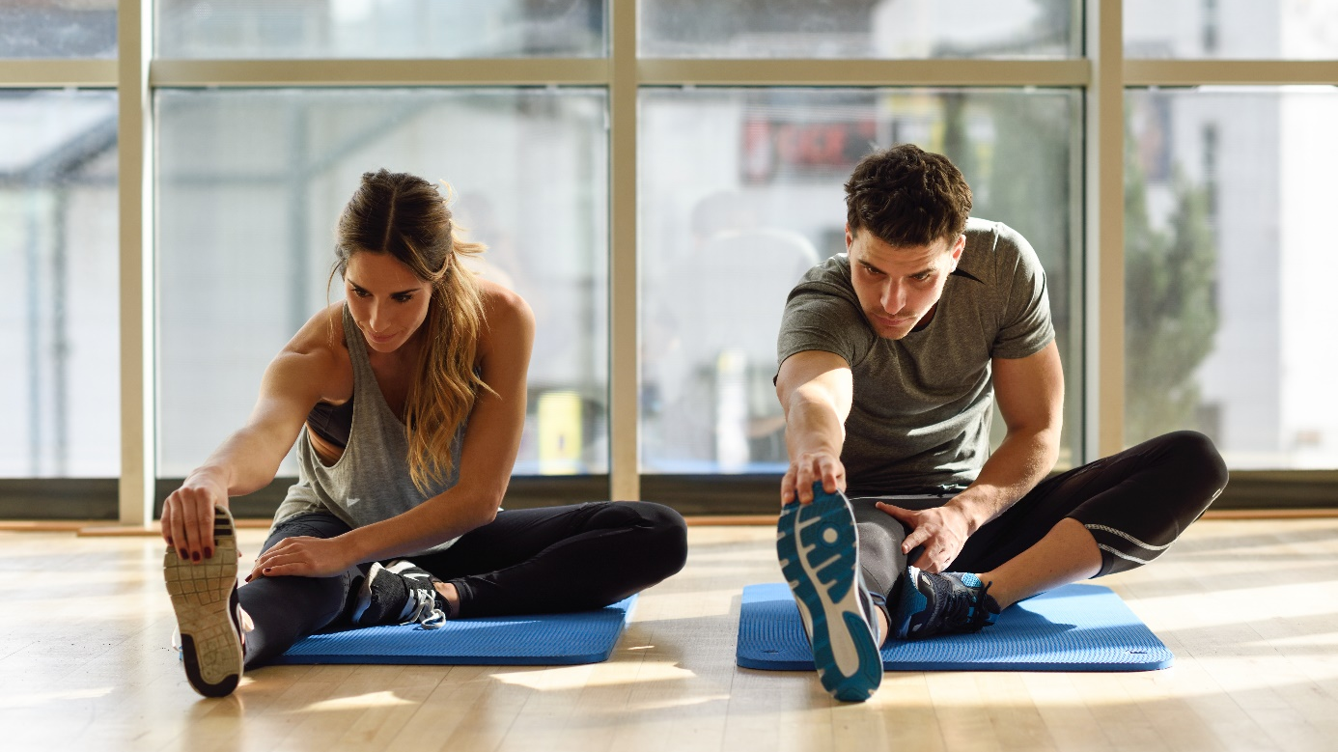
Physical activity in the workplace
Proper and regular exercise is one of the simplest and cheapest ways of improving one’s physical and mental health. Many studies have shown that by doing sport we are in a position to prevent or mitigate the adverse effects of civilisation diseases, such as: hypertension, diabetes, heart attack, obesity, and even lung, breast and bowel cancer.
The Central Institute for Work Protection – National Research Institute, bearing in mind the beneficial impact of exercise on the health of workers, has launched a social information campaign in 2020 entitled “Active at Work”. The campaign will be run between May and December 2020.
EUROFOUND’s research shows that more than 1 in 3 Poles spend more than 40 hours a week at work, with the work duties often demanding a sitting or standing position. It has been demonstrated that a sedentary lifestyle represents a risk factor for the development of multiple chronic diseases, including cardiovascular diseases, that are the main cause of death in the Western World.
The EU guidelines on physical activity say that the human body has been built for motion. Therefore, it requires regular physical activity in order to function optimally and prevent illnesses. Research has shown a direct correlation between physical activity and average lifespan - populations that are physically active usually live longer than inactive ones.
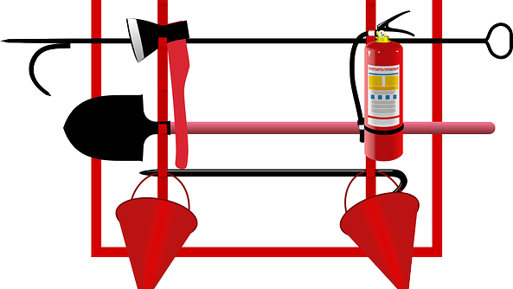
Role and types of portable fire-fighting equipment
Fires usually result from small fires which can be usually put out easily. In order to do so, they must be located very quickly, and there should be proper portable fire-fighting equipment available nearby.
Portable fire-fighting equipment serves the primary role of putting out fires in their initial phase, i.e. at the outset. Such equipment is characterised primarily by low weights and simple use. So, it can be used by any adult person provided that they follow the instructions on the label.
Portable fire-fighting equipment normally includes:
- portable extinguishers,
- fire engines (extinguishers),
- hand-pump extinguishers,
- fire blankets.
Basic fire-fighting equipment can be supplemented with an additional kit, which is optional. It comprises: flappers, fire-hooks, shovels, water buckets and barrels, and sand boxes.
Such a kit can be a useful addition in holiday centres, camping sites, farms and building sites.
PIP Inspectors relaunching audits
On 22 June of this year Labour Inspectors resumed their auditing and supervisory activities. Insofar as possible, the audits are to be carried out remotely outside business premises.
The Chief Labour Inspector together with the Chief Sanitary Inspector have developed new rules for carrying out audits at the time of SARS-CoV-2 epidemic. According to the guidelines, labour inspectors are advised to establish, prior to commencing the audit, with the employer, by the telephone, the procedures for the sanitary regime in operation in the company.
The new guidelines provide that the activities should be (wherever possible) carried out outside the business premises. The documents provided to the inspector will be subject to 24-hour quarantine in tightly locked containers.
However, should it be necessary to carry out certain audit activities on the company premises, the Chief Labour Inspector recommends using a separate room and keep the activities as short as possible.
During a direct audit, inspectors should respect the restrictions and obligations in operation on the employer's premises relating to the prevention of SARS-CoV-2 spreading.
Up to PLN 500,000 of public subsidies for OHS prevention

The President of the Social Security Institution (ZUS) has announced a competition for projects involving, among other things, improving occupational health and safety in the workplace and mitigating the risk of work accidents. The amount of funds earmarked for financing the projects in 2020 is PLN 50,000,000. The applications can be filed starting from 1 August of this year.
The competition sets out to promote and support all initiatives aiming at prevention, improvement of OHS conditions, mitigating the risk of work accidents and occupational diseases, reducing adverse impact of risk factors in the workplace. The projects submitted to the ZUS should address at least one of the parameters set out in the Terms and Conditions characterising work conditions or technical areas.
Excluded from the financing will be initiatives and activities relating to the receipt, supply, commissioning and accepting for use of equipment, fixed assets or other infrastructural elements, their servicing, and training.
The amount of financing depends on the number of staff employed in the enterprise. The maximum amounts are as follows:
- micro business – PLN 140,000
- small business – PLN 210,000
- medium-sized business – PLN 340,000
- large business of 250 and more – PLN 500,000.

