A three-chair generation

In the 21st century, a lack of physical activity is becoming a global problem for many workers, with the current generation being called a ‘three-chair generation’: i.e. the armchair at home, swivel chair in the office and the car seat. A lack of physical exercise has considerable impact on workers’ health, hence reducing their efficiency and work motivation.
The Central Institute for Work Protection – National Research Institute has been running a social campaign entitled “Active at Work” since May of this year. It aims at promoting physical activity among workers. One of its publications shows the results of an early 2019 study published in the American Journal of Epidemiology.
The study demonstrated that exchanging 30 minutes of sitting for a physical activity, even if not very intensive, can reduce the risk of premature death by 17%! On the other hand, spending the same time doing a moderate or energetic activity, which would be twice as efficacious, will reduce the risk of premature death by 35%!
The scientists also discovered that even short activities, lasting a minute or two, bring health benefits.
This means that we should find time for a little exercise every day, also at work. Examples include a short walk or quick stretching every half-hour or so. Two minutes’ exercise every half-hour amounts to 30 minutes during an eight-hour long working day.
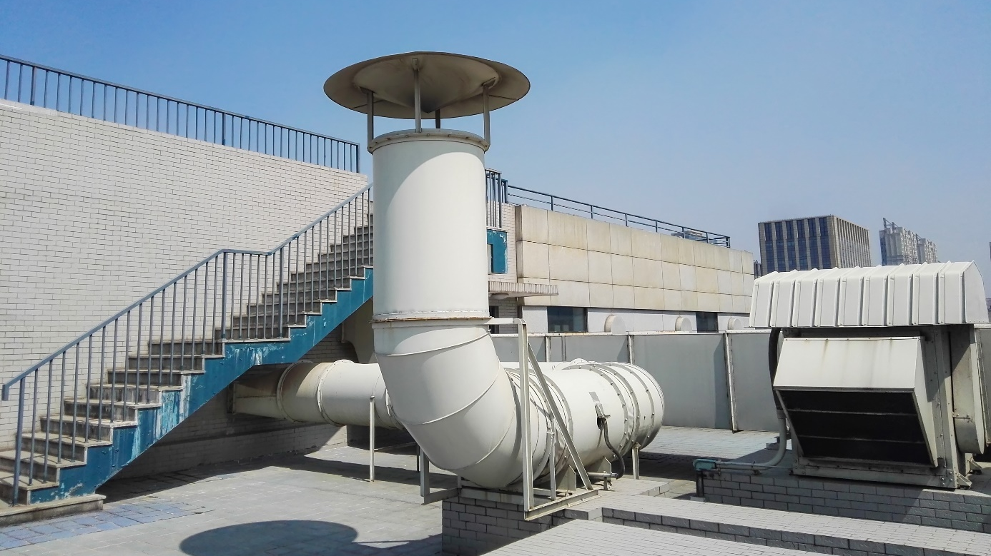
How to reduce the risk of viruses spreading through HVAC systems?
The fact that various pathogens causing infectious diseases of the respiratory system, such as measles, tuberculosis, flu and SARS, including SARS-CoV-2, can spread in the air inside buildings has been known and confirmed by multiple scientific publications.
Specialists have developed special recommendations in the form of advice and guidelines which can help mitigate the risk of such viruses spreading through ventilation systems. It is recommended that the following steps be taken:
- ‘Dilute’ microbiological pollution by circulating the air which should be filtered by means of high-class filters conforming to the latest classifications and standards.
- Limit flow reductions.
- Air the rooms regularly.
- Reduce the number of people in rooms.
- Check the operation of the HVAC system – the actions taken in this respect should include scheduled technical check-ups, system tightness checks and proper and timely air filter replacement.
- Proven biocide efficiency – disinfect the elements of the HVAC installation.
Work in the heat

Working in the summer in high temperatures, and sometimes even in direct sunlight, is difficult for the employee. Concentration and efficiency drop, and elderly workers may even suffer health problems. As every year, we would like to remind employers of their obligations relating to the provision of adequate and safe work conditions in the summer.
Multiple studies have shown that workers’ efficiency drops by 20% during the summer. Therefore, it in the employer’s interests, not only for legal, but also financial reasons, to ensure proper work conditions during such time.
The regulation of the Regulation of the Council of Ministers on prophylactic refreshments of 28 May 1996 sets out the rules for hiring workers in particularly difficult conditions. Working in the heat falls into this category. Where the temperature exceeds 28°C in the office and 25°C outside, the employer is under a legal obligation to provide to its workers, in addition to drinking water, cold drinks enriched with minerals and vitamins.
Moreover, the employer should organise the workstations in such a way as will enable workers working outside, in the sunlight, to rest and cool down under a roof in the shade. Such workers should drink water every 15 minutes and take 15-minute breaks every 45 minutes.
Drinks should be provided to workers automatically, without their having to ask. Where a labour inspector determines a breach of this duty, the employer may be punished with a fine.
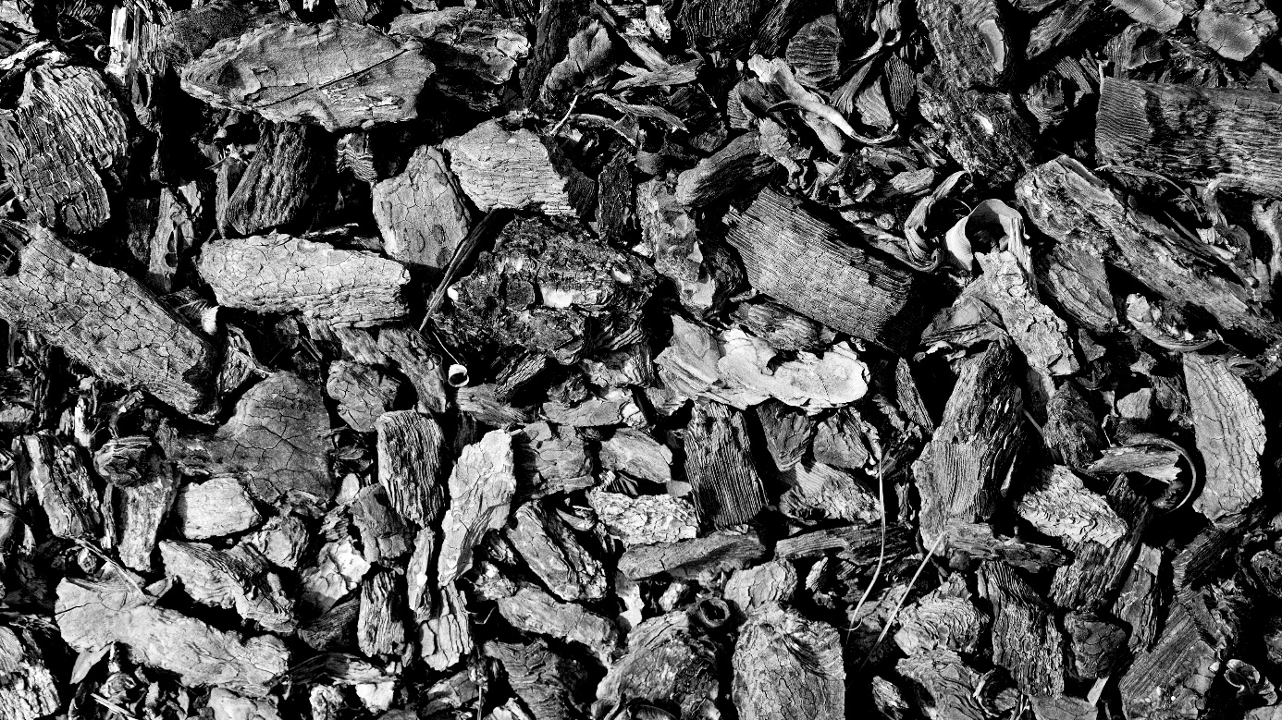
New coal quality norms in operation since 1 July
In Poland, 87% of the coal used in the European Union is consumed for household heating. Therefore, the quality of the coal is paramount to the quality of the air which Poles breathe. Since 1 July 2020 it has been forbidden to sell culm to households and stoves of less than 1 MW of power.
Under the Regulation of the Minister of Energy of 27 September 2018 on quality requirements for solid fuels, new coal quality standards have been into operation since 1 July 2020 which preclude low-quality culms from being sold.
The Act on the system for monitoring and controlling the quality of fuels of 25 August 2006 stipulates that as of 1 July 2020 those marketing culms with grain sizes between 1 mm and 31.5 mm will be punishable with a fine of between PLN 50,000 and 1,000,000 or even imprisonment of up to 5 years.
Due to the above regulations, following 30 June of this year there should be no culm in trade that contains as much as 28% of ash and up to 24% humidity. As explained by the Polish Smog Alarm, a customer purchasing 1 tonne of such fuel pays for a fuel “which can contain as much as 280 kg of useless ash and 240 kg of water”.
Burning the worst types of coal is one of the reasons for the disastrous condition of air in Poland – the PSA claims and call upon the Minister for Climate to take further steps.
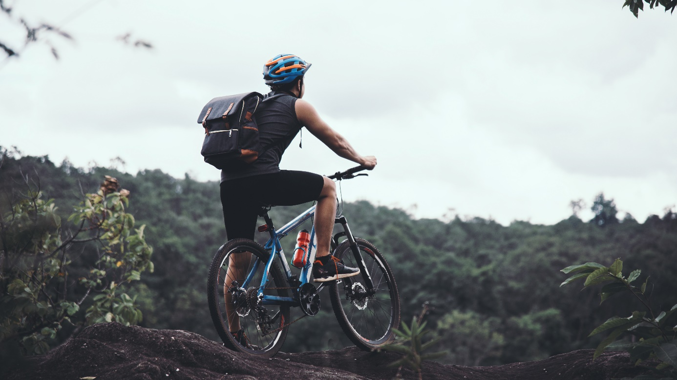
Being active at work and after work
The research carried out by the Ministry of Sport and Tourism show that a mere 21.8% (i.e. about one fifth) of Poles in the age 15-69 do moderate physical exercise for a minimum of 30 minutes 5 days a week.
Doing any systematic physical activity helps reduce the risk or delay the development of many diseases, such as: obesity and overweight, diabetes and cardio-vascular diseases.
If you spend most of the time sitting, remember that any physical activity is better than none.
- Find a minimum of 10-15 minutes a day to move. Work out in the open air if possible. This could be a brisk walk or cycling.
- Walk to and from work, if possible. Cycling is a good solution, too.
- During work, of course whenever possible, take short breaks – change your body position, get up and do some loosening and stretching exercises, e.g. bends or squats.
Where your work requires considerable physical effort, try to do the following in your free time: walk, swim, do muscle-loosening exercises and those releasing your back.

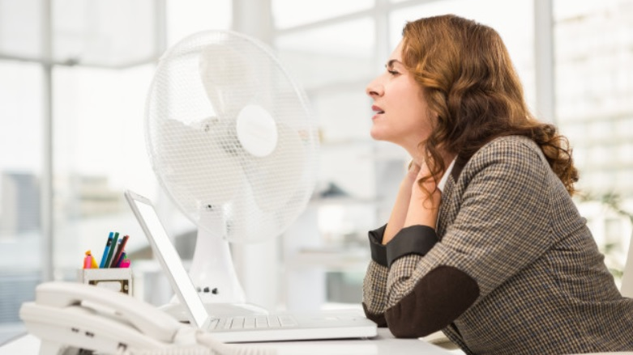
Climate changes pose new challenges for the OHS service
Extreme weather phenomena are listed among top five global risks for business. High winds, tornados, flooding, extremely high temperatures also impact the work safety in Poland.
The Governmental Security Centre in Poland has been monitoring the following phenomena over recent years: storms, thunderstorms, heavy rain falls and snowfalls, hail, high and low temperatures, gales, hurricanes, tornados, cyclones, earthquakes, landslides and floods. These changes are more and more frequently affecting business owners and employers, too.
- Every facility administrator should regularly monitor the RCB's website in order to in a position to properly secure itself against the impact of such phenomena as part of the crisis management – says Małgorzata Kochańska, advisor to the President of SEKA S.A., an expert of the ‘Safe at Work’ Coalition.
As part of their internal actions, employers should develop handbooks or guidelines on how their staffs should behave in such situations.
Poland has been noting record high temperatures over the last years, which are a result of the global climate changes that are underway. During such heat waves, employers have special obligations towards their employees, as set out in Polish law.
The EU imposes a tax on plastics
From 1 January 2021, a tax on non-recycled plastics will enter into force in the entire European Union. All Member States, including Poland, were in favour of the provision.
The implementation of the tax aims at supporting active efforts to fight excessive plastic waste. The tax has been set at EUR 0.8 per each kilogram of plastics which have not been recycled. Environmental organisations are in support of the provision and think that it is “a step in the right direction.
- Recycling must not only be environmentally beneficial, but also financially profitable so that Poland could avoid the penalties in the form of tax on non-recycled plastics - says Szymon Dziak-Czekan, President of the ‘Polish Recycling’ Association in an interview for the pap.pl news portal.
Piotr Barczak of the European Office for Environmental Protection also finds it a good idea. In his opinion, the tax will motivate the Member States to reinforce waste-sorting and effective recycling of plastic waste as well as reducing the amount of plastics in the trade. Such actions will automatically serve to reduce the amount on which the tax is to be paid.
On the other hand, the General Director of Polish Association of Plastics Processing maintains that the document is unacceptable. In his opinion, a mandatory tax will affect Polish entities in the industry, because Poland, among other things, doesn’t have an efficient system for the collection, sorting and processing plastic waste, including packaging.
PIP’s report for 2019
On 21 July of this year, during a meeting of the parliamentary Work Protection Board, the Chief Labour Inspector, Wiesław Łyszczek, presented the report of the State Labour Inspectorate (PIP) activities in 2019. The PIP carried out fewer audits than orders and fines issued.
The number of audits has been falling year by year. Last year, the PIP carried out over 73,000 audits. This was 6,900 fewer than in 2018.
The number of complaints submitted to the PIP is on the rise. As many as 40% of the audits were instigated upon complaints. In this case, their number has been increasing year by year: in 2016 there were 28 complaints per labour inspector with 36 complaints in 2019. The complaints concerned primarily: remuneration for work, form of employment, working hours, legality and safety of work.
Fewer accidents at work. Last year’s positive trend was the drop in the number of accidents among those employed on an employment contract. There were 267 fatal accidents in 2019, 298 in 2018 and 302 in 2017. On the other hand, the number of fatal accidents among those employed on other contracts is an alarming one.
The construction industry carefully overseen as every year. The inspectors carried out 4288 audits at building sites and during building retrofitting and demolition works. Unfortunately, irregularities were detected in as many as 92% cases.
Corporate Social Responsibility is a key to success
One of the key parameters contributing to the development of a business and deciding on its competitiveness is reputation. A strategy of corporate social responsibility (CSR), implemented and consistently developed by an enterprise, can show the society that profit is not everything, that the enterprise caters not only for the interests of its shareholders, but also for the society and environment.
Corporate social responsibility (CSR), as defined by the European Commission in 2011, means “responsibility of businesses for their impact on the society”.
Ethics, caring for the environment, pro-community action in accordance with the law – they all provide a fundamental component to the positive image of a business. They contribute to its reputation. They act as a binding factor between the business and its environment. Actions taken as part of the CSR, implemented over a long-term perspective, build the trust of employees, customers and business partners, which in turn translates itself into increased sales of the business’s products or services and lucrative contracts, often international ones.
As experience shows, it takes years to build trust which can be lost in a fraction of a second. That is why it is so important that the CSR be implemented systematically, based on a detailed analysis of the needs of the staff, local community, partners and the environment.
SEKA S.A. implemented a CSR strategy many years ago and has been following it successfully. Our actions have often been recognised and rewarded.
SEKA MAGAZINE 2 2020
The latest issue of the Seka Magazine has resulted from our observations and discussions with clients and business partners who were willing to share their experiences during this difficult time. It also represents a summary of the most important trends emerging in business over the last four months.
Following the several months of a ‘stress test’ the market has changed. Only time will show whether for the good. Experts emphasize the rapid rise in the importance of all Internet-based business projects. E-commerce, online education and training represent the challenges the world had to take up overnight. These include not only opportunities such as: greater accessibility, easier communication and lower operation costs, There are also certain risks, such as cyber crime and – at the time when restrictions are being eased – sanitary threats, etc.
Seka Magazine is – as usual – a substance-based and at the same time practical compendium of knowledge and positive examples of responsible, safe and healthy ways of doing business. In this issue:
- Coronavirus epidemic and digital training transformation.
- Employees’ mental health under the employer’s care.
- Crisis situation and remote work.
- Home office not only during the pandemic.
- One must get moving! Let’s stay healthy!
- Cyber security.
- Artificial intelligence.
- Virtual reality.

