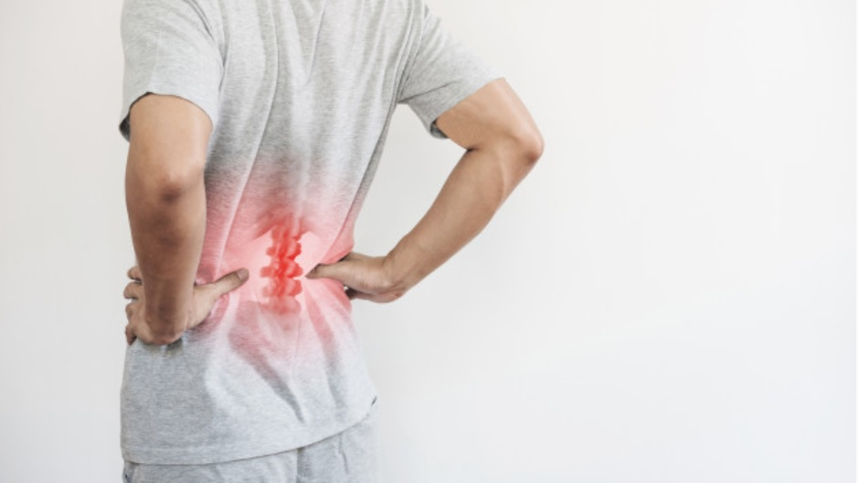
Lighten the Load – an EU-OSHA campaign
Work-related health disorders affect workers of all ages doing all kinds of work. The scale of the problem is large and still growing.
Therefore, EU-OSHA is launching another campaign aiming at preventing muscoskeletal disorders.
The campaign organised by the EU Occupational Health and Safety Agency (EU-OSHA) entitled “Healthy Workplaces – “Lighten the Load” starts in October 2020 and sets out to encourage employers, workers and other stakeholders to undertake joint action to prevent muscoskeletal disorders (MSDs).
In 2000 and 2007, EU-OSHA carried out campaigns addressing a similar problem, i.e. work-related muscoskeletal disorders. Wherefore the need for another one?
Well, a European work conditions survey (EWCS) has shown that about three out of five EU workers have reported suffering from muscoskeletal disorders. The most frequent MSDs reported by workers include backaches and pains in arm muscles (43 % and 41 % respectively). Leg muscles were reported less frequently (29 % in 2015).
Free training and consulting
Do you own a micro, small or medium-size enterprise restarting in business and having a registered seat on the territory of Poland? If so, you can apply for and take part in the ‘New start—new perspectives’ project. The participation in the project is free of charge.
It is co-funded by the European Social Fund as part of the Operating Programme Knowledge Education Development 2014-2020. The project is being implemented by SEKA S.A. all around Poland (more information on efs.seka.pl/). The duration is until 30 June 2022.
As part of the activities, support will be given to 400 micro, small and medium-sized businesses. The project is addressed to those satisfying the following formal requirements:
- being a micro, small or medium-sized business restarting in business, i.e. stopped doing business 24 months prior to joining the project, and then resumed their business as sole traders or members of a partnership or company within 6 months prior to joining the project;
- having a registered seat on the territory of Poland;
- satisfying the condition enabling them to receive de minimis aid or public aid.
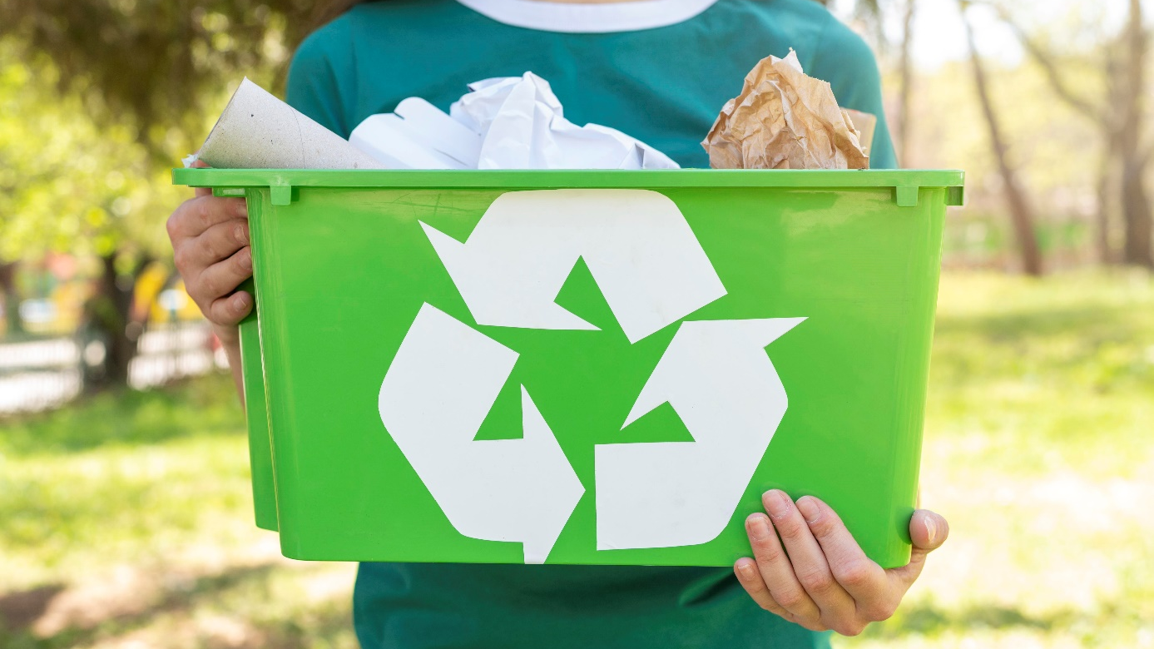
#zeroWaste office – a trend or necessity?
According to (American) scientists, we spend nearly a third of our adult lives in the office. Why not implement home rules, e.g. caring for the environment, even there? Naturally, a decision on working in the zero-waste mode is best taken by the employer and consequently implemented among the staff by raising awareness and implementing a proper culture of work.
The natural environment, destroyed over several hundred years of aggressive exploitation, now needs man’s help and support. For this reason recycling, energy saving, only purchasing things that are necessary, waste sorting and giving up plastics, choosing the bicycle as the means transport of choice – these are all now a necessity rather than a mere fancy. The zero-waste trend is increasingly finding its way into the minds and everyday life of Poles. It would be good if it could extend to cover the business environment as well.
Chairs, desks and carpets can be thought of in the zero-less or zero-waste mood as early as at the designing stage, i.e. be designed in 100 per cent from recycled materials.
A proper organisation of workstations will lead to electricity savings. According to OHS regulations, workstations should be designed to have access to daylight. There are many ways to make the office brighter and electric lights to be used less frequently.
Sorting waste properly enhances the chances of the materials being re-processed and re-used.
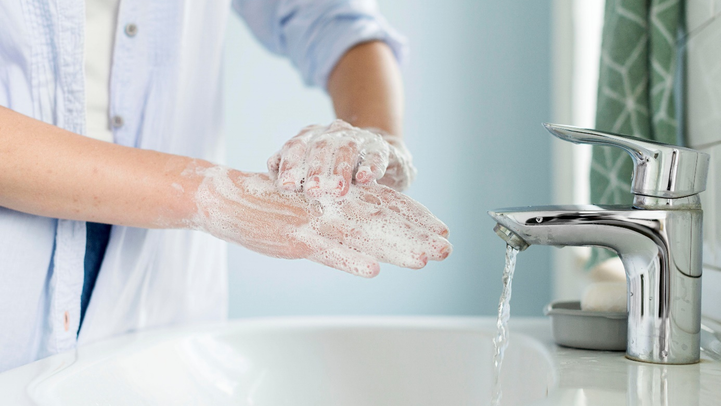
How to wash one’s hands properly?
The coronavirus epidemic has not be called off and nobody knows how long it will last. The rules implemented at the outset are still in force and, as a matter of fact, most of them are worth implementing in one’s daily routines. Such as washing your hands properly
Most people do not pay much attention to how they wash their hands – instead, they do it quickly and carelessly. But it is there that most bacteria and other germs gather, which are then easily spread around the whole body, particularly the face.
40 seconds!
This is how long we should take washing our hands. Naturally, this refers to us, ordinary people. Doctors and other medical personnel are required to take much more washing their hands, sometimes even a couple of minutes.
Follow these rules:
- Rinse your hands and take a proper amount of soap;
- Rub the inside of your palm, then the outside;
- Clean the spaces between the fingers, their upper parts and the inside of the palm;
- Put soap on the thumb and rub the outside of the other palm with circular motion;
- Repeat these activities for a minimum of 40 seconds;
- Rinse off the soap;
- Dry your hands, preferably with a paper towel.
How to order one to work remotely?
The concept of remote work was only introduce to our legal system by the so-called SpecAct aiming at preventing and mitigating the spreading of the coronavirus. However, as of yet there are no special rules in the Labour Code for its ordering, supervising or revoking. So, how to order staff to work remotely in line with the law?
Under Art. 3 of the act on special solutions relating to the prevention, counteracting and combating COVID-19, other infectious diseases and crises caused thereby of 2 March 2020, an employer can order an employee to do, for a fixed period of time, the work as specified in the employee's contract of employment outside the place where it is normally performed (remote work).
The provision conferred a unilateral right on the employer. This means that the employee’s consent to remote work is not required. An employer can instruct all employees, selected job groups or only those employees who may have had contact with those infected with the coronavirus to work remotely. The decision is at the employer’s absolute discretion.
An instruction to work remotely does not affect the contents of the employment contract and hence it does not require the contract to be amended, whether by mutual consent of the parties or by notice to change the conditions of work.

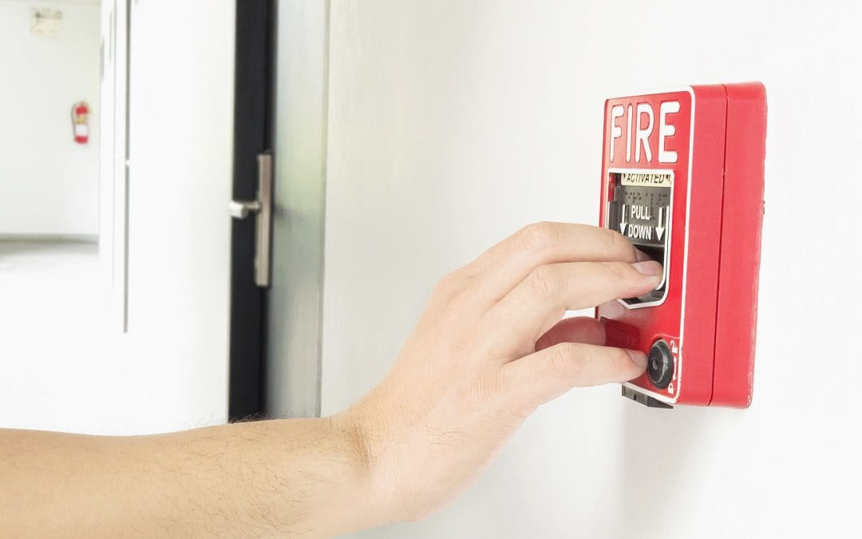
Fire safety in schools at the times of COVID-19
Ensuring fire safety entails mainly preventative actions, such as fire-fighting and rescue drills involving test evacuation among other things. How to prepare and take proper steps at the times of pandemic and given the currently binding rules?
Under the act on fire safety, a test evacuation should be carried out within 3 months of the beginning of a school year. However, the currently binding so-called SpecAct forbids public gathering of over 150 people; as a result, evacuations cannot be carried out at schools.
The current epidemiologic situation forces educational institutions to comply with the current sanitary regime. Consequently, school headmasters should develop and implement a preventative action plan for the protection of health of the pupils/students and staff as well as prevention of the SARS-CoV-2 virus spreading. The document should contain guidelines not only for the personal protective equipment as well as hand and surface disinfectants, but also for the organisation of work, information activities and aspects of fire safety.
Each educational institution is required to have in operation a safety manual containing a set of specific procedures to be followed in case of emergency. Currently, it should be updated in view of the additional threat posed by the coronavirus epidemic.
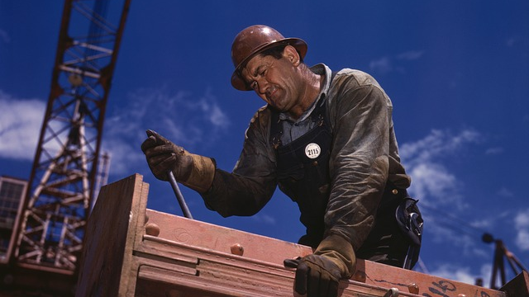
Employers’ obligations with respect to temporary workers
An employer’s obligations with respect to temporary workers and those employed on contracts of mandate are the same as those with respect to regular employees employed on contract of employment. Thus, during hot spells employers must ensure, among other things, that all employees have sufficient amounts of drinking water and drinks.
The obligation to ensure safe and hygienic work conditions rests with the employer. The employer is responsible above all for an organisation of work in a manner compliant with the regulations on equipment and protection of the employee against hazards occurring in the workplace.
Employers’ obligations with respect to temporary workers, doing work in a hot microclimate, i.e. with the indoor temperatures exceeding 28°C and outdoor temperatures exceeding 26°C, are laid down in the regulation of the Council of Ministers on prophylactic meals and beverages of 28 May 1996 (Dz.U.279, Dz. U.2019.1160).
The employer is required to ensure a proper amount of drinking water, and mineral and vitamin enriched beverages.
Additionally, when working in the open air, a special room should be provided where the workers can rest and cool down. Workers, on the other hand, should drink water every 15 minutes and take 15-minute breaks every 45 minutes in order to avoid dehydration, exhaustion or even heat stroke.
What are the differences between remote work and telework?
The concept of remote work was until recently missing from our legal system. It was only introduced by the so-called SpecAct and is not the same as telework for the purposes of Arts. 67⁵–67¹⁷ of the Labour Code.
In the explanations posted on their website, the Ministry of Family, Labour and Social Policy stated that “remote work is a broader concept than telework, as it involves working outside the normal workplace upon instruction from the employer – within the meaning of the SpecAct – in order to prevent COVID-19”.
Art. 67⁵ of the Labour Code defines telework as work performed regularly outside the workplace using means of electronic communications. A teleworker is an employee who does work in the above manner and submits the outcome of his/her work to the employer, especially by way of means of electronic communications, e.g. by email.
Thus, the difference between remote work and telework lies in that the former does not required any outcome of work to be provided by means of electronic communications; consequently, it can be applied more broadly that telework.
Another important difference is that telework is done on a regular basis, whereas remote work ONLY during the epidemic.
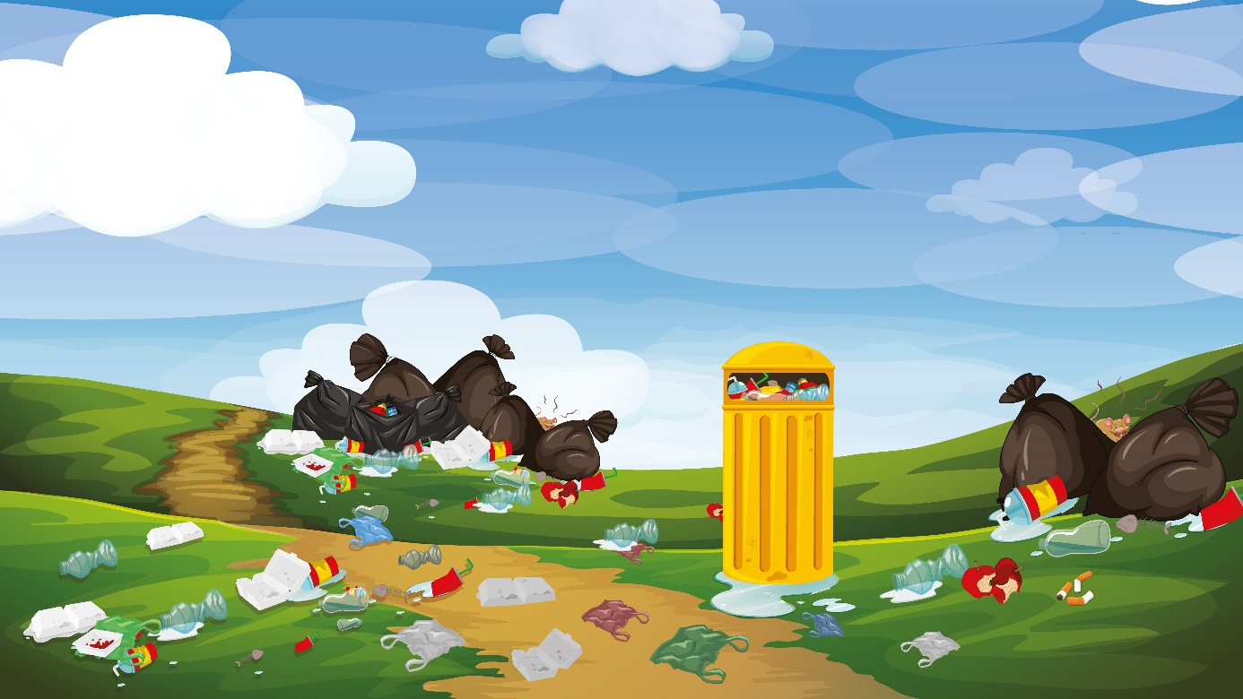
Higher penalties for dropping litter
The Ministry of Climate wants higher penalties for those dropping litter in public areas, roads, squares or green areas. The fines are to be up to PLN 5, 000 with the methods of perpetrator identification to be perfected.
The Ministry of Climate has proposed stricter penalties for improper waste-handling. The current penalties for dropping litter in public or private areas are considerably lower than the costs of their legal disposal, e.g. at sorted waste collection points, which encourages perpetrators to break the law regularly. Imposing higher penalties for dropping litter in public areas (roads, squares, gardens, beaches, lawns and green areas) of up to PLN 5,000 will prevent this according to Jacek Ozdoba, Deputy Minister of Climate. The penalties for dropping waste on another’s agricultural land will be increased to the same level.
Moreover, the waste-managing entities which have not obtained a decision or entry into the relevant register as required by law can expect sanctions in the form of administrative penalties.
It is being planned that local councils be in a position to release the real estate owners who compost bio-waste from a part of fees due for the brown container. Currently, local councils, particularly in rural areas, have to ensure that bio-waste is collected even where it is processed by the property owner and the brown containers are actually empty, which generates unnecessary costs in the system.
OHS Guides
‘Safety First’ – this is a slogan often heard during conversations, training courses, public appearances or in the content of traditional or online media posts. It is of paramount importance in the context of occupational health and safety as, heavily regulated, it is to protect people’s lives and health. The responsibility for the situation in each company rests with the employer.
Many employers and employees alike everyday seek answers and advice on a proper application of OHS rules and regulations. In the face of a threat, which includes the pandemic caused by the SARS-CoV-2 coronavirus, doubts abound, and hence obtaining answers becomes even more urgent.
In the virtual space one can find plenty of OHS-related information on current regulations, rules, obligations and penalties. However, one ought to bear in mind that such content – published on various portals or blogs – is not always correct and true. Legal regulations, written in Legalese (often hardly comprehensible to an average reader), require adequate preparation and filtering when interpreted by an experienced OHS professional. Therefore, it is essential to verify the credibility of the source of information from which one is to derive knowledge.
OHS knowledge in a nutshell – this is how one can describe the guides we have prepared for our clients, partners and readers. They cover trustworthy and thoroughly prepared topics concerning safe and hygienic work conditions while being written in a readable style and using language that is easy to understand.

