Working remotely at the time of COVID-19 – monitoring and revoking
The employer has a full right to request an employee to do work outside the office, i.e. outside the place where it is normally done. What controlling options does the employer have in such a case?
Communications. The employer should, above all, specify their expectations as to the manner of communication during work and how its outcome is to be delivered. It is possible in practice to request one’s employees to meet online.
Surveillance. Surveillance in relation to remote work is admissible if it has been introduced in the Work Rules in operation at the employer's enterprise and each employee has been notified in writing of the purpose and scope of such monitoring and how it is to be performed.
It must be remembered that monitoring must not breach the correspondence secrecy or any other personal rights of the employee.
Remote work is introduced and revoked at the employer’s sole discretion; hence the employee’s consent is not required. Remote work can be revoked, if: 1 – the reason why it was introduced has expired, i.e. preventing the coronavirus from spreading; 2 - the employer needs the employee or a group of employees, e.g. from a certain department, to ensure proper work processes; 3 - the efficiency of remote work is considerably lower than that of the original work.
What do PIP Inspectors check when carrying out audits at the times of the coronavirus?
On 22 June, the PIP (State Labour Inspectorate) inspectors resumed their auditing and supervisory functions. The PIP bodies are to verify a proper application of the regulations aiming at mitigating the risk of COVID-19 infections. Such audits will be carried out primarily at state and local administration bodies, building sites and retail facilities.
In these sectors of the economy, the inspectors will carry out short audits, not exceeding 2 days. In addition to the routine tasks, each audit will involve the issues relating to the compliance with the so-called SpecAct. The audits will cover the following areas:
- Ensuring personal protection equipment to staff, such as face masks or visors, and gloves;
- Providing disinfecting agents, hand-disinfecting liquids, as well as other hygienic means;
- Enforcing proper distance between the office staff and clients or visitors.
Due to the epidemic, some civil servants work remotely or come to work in turns. The inspectors will also check whether remote work has been organised in compliance with the current regulations.
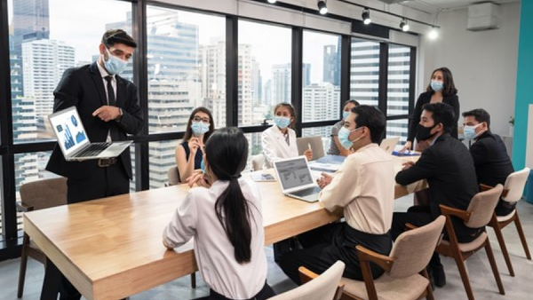
How to organise a business meeting, congress or conference at the time of epidemic?
The current state of coronavirus epidemic requires businesses to comply with the rules and regulations introduced by the so-called SpecAct. However, enterprises have to keep operating and achieving sales targets, which often involves organising business meetings, congresses or conferences. How to take up such a challenge in current times?
Under the current regulations, businesses and other entities engaged in event organisation, promotion or management, such as: trade fairs, exhibitions, congresses, conferences or meetings, are allowed to organise them, on condition, however, that the number of participants or delegates at such events will not exceed 1 person per 4 m2 of the area available to the participants, spectators or clients, excluding the staff.
Other regulations require the entities organising such events to ensure:
- Disposable gloves or hand disinfectants to their staff, regardless of the type of contract they work on;
- Proper distance between workstations of at least 1.5 m, unless this is impossible given the nature of the business and where the enterprise has ensured proper personal protection equipment as required by the epidemic regulations.
Penalties for failure to keep proper BDO (Waste Database) records
Each waste holder is required to keep its records. Since 1 January 2020, all documents in the records must be prepared through the BDO. A business which, despite the obligation, fails to keep such records or meet specified deadlines, or fails to disclose the actual amount or type of waste disposed will be liable to a fine or imprisonment.
Given the current situation due to the COVID-19 epidemic, waste records can be kept in printed form until 31 December 2020. However, all the sheets issued during that time are to be transferred to the BDO System by 31 January 2021 at the latest.
A business operating without a BDO record may be punished with a fine of between PLN 100 and over PLN 1 million. Imprisonment can be imposed, inter alia, for: recycling medical or veterinarian waste which is not recyclable; treating medical or veterinarian waste, including infections medical or veterinarian waste, through co-incineration. Arts. 171-193 of the Waste Act sets out all situations punishable with fine or imprisonment.
In addition to fine or imprisonment for violating the Waste Act, businesses can also be punished with an administrative penalty of between PLN 5,000 and 1 million, which can be imposed by the relevant Regional (Voivodship) Environmental Protection Inspector. A full list of situations where the authority can impose an administrative fine is set out in Art. 194 of the Waste Act.
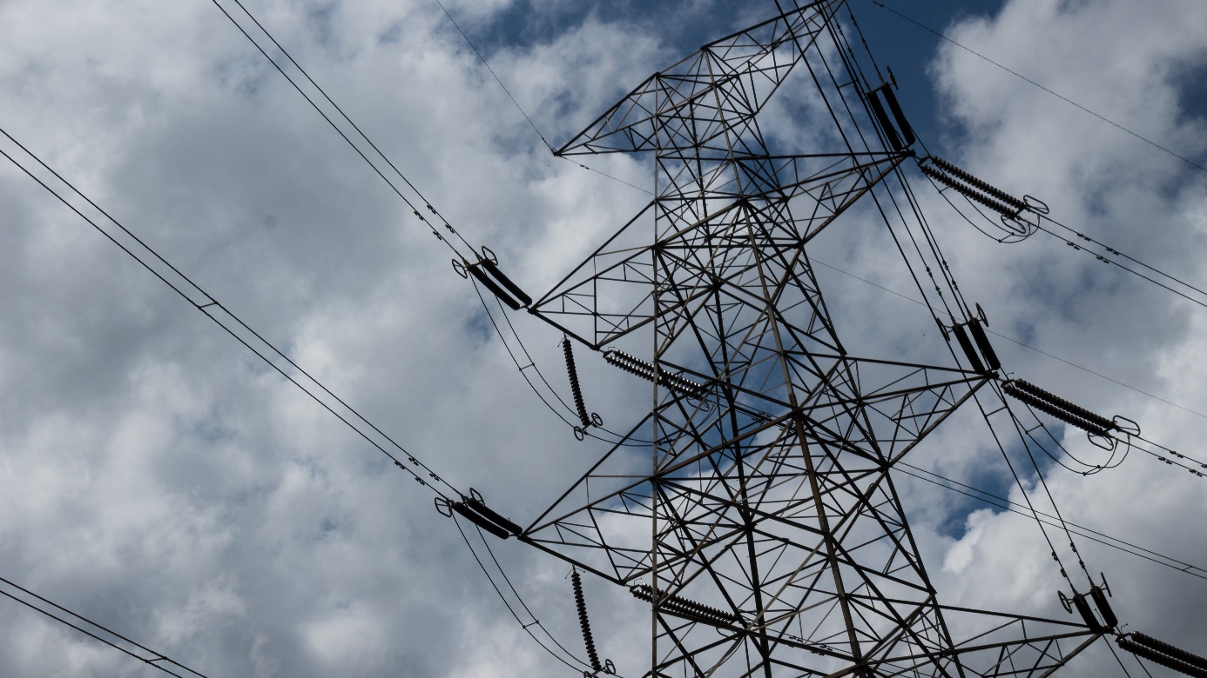
New OHS regulations for power facilities
The coronavirus epidemic has also affected the entry into force of new provision of the regulation of the Minster of Energy on the occupational health and safety for power facilities of 28 August 2019. Thus, rather than 26 March of this year, the provisions will enter into force on 26 September 2020.
The new Regulation renders the definition of power facility more precise.
Considerable emphasis has been given to ensuring safety of power facility maintenance. The new regulations state that each facility should be provided with a maintenance manual, containing all information required for its safe maintenance.
The provisions also apply to works carried out in confined spaces (e.g. tanks or ducts). Where, as a result of such works, dangerous gases, dusts or vapours are generated, the worker should, before starting any work, check whether their concentrations might not be dangerous.
Further, the Regulation provides for the rules of safe conduct of maintenance works in gas pipelines, hydrogen installations or tanks, and water electrolysers.
The Regulation also specifies the procedure for the procurement and preparation of works involving power facilities.
What now with remote work?
Remote work has been quite popular with both employers and employees. It was introduced into the legal system by the so-called SpecAct in March 2020., However, the regulations came out of force on 4 September of this year.
Given the lingering state of epidemic caused by the SARS-CoV-2 coronavirus and the fact that the previous regulations came out of force on 4 September, the Government amended the statute in relation inter alia to remote work.
Under the current regulations set out in Art. 3 of the SpecAct, following 5 September of this year, during the epidemic threat or epidemic state declared in relation to COVID-19 and within 3 months of its being revoked, an employer can instruct an employee to do the work specified in the employee’s employment contract, for a definite period of time, outside the normal work premises, i.e. to work remotely.
This means that both during the state of epidemic threat or state of epidemic and for the 3 months following their revocation, employers will be allowed to order their staff to work remotely.
It is worth noting that it has been announced that remote work will be ultimately regulated permanently, i.e. in the Labour Code.
OHS Officers the most wanted profession
The pandemic has seriously affected the job market. One of the most evident changes can be seen from the Top Jobs in 2020/2021 prepared by Antal. The most sought-for jobs include such professions as: OHS officer and e-commerce expert.
The job market is changing. Thus, the industries which enable efficient operations in the area of instructions and prohibitions imposed by the Government are gaining in popularity.
The OHS officer is at the very top of the top 2020/2021 jobs; whose key duty is to monitor and audit safe conditions of work. This is not surprising as during a pandemic, which poses a threat to human health, people are paying increasing attention to the area of safety.
The next positions in the ranking are occupied by:
- e-commerce expert,
- digital manager,
- business intelligence specialist,
- UX designer,
- Big Data specialist,
- application developer,
- infrastructure specialist
- automation engineer,
- business analyst.
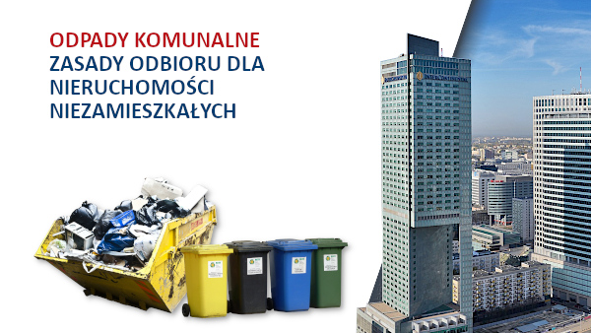

MUNICIPAL WASTE – Current rules for non-residential properties
The City Council of the Capital City of Warsaw adopted a resolution in May of this year changing the rules for collection of waste from non-residential properties (e.g. commercial and office buildings, shops, hotels, restaurants, etc.) situated on the territory of Warsaw.
According to the ordinance, the collection of waste from non-residential properties will be excluded, as of August 2020, from the municipal waste management system hitherto administered by the City. Owners of non-residential properties are required to enter independently into contracts for waste collection with authorised entities entered on the register of regulated business activities. Following that, payments for the service of municipal waste collection and management should be settled directly between the owner of such non-residential property and the waste collecting company.
Another obligation for non-residential property owners, under the act on the maintenance of cleanliness and order in municipalities or as a result of the restrictions imposed by the local by-laws binding on the area in question is to enable waste sorting in a designated place as well as e.g. providing on the premises adequate waste-sorting containers.
The direct cause of the changes was an amendment of the Polish regulations made in July 2019.
Who is more vulnerable to stress?
Stress involved in work, harassment or violence in the workplace exerts a direct impact on employee safety. It is worth noting here that not only is stress management an employer’s moral obligation – it is also a legal requirement set out in the framework directive 89/391/EEC.
People differ in terms of susceptibility to various stress-inducing factors. This depends inter alia on their temperament or personality traits. They influence the intensity of action and high emotion.
Sensitive individuals, who are called ‘highly creative’ by psychologists, respond to ordinary events - whether positive or negative – in a far stronger way than other people in the same situation. They reach fairly easily the level of optimal stimulation, and further increase in the intensity of the stimulus can result in drastic deterioration of the person’s well-being.
Those of ‘low creativity’ are extremely little sensitive to stimuli and need much more intensive stimulation in order to obtain an optimal level of well-being.
The knowledge of individual stress susceptibility can allow the employer to shape the work environment in such a manner as to allow different employees having different temperaments to perform their duties calmly and efficiently.
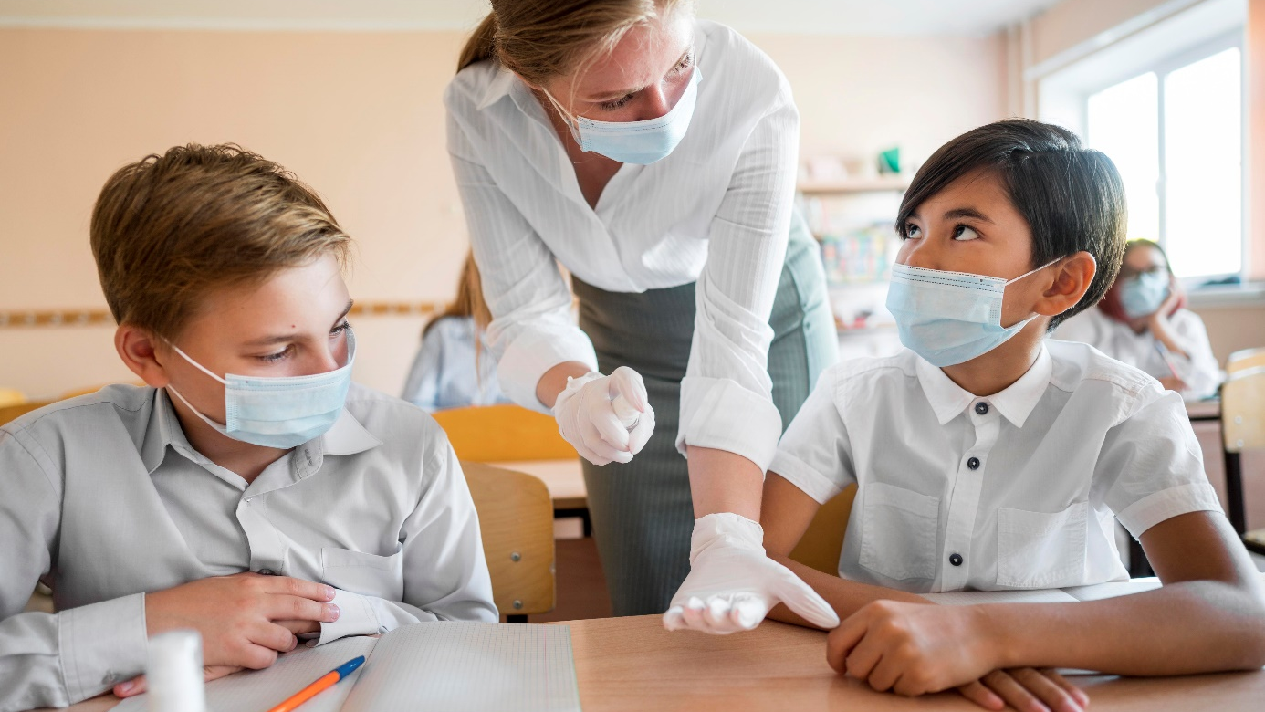
Safety in the school
The State Labour Inspectorate launched on 1 September a prophylactic programme for schools entitled “Safety in the school”. The activities aim at ensuring safe conditions at schools to teachers and pupils alike through promotion of legal requirements and good practices in the area of preventing and reducing hazards in schools.
The first stage of the programme involved circulating to heads of schools and educational institutions a letter of intent containing the key assumptions of the project.
The PIP also provides free-of-charge training in that respect. This is the next stage in the programme involving individual training courses taught by labour inspectors in schools as agreed upon with the institutions’ managements. During such courses, the staff and the head teacher will be become familiar with occupational health and safety issues, including those relating to how to properly carry out and update occupational risk assessment due to, inter alia, the occurrence of new risk factors.
Such activities will be supported by PIP counselling on safe work conditions and distribution of topical posters presenting good practices and anti-COVID solutions.
The PIP has also prepared a leaflet presenting desirable conduct in seven steps.

