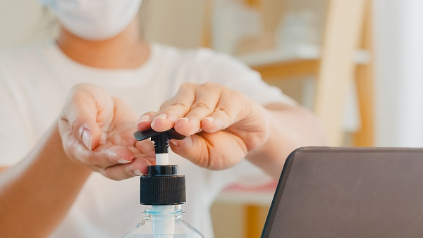
A positive impact of the pandemic – better quality of OHS standards
A vast majority of employers, i.e. as many as 94 per cent of those surveyed, and slightly more than half of employees – 52 per cent, have noticed a positive impact of the pandemic on higher quality of OHS standards in companies. And that is good news.
The Safe at Work Coalition has produced, for the seventh time already, a report entitled ‘Work Safety in Poland’; this year’s topic is the pandemic and the impact of the coronavirus on the Polish job market. The research has been carried out in answer to the unexpected challenges companies all around the world have been facing.
March 2020 marked the beginning of the coronavirus pandemic in Poland. The situation surprised everyone – from those in the government to shop-floor workers. No-one really knew – neither the health service, nor the lawmakers – what the SARS-CoV-2 virus was like, how it was transmitted and what restrictions should be implemented.
One thing was evident – above all, safety should come first. Therefore, companies’ OHS services were deployed at the frontline of the fight against the epidemic. It was their duty, during the initial phase, to work out solutions and implement a proper sanitary regime, even before any guidelines were given by the regulators.
The research shows that employees generally assess positively their respective employers’ safety initiatives during the pandemic.
Take care of your health while working from home!
As a result of the pandemic, most employees are working from their homes nowadays as far as their duties and work capabilities allow this. Undoubtedly, one advantage of working from home is savings: of time and costs of transport tickets, fuel, meals, clothes, washing, etc. However, a lack of physical activity is the greatest downside.
Unlike in the office, at home one has everything at hand: coffee in the kitchen, toilet or bathroom – next door. There is no time for incidental activities. If this is coupled with a heavy workload, one might not ever leave one’s desk for several hours.
The best solution is to work out such activities that will suit the home-working schedule. So, how to move more while sitting?
- An ergonomic workplace – find a proper place for work in your flat. Preferably one with a desk and chair, and access to daylight.
- Active breaks – take active breaks every now and then. Get up from the chair and move, for instance: go and make some coffee, or walk around the corridor for several minutes. Physiotherapists recommend taking breaks from sitting every 30 minutes.
- Fidgeting on the chair – fidgeting on the chair is good for your health – it helps relax tense muscles. Thus, rotate your wrists and ankles, put your arms up over your head, turn your head left and right, up and down.
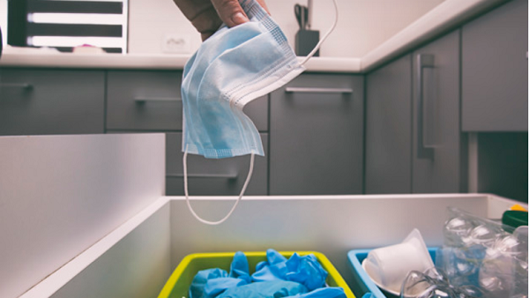
How to handle waste during the pandemic
The obligation to wear face masks and disposable gloves leads to new waste piling up, and its disposal is troublesome. And what about the waste generated by those being quarantined? The 5-Fraction Coalition clears up the doubts.
The rule is simple: the pandemic does not release one from the legally imposed obligations (that is, unless the Government amends the relevant statutes). This means that waste should still be sorted and regulations should be observed.
Surgical, cloth or dust masks, as well as disposable gloves fall under the category of mixed household waste and so should be dropped into the black bin.
In the office, or other workplaces, it is advisable to designate a special place for such waste, such as a simple box in the toilet or cloakroom.
Those sent to quarantine by the Sanepid must by no means leave home. Even to dispose of waste! Those isolated (ill or suspected of an infectious disease) should fill a plastic bag with waste up to ¾ of its volume, then bind the bag tightly, spray it with a disinfectant and wait 72 hours before handing the waste over for disposal.
During such isolation, troublesome waste, such as: used electric or electronic appliances, batteries and rechargeable batteries or fluorescent bulbs should be kept at home and disposed of at a waste-sorting point after the isolation has ended.
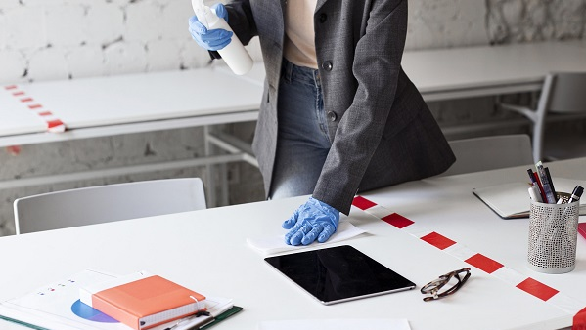
Does one have to wear a mask at an office?
On 24 October further amendments and tools for fighting the SARS-CoV-2 virus came into force. Currently, all Poland is designated a red zone, and it is obligatory to cover one's nose and mouth in public places, including workplaces.
Under section 27 (1) (2) (c) and (d) of the regulation of 9 October 2020 on the imposition of certain restrictions, orders and prohibitions in relation to the epidemic, its obligatory, until revoked, to cover one’s nose and mouth, by means of clothes or parts thereof, masks, face masks, visors or protective helmets in publicly available spaces, including in workplaces and public-utility buildings.

Does it mean that those working in offices are also required to comply with those recommendations?
On the gov.pl website it reads that no, employees in an office are not required to cover their mouths and noses, “if the employer has ensured adequate distance between workstations and has complied with the sanitary requirements”. An exception is where an office employee has contact with e.g. a visitor or customer. Then, they should wear a mask or visor.
This means that it is not necessary to cover the face in the workplace provided that the following conditions are met: an employee is alone in an office or room, or the distance between employees is a minimum of 1.5m in shared spaces.
Migraine at work – how to cope?
Migraine is still treated as an excuse, while being a serious and troublesome illness generating considerable costs. Those suffering from the disease are often excluded from the social, family and professional life. The data from NIZP-PZH research show that migraine in Poland affects approx. 3.3-3.9 million people, including some 400 thousand suffering from chronic migraine.
In 2018, migraine-related absenteeism reached 95,000 days per year costing nearly PLN 31 million. Those employees who do not go on sick leave for this reason have lower productivity, even by as much as 50-70 per cent. The annual costs of inefficient work of a person affected by migraine attacks range between PLN 6.2 and 8.5 billion.
Fortunately, migraine can be treated successfully. Above all, however, the awareness of those suffering from headaches should be raised of the fact that they could be migraine-related. What then are the ways to fight migraine in the workplace:
- First and foremost, tell your colleagues that you suffer from the attacks and how they could help you;
- Avoid fluorescent lights – their blinking could trigger an attack;
- Avoid noise, listening to music – ask for silence at work;
- Eliminate intensive scents from your working environment.
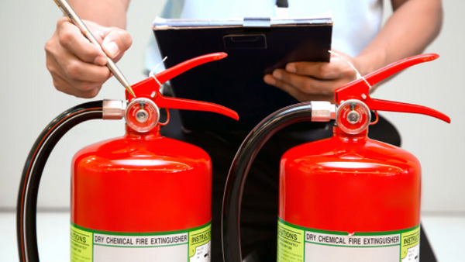
Fire safety at the times of a pandemic
Fire safety manuals, periodical fire checks and other fire-safety-related obligations have not disappeared upon the arrival of the new coronavirus and the introduction of the pandemic state. Only the direction of actions has changed as all measures have been dedicated to preventing the spread of infections.
We would like to remind everyone that despite any restrictions, ensuring fire safety of a facility is the responsibility of its owner, administrator or user under a civil-law contract establishing facility administration or use.
Fire safety involves a number of activities aiming at protecting the health, life and assets against fire, natural disaster or another local threat. At the current situation where all actions focus on preventing the Sars-CoV-2 virus from spreading, compliance with fire safety obligations could be given a lower priority.
A fire safety audit is a timeless solution as, carried out by independent experts, it allows to check the levels of actual safety and compliance of the facility with the current fire safety regulations. It does not entail any financial penalties which could arise as a result of an audit from the relevant authorities.
We would like to remind everyone that the pandemic does not release anyone from the obligations to comply with regulations.
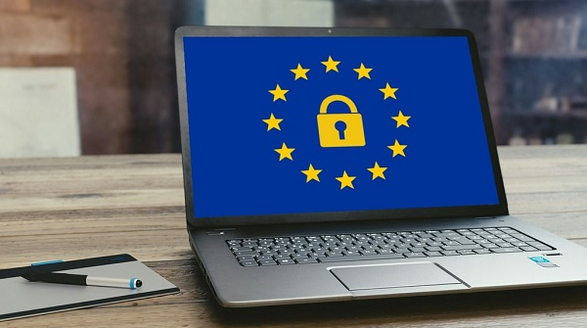
GDPR in HR – prepare for an audit
The HR Departments process job applicants’ personal details as early as the recruitment stage. Once hired, an employees’ data are processed not only in the course of employment, but also following its termination.
Therefore, a number of data protection requirements must be met. Proper data protection documentation should be drawn up and implemented.
Is such documentation in compliance with the law? Isn’t the scope of data required from job applicants too broad (e.g. driving license, record of convictions)? Does the employer remember of the data minimisation principle?
An entity processing data for business purposes enjoys is assigned the status of Data Controller (DC), and as such is required to comply with the requirements under data protection laws, including the General Data Protection Regulation (GDPR). Failure to comply with the regulations (even if as a result of ignorance) could attract considerable penalties.
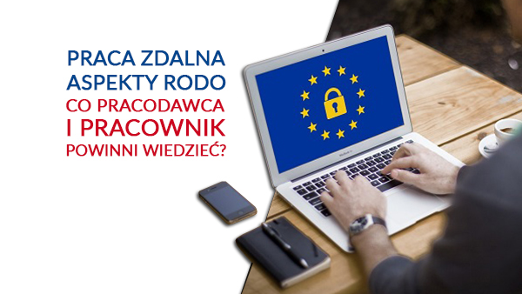
Remote work and GDPR - what should one know about it?
Further confirmed Covid-19 cases clearly show that the pandemic is still developing. Thus, the government will undoubtedly keep implementing further restrictions aiming at preventing the virus from spreading. This means that remote work will in all probability stay with us for longer.
Currently, there are no regulation in force concerning remote work, apart from those in the so-called SpecAct of March 2020. Yet, questions are many (such as those in relation to the GDPR), whereas answers are still too few.
Each entity processing the personal data of employees, customers, pupils or students is required to ensure adequate protection of such persons’ personal data. In the event of a serious breach of the GDPR, the Data Controller (DC) may incur severe financial penalties.
At the times before the coronavirus it was easier to comply with the GDPR requirements in that protection was only required from those business servers, laptops and Internet connections which were used for personal data gathering and processing. Currently, with most employees working remotely – outside the usual business premises, it is more difficult to ensure the security of stored information. Perhaps people also believe that home is as secure as business servers?
Alas, such an attitude might be mistaken.
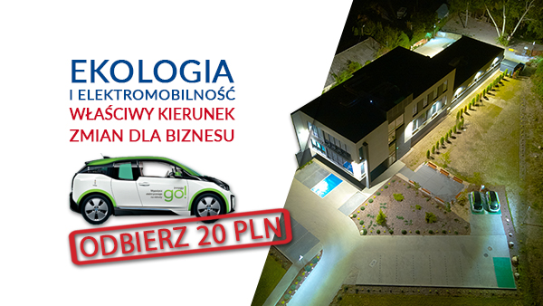
Environmentalism and electro-mobility – the proper direction for changes in business
Never before has the state of the environment been so alarming. Today, we are all coming to realise that the comfort of our life and work hinges on the welfare of the planet. In other words, a long-term success lies in a combination of business and environmentalism. How to achieve this synergy? Here are a couple of eco-solutions at innogy. Join them – you’re welcome!
First... we began with ourselves. In our offices, we saw the back of plastic PET bottles. And rather than shedding tears for that reason, we started shedding Warsaw tap water which we now drink everyday from reusable glass bottles. Replacing plastic with tap water means for us as many as 160 thousand bottles less. All that thanks to the ‘innogy goes green’ initiative, through which we are implementing pro-environmental solutions in the company, as well as promoting them outside.
They say that anything can be put on paper, but... cutting down trees relentlessly is unacceptable. For this reason, we only use recycled paper for traditional mail and printed materials. Thus, we save 268 tonnes of wood a year!
We also promote pro-eco attitudes among our Customers. We encourage them to switch from paper invoices to electronic ones. Currently, nearly 200 thousand of our Customers use this option. These genuinely clean savings result in 5 million sheets and 1.2 millions of envelopes saved.
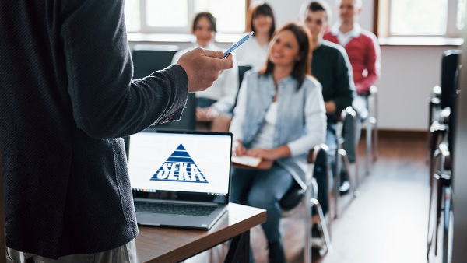
Importance of OHS education
Education plays a key role in everyone’s development. The same applies to OHS education. The knowledge of the hazards and ways of preventing them raises the level of safety at each enterprise.
Today, it is each citizen's obligation to complete elementary educations, whereas each employer is required to educate his employees in OHS rules and r’gulations.
OHS education is not only dry statutes and implementing regulations, but it also involves practical knowledge. These conclusions are based on the many-year long experience of safety officers. Therefore, it should not be treated as an annoying and boring duty, but rather as an opportunity to acquire additional knowledge of safety.
It is worth reminding here that safety for the purposes of OHS is caring for the life and health of employees by: workplace ergonomics, workstation instruction, first aid and emergency courses, fire safety and prevention, and occupational health and safety checks and audits.
Is anything more important than one’s life and health? There should be no doubt as to the answer to that question in a democratic and well-educated society. OHS education is key to ensuring safety to everyone at work, but also elsewhere.

