OHS services on the guard for safety
Since the onset of the pandemic, most enterprises have not returned to standard working conditions – employees have been performing their duties remotely, or in a hybrid form, i.e. alternately: a week in the office, another from home. This, however, only applies to industries where the nature of work allows such practices.
Production facilities have been working without a halt – the development of the COVID-19 epidemic has not resulted in a slowdown in their operations.
Some several dozen, or sometimes even several hundred, people work at the same time at a production hall. How then, in such circumstances, to comply with the sanitary recommendations; who should protects the workers against infections?
- At enterprises, it is the OHS services who deal with those matters, among other things. Since the very beginning, OHS officers have been engaged in creating adequate procedures and actively seeking solutions protecting both the staff and the production. Also, the supervision of external authorities over work conditions has not been suspended during the time. - explains Małgorzata Kochańska, Ph.D., advisor to the President of SEKA S.A.
She adds also that as a result of such activities, the level of safety in workplaces has increased, particularly in the area of hygiene. Workers understand the situation and adapt to new organisational solutions and personal protection measures. Soaring numbers of infections have forced them to exert greater discipline in that area.
‘Frozen in a pandemic’. This is on how important content is at the time of a crisis
The Internet has its own rules, and, above all, its content. Good content. Such as answers the current needs of users: it teaches, explains, offers solutions and tips. And in addition is friendly to the digital environment, i.e. the so-called Google robots.
At a time of crisis, the content addressed at a certain group of users must be (MUST BE) verified, credible, toned down and straightforward. Texts posted online, blogs and portals should contain eye-catching headings and carefully selected keywords. They should have a proper text structure as well as language that is adequate for the message.
Without content a business is absent from the Web. And the Web is life.
In relation to new cases of infections, shown everyday in the form of an ever-rising curve, the government keeps imposing new restrictions. Now, we are facing the threat of a new lockdown.
All those who took advantage of the opportunities given by the Internet during the first wave, are now moving their businesses back to the virtual reality. What is most important in all of this? Content! Content incorporated in the entire marketing communications of the business. The marketing man and copywriter is a mandatory combination for a time of crisis.
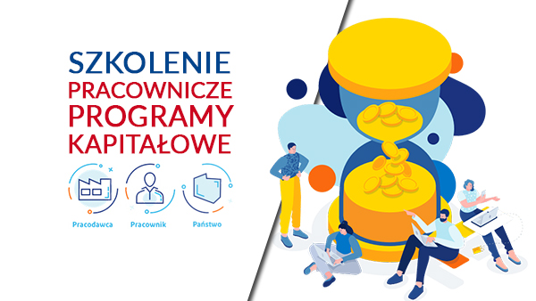
Employee Capital Plans
The Act on Employee Capital Plans (ECP) entered into force on 1 January 2019. It sets out for each employee to be supported by his employer and the state in saving voluntarily for the future. In order to ensure that the changes are introduced smoothly, the programme is being implemented in stages.
First, since 1 July 2019, the largest employers employing over 250 employees have joined the programme. In 2020, other companies have joined: those employing at least 50 employees (since 1 January) and at least 20 employees (since 1 July). On 1 January 2021, in turn, the programme will include small firms and institutions from the public finance sector.
One joins the ECP by operation of law. This means that one does not have to enrol. On the date specified in a relevant programme implementation stage, each employee aged 18 to 55 will receive a private ECP register. The level of contributions is calculated as a percentage of the employee's salary and paid into the account on a monthly basis. The contributions come from three sources:
- Employer – 1.5% of the remuneration, plus optionally – up to 2.5%
- Employee – 2% of the remuneration, plus optionally up to 2% of the remuneration
- State – one-off welcome payment of PLN 250 and annual payment of PLN 240 (once a year).
Comprehensive HR and payroll services – what is the support like?
Each company engaged in business is under numerous obligations under statutes and implementing regulations, such as: Labour Code, tax law and social security law. Meeting all these requirements on one's own means losing a lot of time constantly tracing the changes. We are offering hints on which solutions, offered by SEKA S.A., are the most effective.
The heavy workload and numerous obligations force businesses to hire experts in different fields. In this case, as our experience tells us, outsourcing the services may be a good solution. It is much more advantageous as it provides the employer with access to various experts, not only those in accounting and HR, but also to those in labour and employment law.
The comprehensive services offered by SEKA S.A. mean supporting employers in complex HR and payroll processes, from hiring to firing, if necessary. In the event of any disputes arising out of employment, the business can count on our legal team’s support.
Given the diversity of industries and needs, each client can choose a suitable service package: full HR and payroll outsourcing, HR function outsourcing or payroll outsourcing.
For over 30 years now SEKA S.A. has been supporting businesses in the complicated process of running their operations.
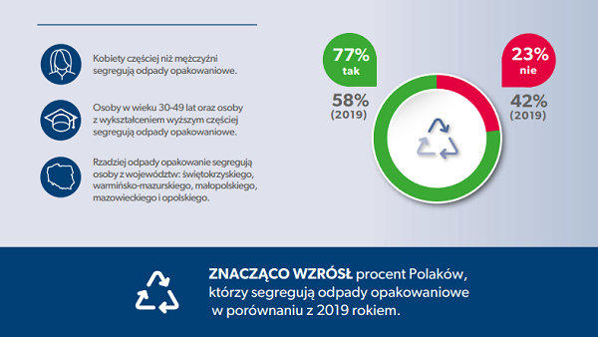
Survey: the number of those who sort packaging waste has risen
From 58% (in 2019) to 77% (in 2020) has increased the number of people sorting the packaging waste - this is the finding of a survey carried out by Kantar for the ProKarton Foundation. In addition, the level of awareness of how liquid food cartons should be recycled has risen by 9 percentage points.
It is yet another time that the ProKarton Foundation, in collaboration with Kantar, a research firm, has carried out a survey measuring the level of Poles’ knowledge of packaging waste sorting. An analysis of the findings shows an upward trend with 77% of those surveyed declaring waste sorting, which is as much as 19 percentage points up on 2019.
Packaging waste is most frequently sorted by those aged 30-49 with tertiary education, with the rules more frequently observed by women.
The regions where people sort the most include: Podkarpackie, Podlaskie
and Pomorskie Voivodships, less frequently in: Świętokrzyskie, Warmińsko-mazurskie, Małopolskie, Mazowieckie and Opolskie Voivodships.
- Although the findings of the survey unequivocally show a rise in the level of waste sorting, more than a half of those surveyed have declared that their knowledge packaging waste sorting rules has not changed over the last year. Among the remaining ones, 33 per cent think their knowledge of the matter has improved with 8 per cent noting a decrease in such knowledge - says Łukasz Sosnowski, President of the ProKarton Foundation and survey initiator.
Occupational risk assessment updates in relation to COVID-19
The risk of SARS-CoV-2 infections poses a new challenge for employers whose obligation is to take care of their employees’ health. Exposed employees’ health currently requires the existing risk assessments to be updated and additional personal protection measures to be implemented.
When carrying out a risk assessment, one should identify the workstations and situations with the greatest likelihood of contact with those potentially infected with SARS-CoV-2 or object or rooms contaminated with the virus:
- Places where typically a considerable number of people are present or in transit at the same time (e.g. corridors, lifts, social rooms and toilets);
- Workstations where tasks are performed requiring the simultaneous work or cooperation of several people at a small distance from one another;
- Workstations where tasks are performed requiring contact with customers or other external visitors;
- Situations requiring simultaneous presence of a considerable number of people in one room, e.g. meetings, training, conferences, etc.;
- Situations requiring contact with people from outside the organisation (e.g. business trips).
Another step is to assess and evaluate the risk of becoming infecting with SARS-CoV-2 in relation to the above situations in the workplace. It involves a determination of the likelihood of adverse implications of such threats for the health and life of employees, as well as of the severity of such implications.
What does the new SAF-T (JPK_VAT) with return consist of and how it should be filed?
Since 1 October 2020, all VAT payers, regardless of the size, have been required to file a new SAF-T with return. It is a single file replacing the VAT-7 or VAT-7K returns with attachments and the JPK_VAT, which were previously filed separately. What do these changes mean for businesses in practical terms?
JPK_VAT with return is an electronic document consisting of two parts: VAT information (a set of data on sales and purchases from the business’s records for the period in question) and VAT declaration (VAT-7 and VAT-7K returns). The JPK_V7M form should be completed in the case of monthly settlements, whereas JPK_V7K – in the case of quarterly settlements.
JPK_VAT comprises: a set of data on sales and purchases from the business’s records for the period in question; entries from a current VAT-7 (or VAT-7K) return; additional data required for verification purposes.
The new audit file does not apply to the simplified VAT return in relation to taxi services, taxable at a lump-sum tax (VAT-12) and such other tax returns to which the previous regulations apply (e.g. VAT-8, VAT-9M, VAT-10 and VAT-14).
The new JPK_VAT file can only be filed electronically, in the case of monthly settlements – by the 25 day of the following month, or quarterly. The file can be signed with a qualified signature, trusted profile or authorisation data.
Accident at work when working from home
Remote work has undoubtedly many advantages, but it also carries risks for the employer. What if an employee has an accident while working in the home office mode?
An accident at work is a sudden event brought about by an external cause. It results in an injury or death and occurs in the course of or in relation to an employee’s performance of their normal duties in relation to work or a superior’s instruction. And also, in the course of or in relation to an employee performing activities for the benefit of the employer, even without an instruction, and while remaining at the employer’s disposal on the way between the employer’s premises and the place where one’s work duties are to be performed.
Will any incident occurring to an employee while working remotely be deemed an accident at work? It will, provided that it happens in relation to the work-related activities. For instance, accident at work may involve an employee getting an electric shock while plugging in his or her company phone or laptop.
It will not, where an employee trips over a pavement slab while throwing away rubbish. Even though such incident may occur during an employee's working hours, it will not be as a result of the employer's instruction or in any manner related to the employee's work duties. The procedure relating to an accident occurring during remote work is similar to that applicable to accidents occurring in the workplace.
Amended regulations concerning waste management
Since 5 September of this year, Voivods (heads of regional governments) have no longer been authorised to issue instructions to business on matters relating to infectious waste and other waste management. Therefore, the Ministry of Climate and Environment has sent a letter to Voivodship Offices reminding them of the change in regulations.
On 5 September 2020 (i.e. following 180 days of the relevant act coming into force) Arts. 11a-11c of the act on special solutions with regard to preventing, counteracting and combating COVID-19, other infectious diseases and crises caused thereby of 2 March 2020 came out of force.
Since then, it has been the minister responsible for health matters who is authorised to issue such instruction to legal entities, organisational units without legal personality and businesses. Such instructions may be issued at his own initiative or at a voivod’s request. These rights will continue during an epidemic alert or state of epidemic as well as for a term of 3 months after they are revoked.
Pursuant to a new Art. 11h (1) of the act, a voivod can issue instrucitons binding upon all administrative bodies acting in the voivodship (region), state legal entities, local authorities, local-government legal entities and other local-government organisational units without legal personality.
Remote work during COVID-19 – working time organisation
The organisation of working time is typically regulated by the Work Rules or individual arrangements between the parties to employment, under the relevant employment contract or employee’s individual working time requests. Shifting to remote work does not affect such regulations or arrangements.
Remote work does not affect working time systems or working time schedules applicable to each worker group. Nor does it affect the working time limits, which, in the case of full-time employees working under a standard working time system, will still be 8 hours a day. Where work is provided part time, the working hours will be reduced accordingly.
Certain employees may have been working under an individual working time schedule prior to going remote. Here also nothing changes, meaning that such individuals keep working in accordance with the previous arrangements under their respective individual working time requests.
A change in working hours resulting from an individual request is not easy and requires formal steps to be taken, and if an employee does not accept it, it can only take effect following the lapse of the applicable employment contract termination notice period.
The flexible working-time system, whereby work can begin within a prescribed range of hours, still applies to remote work (Art. 140¹ (2) Labour Code).

