How to manage remote work?

A year ago only a few companies allowed their staff to perform their duties remotely. Many employers found it hard to, colloquially speaking, wrap their heads around this kind of working mode. However, as the practice has shown – everything is possible. To the degree that those in power have announced incorporating provisions regulating remote work into the Labour Code.

The most important things in managing remote work are proper team preparation and clearly defined rules for remote work. Your staff need to know: what and how they are supposed to deal with, and why. One should also clearly communicate the expectations and deliverables to be submitted.

Here are some specific and useful hints:
- Implement a task-based working system and establish reporting rules for the activities performed;
- Specify the hours when an employee should be available for contact from superiors;
- Allow flexible working hours wherever possible;
- Provide the necessary equipment and software, including teleconferencing tools;
- Help prepare a station suitable for remote work in accordance with ergonomic principles;
- Support your managers in online team management by organising training in that respect;
- Encourage your staff to report concerns and make suggestions on how their work organisation could be improved;
- Encourage your staff to provide mutual support over the phone or social media.
New training era. What happened in 2020? Where are we now and what awaits us?
Before the pandemic, traditional training prevailed. We knew it, had the necessary experience; one could even say – it was much simpler. After the state of pandemic was introduced and we all were locked down at homes, we came up with a new solution - online training.
It posed new challenges while at the same time offering new possibilities.
A single most important advantage of online training is the ease of acces from any place with Internet connection. Thus, we can save not only time, but also money spent on travelling and accommodation. Another upside of online training is that the times can be adjusted to suit all participants.

Ensure better protection of your personal data
During online training courses the personal data of trainees are processed. It is necessary for the identification purposes when logging in or when issuing certificates. Each trainee should remember to take proper care to protect their personal data.
What awaits us in the future? Certainly, online training courses will stay with us after the pandemic is over. They are a good solution for all times. Therefore, it is worth investing in good equipment and gaining experience in delivering courses online.
Sitting down is bad for you!
The adverse consequences of sitting down have been described in numerous self-help guides and virtually every physiotherapist draws attention to them during visits, counselling and courses of physiotherapy. It is not without reason that both the Labour Code and OHS Regulation contain provisions on workplace ergonomics. Current times have somewhat forced most employees to spend many hours sitting down; so how to alleviate the problem?
The title of this text is somewhat tricky as in actual fact sitting down is inevitable, at times may even be necessary or desirable, e.g. in the case of physical work. However, taking into account office work and the many hours, sometimes entire days, spent sitting at the desk - it is harmful for the body. Thus, one should learn to sit properly and keep developing this skill.
Regardless of where we sit, we should always follow the following three guidelines:
- While sitting, keep your spine in a neutral position. To this end, it is best to completely ignore your armrests and back support and sit on the edge of the chair. Sit down such that only the edge of your bottom rests on the seat. The knees should be kept slightly outside the hip width.
- Get up and move your body every 20-30 minutes. To this end, you can do some mobilising and muscle-relaxing exercises.
- Every day, do exercises for 10-15 minutes that will strengthen and mobilise your entire body.
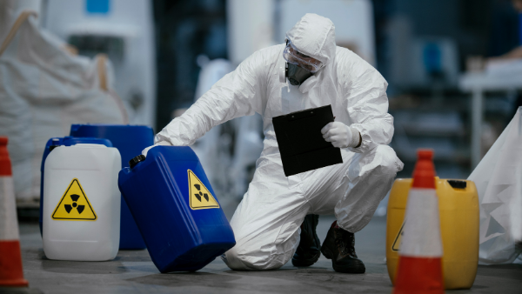
Storing dangerous materials - some rules
Chemical substances can have adverse impact on the surroundings, pose a risk of fire or explosion, but also be dangerous to human health and life. Storing them improperly can also be harmful to the environment. Certain safety rules should be observed when storing such materials.
Both the employer and warehouse manager should:
- Be familiar with OHS and fire safety laws, and the rules for handling dangerous materials;
- Ensure that dangerous materials are properly stored and transported around the warehouse;
- Organise the work in a warehouse containing dangerous materials so as to ensure full fire protection;
- Equip the warehouse with proper fire-safety systems and ensure fully operational handheld fire-fighting equipment;
- Maintain a dangerous materials warehouse in proper technical condition and carry out the prescribed regular checks and audits;
- Ensure that dangerous materials in the warehouse are properly marked or labelled (information and warning signs);
- Perform internal audits in the warehouse and remove any defects or irregularities detected;
- Organise staff training in occupational health and safety, fire safety and dangerous materials handling.
Will employees come back to offices after the pandemic is over?
The epidemic state has been in force in Poland since 20 March 2020. Since then, most businesses have shifted to the home-office mode. The several summer months of relaxed pandemic-related restrictions did not change the situation. Will their employees come back to work in offices after the pandemic is over, or will remote work stay with us forever?
During the pandemic, we have seen a dramatic and global rise in the development of digital tools enabling both remote work and online education. Several years ago, our current reality would have seemed a fantasy. Today, online communications, work management and education for the youth by means of various types of online platforms have become a norm.
According to the eNewsroom.pl portal, experts are identifying a number of implication of the change – both positive and negative ones.
The upsides include the fact that the senior generation being forced to use the new technologies will eventually catch up with the younger generations and hence may be capable of a better understanding of their world and of mitigating the adverse implications of living in the cyberspace.
Yet, despite that they will not be willing to keep working from home. As soon as the pandemic is over, there will be a rebellion among employees, who will want to get back to their offices.
Preventing incorrect posture at work – a checklist
Musculoskeletal disorders (MSD) are most frequently work-induced, as a result of prolonged periods of sitting or standing up in the same position, or doing things in an improper or uncomfortable way. That is why a correct body posture at work is of paramount importance for preventing disorders.
MSDs include dysfunctions of anatomic structures, such as: muscles, joints, ligaments, tendons and nerves, or local blood circulation systems, induced or largely aggravated by work or directly through impact of the environment in which work is performed.
Thus, an employer should ensure that workstations require the employees to adopt a neutral body position – it is a comfortable position with joints laying out naturally. Moreover, it serves to reduce the stress and tension in muscles and the skeletal system, thus reducing the risk of musculoskeletal disorder among workers.
In order to identify threats and possible precautions, it is worth carrying out a risk assessment for the workstations in question. To this end, one can follow a checklist containing questions concerning the position of the back and neck, arms and hands, and legs during work performed in a sitting or standing position.
Such a checklist should incorporate questions about the tasks and activities which may involve incorrect body postures.
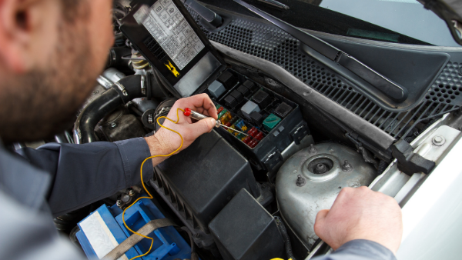
Who can repair electric and hybrid cars?
SEP qualifications for up to 1kV are required from those servicing electric and hybrid vehicles. This means that each garage employee should complete a dedicated training course and pass an examination before an examination board.
The sales of electric and hybrid cars in Poland has been increasing over the recent years. According to an ACEA report, 2,173 electric cars were sold in the first three quarters of 2020. This was a nearly 83% increase year-on-year, compared to the same period of 2019. Between January and September 2020, plug-in type hybrids found nearly 2,400 owners, whereas classic hybrids – 38,866 owners.
With time, these cars will be increasingly visiting garages. As these are electric cars, their engines will inevitably suffer from problems similar to other electro-energy devices, such as electric engine coiling failures, bearing failures or those related to power supply.
Therefore, one should be aware that mechanics will have to deal with currents reaching 350A and approx. 600V in voltage. Hence, in order to be able to service such cars, not only SEP 1kV qualifications, but also specific knowledge, including that in OHS, will be required.
Training for those servicing electric and hybrid cars ending with an electric qualification examination for voltages of up to 1kV– a training course offered by SEKA S.A. and dedicated to those engaged in servicing and performing statutory technical checks on hybrid and electric cars.
URE reminds us about reporting obligations
The Energy Regulatory Authority (URE) reminds businesses about their obligations under the act on RES (renewable energy sources) with the first reporting deadline lapsing on 30 January of this year.
The reporting obligations concern those businesses which have won auctions for the sale of electricity from renewable energy sources and power producers which have obtained a certificate allowing them to use the so-called guaranteed tariff systems FIT (feed-in-tariff) and FIP (feed-in-premium).
This is set out in Art. 70 (b) (1) of the act on RESs: “For the purposes of sale of unutilised electric energy under Art. 70a (1) or (2), the power producers referred to in the above provisions, shall file with the President of URE a declaration on the intention to sell unutilised electric energy at a fixed purchase price determined in accordance with Art. 70e”.
Updated forms are available from the URE website with the deadlines applicable to the different types of reports.

Auctions and FIT (feed-in-tariff) /FIP (feed-in premium)
The URE also reminds us about the reporting obligations under the act on RES relating to the participation in the action-based support system, as well as those under the act on the RES in relation to the participation in the FIT/FIP systems.
Remote work during COVID-19 – working time records
Home-office mode of work has its own rules; yet the Labour Code is still applicable. The performance of remote work requires that a manner is established in which employees are to report their presence at work, since an attendance list or working hour recording systems will obviously not work out.
The manner in which working hours during home-office work are recorded should be specified in a relevant instruction to work remotely or in an applicable bylaw, if the employer elects to implement one. In this respect, a majority of employers did not have any internal regulations.
Firms having relevant internal regulations concerning home office or remote work in place before the pandemic can apply the solutions set out in them.
In practice, 3 options are used for recording remote working hours:
- Sending the line manager an email confirming the commencement of work;
- Logging into a certain IT system or messenger application used for business purposes;
- Clocking in and out in a dedicated working time management application.
Another possibility is an electronic attendance list available on the company server to be signed by logging into the company intranet.
OHS services market forecasts until 2030
In 2020, approx. 5,600 companies offered OHS services employing some 10,000 OHS specialists. Experts are forecasting that the demand for OHS services will be mainly on the rise over the next 10 years and the number of such entities could slightly exceed 12,000.
The level of demand will most likely be dependent on the following factors:
- The industries the clients will come from;
- The sizes of the client’s enterprises;
- The manner of corporate governance;
- The general business situation in the country.
In outsourcing OHS services from external service providers, the ever-increasing awareness among employers of the importance of OHS in their businesses will be an important factor.

High level of demand for OHS services
The demand for outsourced services will remain on a high level or will keep rising, particularly in relation to works requiring ongoing supervision, such as the construction industry, or particularly dangerous works, e.g. in the chemical industry.
On the other hand, back office is an industry facing a likely decline in the demand for OHS service outsourcing due to the departure from an obligation to provide regular OHS training courses to office workers (2019 Labour Code amendment).

