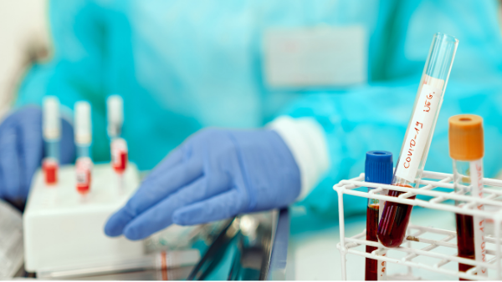
Types of work exposing employees to biological agents
When performing their work duties certain employees are more exposed to being infected with SARS-CoV-2 virus. Such situations occur in jobs involving intended or unintended contact with a biological agent. Employers are required to ensure their employees a proper level of protection against the risk of contracting COVID-19.
The risks of an employee falling ill with COVID-19 can be twofold: as a result of specific work processes performed or caused by the general epidemiological conditions.
In the former case, the risk is directly related to the type of industrial, service, research or medical activities involving intended or unintended contact with a biological agent.
Two kinds of workplaces can be distinguished taking into account the type of contact with a biological agent: those involving direct and intended contact with SARS-CoV-2 and those where despite a lack of intended contact with SARS-CoV-2, the nature of work may expose the employees to the coronavirus.
Each of the above cases is different and requires a separate approach, both at the risk assessment stage and as regards the preventive and corrective actions to be taken.
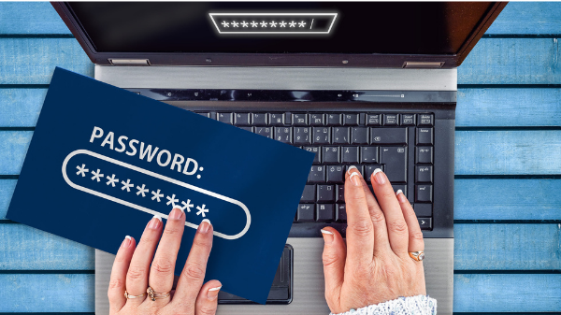
Security in the Internet
Abcd. 1234. 1q2w3e. One’s child’s birthday. Yes, these are examples of passwords intended to secure one’s email box, social network account or another important location in the Web. As demonstrated by the research carried out by a scientist of Virginia Polytechnic Institute and State University and the authors of Dashlane application – most users make these errors. And such passwords will be decoded by an encoding algorithm in a fraction of a second!
The study evaluated 6.1 million passwords from databases which have leaked out over recent years.
The most frequent mistakes include: using the same, or slightly modified, password across different websites; combinations of letters and digits laid out next to one another on the keyboard, such as “qwerty”, "123456” or “1q2w3e4r”; names of superheroes or comic book or TV series characters, and also film titles or names of music bands: superman, pokemon, starwars.
The most important principle when setting up a password is its uniqueness. Thus, use a password that:
- consists of more than 8 characters,
- consists of a combination of lower and upper case letters, digits and special characters,
- is not a popular phrase, slang, city or person's name.
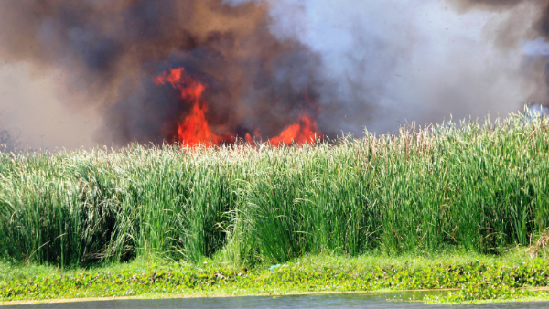
Up to 25 years’ imprisonment for environmental offences
The Ministry of Climate and Environment, in collaboration with the GIOŚ (Chief Environmental Protection Inspector) and Ministry of Justice, are working on introducing stricter penalties for offences against the environment. This has been announced by the Head of Department for Combating Environmental Crime of the Main Environmental Protection Inspectorate, Krzysztof Gołębiewski.
- Where an offence against the environment, such as dumping dangerous waste, results in a person’s death, it may be deemed an ‘environmental crime’, penalised with up to 25 years’ imprisonment – Krzysztof Gołębiewski tells PAP.
The proposed solutions aim to amend certain provisions of Chapter XXII of the Criminal Code. In that chapter, offences are codified against the environment, such as unlawful storage, disposal, processing, recycling, treatment and transportation of waste which may be harmful to human life or health or result in significant deterioration of the quality of water, air, earth's surface, or damage to the fauna or flora.
As announced by Gołębiewski, analyses are also being carried out concerning a possibility of introducing a punishment of 25 years’ imprisonment for a qualified offence, i.e. a perpetration resulting in a person‘s death or serious health detriment to many people.
The proposed amendments will include higher fines for inter alia forest littering, and an obligation to restore the status quo ante by removing any waste dumped.
OHS in the solar energy sector
Renewable energy sources are an alternative and cheaper way to generate electricity. The interest in this kind of energy has been increasing dynamically over the last several years. For this reason, a greater attention should be paid to ensuring safety to staff supervising, operating and maintaining such installations.
Potential hazards involved in ongoing operation and monitoring of installations include:
- electric shocks,
- electric arc,
- fire.
Employees can also be exposed to electromagnetic fields at levels relevant in the view of OHS regulations. Changeable open-field environment conditions can also pose threats to the operators.
During technical checks and maintenance works electric hazards as well as exposure to electromagnetic fields can occur. In the case of repairs works, mechanical hazards (such as risk of being hit, crushed, cut or risk of falling from a height) and risk of being burnt occur in addition to electric, electromagnetic and environmental hazards.
It is imperative that OHS standards should be created and implemented for such works taking into account the specifics of the power plant and staff qualifications.
Remote work during COVID-19 - remuneration
The remuneration for employees working remotely should not, in principle, change as the only change is actually the place where work is done. However, there may be differences due to specific pay supplements or work-related benefits.
In practice, there are often remuneration components related to employee travel and use of private tools or equipment. In the case of remote work, the entitlements should be analysed.
A commuting allowance for travelling by public transport or one’s own car, which is often specified as a monthly lump sum, should not be paid. An employee working remotely does no longer satisfy the conditions for eligibility for such entitlement.
There would be grounds for reducing an employee’s income due to use of a company car for private purposes if such employee left the car in the company car park for the duration of remote work and hence could not objectively use the car for private purposes.
Using private equipment, such as: computer, printer or stationery are exempt from tax as a cash equivalent. However, it should be remembered that such equivalent should take the form of reimbursement of the costs incurred by an employee on behalf of the employer and serve to compensate for the detriment to the employee’s personal assets due to their being used for work-related purposes. '
Fire hazards at large sites
Large volume sites are classified in fire safety regulations as production and warehousing facilities. Due to the nature of the technological processes and materials stored, special fire hazards occur there.
The basic installations to be installed at such site, and which have a real impact on fire safety, include: fire sprinkler system and smoke-venting installation. They must operate automatically, i.e. without human intervention.
All fire safety systems should be manufactured and installed in accordance with the design approved for fire safety by a fire-safety expert.
Only after proper tests and examinations have been carried out confirming their proper operation can they be admitted to use.
Moreover, during operation they should be subjected to checks and maintenance works at least once a year in accordance with the Polish norms.
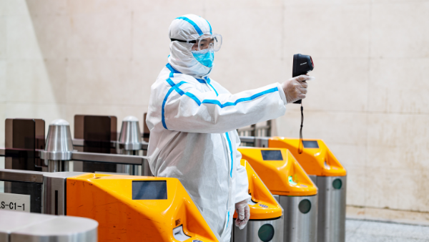
COVID-19 – preventive action in the company
With the arrival of the COVID-19 pandemic in Poland, a new hazard arose posed by a harmful biological factor, i.e. the SARS-CoV-2 virus. Therefore, both employers and business owners are required to undertake action aiming at mitigating the risk of exposure to the agent.
On 29 December 2020, a regulation came into force amending the Regulation on biological factors harmful to health occurring in the work environment and protection of the health of employees professionally exposed to such agents. The SARS-CoV-2 virus was classified into hazard group 3.
Due to the amendment, an obligation has been imposed upon employers to update the assessments of occupational risks to which employees are or may be exposed, giving regard to the classification and list of harmful biological factors as set out in the amended Schedule 1 to the amended regulation within 30 days of the regulation coming into force.
The State Labour Inspectorate has drawn up a list of preventive action to be implemented by employers in their respective workplaces in order to protect their employees against becoming infected with the virus or to limit the spreading of the disease.
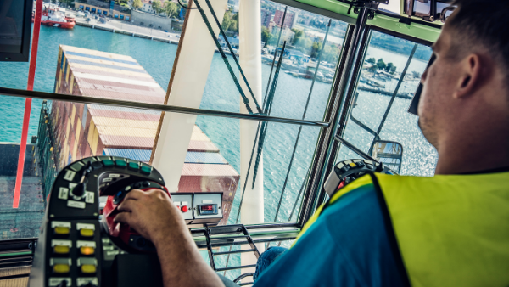
OHS principles for crane operators
Falling from a height, electric shock, injuries caused by falling objects or moving parts of the crane - these are the most important hazards to which a crane operator is subject. Each employer is required to organise work such as to ensure maximum protection to the workers against accidents during their work duties.
Operators must not work longer than 8 hours per day. The working hours include the time necessary to climb and descend the crane. This means that a crane operator’s working hours begin when the operator starts climbing the crane tower and ends upon complete descent.
The employer must keep precise records of working hours in the duty log.
A crane operator may refrain from carrying out an instruction involving activities set out in section 11 of the Regulation of the Minister of Entrepreneurship and Technology on occupational health and safety in operation of tower and fast-erecting cranes of 22 October 2018. He or she should notify the employer, manager or another designated supervisor of the reason for refusal to perform the activity in question.
In the event of breach of the rules set out in the Regulations, operators, and trade unions, can report such violations to the State Labour Inspectorate.
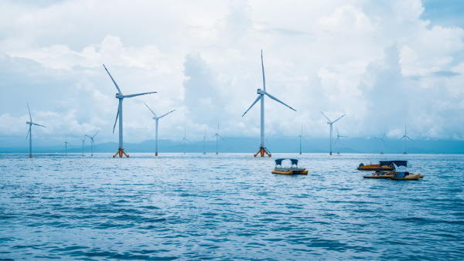
A statute has come into force on promoting the generation of electricity in sea wind farms
On 18 February 2021, the act came into force on promoting the generation of electricity in sea wind farms. The solutions implemented answer the need for a rapid increase in the share of renewable energy sources in the national energy sector.
As pointed out by Rafał Gawin, President of URE, the energy regulator, sea wind farms are the only large-scale while at the same time zero-emission technology based on renewable energy sources. On the other hand, the regulations under the act are of paramount importance in the context of Poland’s commitments to achieving climatic goals, both on the European level and those set out in Poland’s Energy Policy by 2040.
On 18 February the first phase of support was launched. Investors can already apply to the regulator for financial support.
In the first phase of the system, support will be granted by way of administrative decisions by the President of URE and can apply to sea wind farms of a total installed power of up to 5.9 GW.
In the following years, the support will take the form of competitive auctions, an already familiar mechanism for supporting other power-generating technologies based on green sources.
The differences between both phases only lie in the manner of selection of the projects eligible for aid in covering a negative balance.
E-learning - a way of learning during a pandemic
By definition, e-learning is supposed to support remote education by means of modern IT technologies and the Internet. Therefore, it is crucial that the materials presented be of high quality and capable of attracting the user’s interest.
The current situation brought about by the SARS-Cov-2 pandemic has led to both work and education moving to the virtual space. It is there, by means of IT tools, that – as one might say – the everyday life is led by workers, pupils and students alike.
During this time, e-learning systems of various kinds enabling distance learning are enjoying great popularity. They incorporate very sophisticated tools supporting the education process.
In creating e-learning courses one ought to bear in mind a vital principle - the user must be interested. Boring excerpts of legal provisions will bore everyone to death within minutes, hence it is worth working on the usefulness of the message. In this respect, the guidelines from the Ministry of Educations, which were drawn up for the participants of the ‘E-learning in practice’ workshop, might prove useful.
Taking into account the above guidelines and having many-year experience of educational activities, SEKA S.A. offers a wide range of training courses in the form of e-learning. Starting from soft-skill training, to legal awareness, to statutory OHS training.

