Employer’s obligations when an employee has COVID-19
In the event of a positive COVID-19 test result, everyone is under an obligation to stay quarantined and follow the guidelines of the Sanitary Authority. What obligations rest with employers and formalities are they required to complete if a member of their staff is diagnosed with the coronavirus?
Each employee diagnosed with a SARS-CoV-2 infection is required to inform their employer of the fact. It can be done by the phone or email.
Upon confirmation from the system that a person has been quarantined or home-isolated and applies for a sickness benefit, the employer should pay to them sick pay for the period of incapacity as a result of the illness.
The CIOP-PIB (Central Institute for Labour Protection – National Research Institute) in consultation with the Chief Labour Inspectorate has developed guidelines for action in the event of a suspected COVID-19 infection.
Under those guidelines, it is recommended to:
- Establish procedures for events of COVID-19 symptoms occurring in any employees;
- Provide the employee suspected of an infection with a protective face mask and gloves, and isolate them from other employees;
- Identify the individuals who had direct contact with that employee;
- Report the suspected COVID-19 infection to the Poviat or Voivodship Sanitary-epidemiological station.
Remote work during COVID-19 - OHS
Working remotely does not release one from the obligation to observe OHS regulations, including those relating to the place of work which should be ergonomic. However, there is a real practical problem here as employer have little impact on the place and condition in which their staff will actually work. How then to ensure that OHS rules are followed when working on a home-office basis?
It appears a good practice in that respect to take statements from the staff that they undertake to organise their respective workstations in a manner compliant with the general OHS requirements. It would be helpful in this respect the OHS Department to draw up a list of the most important requirements that a workstation should meet.
A short survey could also be prepared to be completed by the employees attaching photos of their places of work to be emailed to the OHS Department. This would be a workstation approval of sorts allowing one to assess the OHS conditions and providing the employees with guidelines on how to carry it out.
Accidents can also occur during remote work. It such a case, it should be established whether the event was in relation to work or rather as part of housework activities, such as cooking or cleaning.
Hence, an employer who decides to draw up a remote-work manual should include in it a procedure for the determination of causes and circumstances of work accidents, the key element being ensuring access to the employee’s home in order to inspect the accident site.
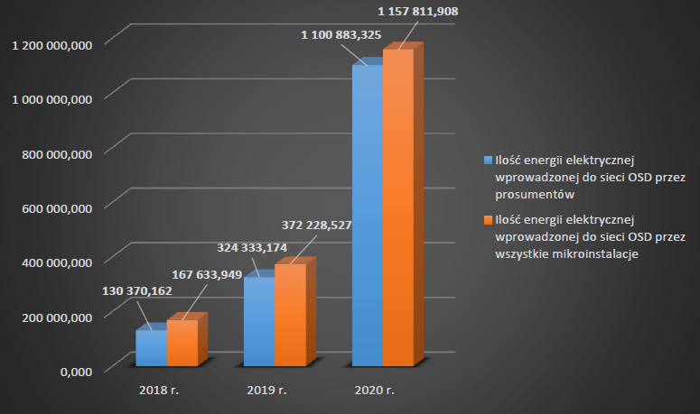
Electricity production from micro-installations has tripled
The latest URE (an energy regulator) has shown a rapid growth in micro-installations over the past three years (2018-2020). It amounted to around 202% in the period 2019/2020. Nearly as much as 100% is accounted for by prosumer photovoltaic installations.
At the end of 2020, the total power of micro-installations installed exceeded 3 GW, with the total electricity generation from those installations amounting to 1,157,811,903 MWh in 2020. This is a triple rise (compared to 2019) of the amount of electricity introduced into the grid from micro-installations.

The greatest amount of electricity derived from photovoltaic micro-installations.
Last year, electricity was generated by nearly 460 thousand micro-installations, with the aggregate installed power of over 3 GW. In terms of numbers, solar energy (PV) micro-installations took the greatest share – nearly 459 thousand. To compare, there were a mere 493 micro-installations using other renewable energy sources.

98.5 per cent of micro-installations are prosumers.
Prosumers used 452,000 out of 459,000 of all micro-installations introducing slightly more than 1.1 TWh of electricity into the distribution networks. As at the end of 2019, there were approx. 149,000 prosumers in Poland, whereas at the end of 2018 - 51,000.
Advantages of remote work from both the employer’s and employee’s perspectives
During the pandemic, it has been possible to notice, which aspects of remote work has worked out properly and what needs to be improved.
From an employee’s perspective, advantages include:
- An improved work-life balance;
- No need to commute everyday to and from work.
- Greater flexibility in planning activities, adjusting them to one’s individual daily and work rhythms.
- Potential increase in work autonomy, greater commitment to one’s duties.
- Being able to take employment despite limited mobility as a result of illness or disability.
On the other hand, there are fewer advantages to remote work for employers, and these are:
- Lower media and office-space related overheads;
- Reduced risk of road accidents and related compensation costs;
- Opportunities for hiring qualified workforce from outside the company’s location.
- Greater flexibility of operations and business services.
Disadvantages of remote work from both the employer’s and employee’s perspectives
Naturally, remote work can be assessed differently by employers and employees. What are its disadvantages?
Downsides of remote work from an employee’s perspective:
- Having to plan and organise one’s working day;
- Limited access to the organisation’s resources;
- Technical obstacles and restricted access to training;
- Less living comfort;
- Less contact with colleagues;
- Having to solve problems on one’s own;
- Risk of developing muscoskeletal conditions;
- Feeling of discomfort in the case of lower productivity or efficiency.
Downsides of remote work from an employer’s perspective:
- Having to provide proper equipment for remote work;
- Managers having problems supervising the work of their subordinated staff;
- Difficulties in carrying out occupational risk assessment;
- Data security issues;
- Potential problems ensuring adequate support to teleworkers.
Why review extinguishers and other fire-safety equipment?
Regular checks on fire extinguishers and other fire-safety equipment are mandatory. These issues are regulated by Construction Law and regulation on the fire safety in building and other construction facilities and areas.
It is inadmissible to work on premises without working fire-safety installations or supervision from those in charge for safety. Correct work processes are ensured by proper authorities which may impose severe penalties in case of any violations.
Fire-safety checks must be conducted in accordance with the equipment manufacturer or fire-safety installation installer guidelines; however, at least once a year.
The following fire-safety elements must be checked annually:
- Smoke-removing systems;
- Fire doors and gates;
- Gas detection systems;
- Indoor and outdoor hydrants;
- Fire extinguishers and extinguishing units;
- Safety markings;
- Emergency lighting;
- Fire switches.
Fire signalling systems, on the other hand, must be checked on a quarterly basis.
Take care of your work-life balance!
An employee’s mental state also has impact upon safety when working from home. When working from home, employees have noticed that the boundaries between their professional and private lives are becoming blurred, the working hours are getting longer and work intensity increases.
Full-time remote work while being isolated from one’s colleagues, friends and, sometimes, from other family members can cause disruptions to one’s daily life and work rhythms as well as resulting in additional stress, tension, physical and mental strain. In order to mitigate such effects, employers could consider employing certain strategies comprising the following actions:
- Developing daily schedules, beginning and ending one’s working day with the same ritual as during one’s regular work;
- Beginning and ending one’s professional activities at the same time every day;
- Establishing hours when contact is possible with co-workers and superiors;
- Planning one’s working day and adhering to it (monitoring the working time so as to avoid overwork);
- Switching off the PC/laptop and company phone after one’s work is over;
- Scheduling and observing regular short breaks and lunch breaks;
- Selecting a room or space dedicated to work;
- Determining working hours during which one needs peace and quiet and should not be disturbed.
How can OHS outsourcing help employers during the pandemic?
We have been addressing the pandemic and rules for functioning well during this time for over a year now.
Yet there are still many subjects to be discussed in order to ensure maximum protection to one’s employees and oneself against falling ill with or spreading the virus. One of such important issues is the area of personal protective equipment.
Face masks, disposable gloves, disinfecting liquids – these are all examples of personal protective equipment (PPE) which employers must provide their employees with.
It is in relation to this area that the greatest problem has been since the outburst of the pandemic.
Currently, the products are much more readily available. However, we are facing another problem - many new suppliers and companies have emerged whose credibility and reliability need to be verified. Verification of suppliers and documents attached to products belongs to the competences of OHS specialists and it is they to whom such a responsible task should be delegated.
During the pandemic, a key task is to minimise the risk of infection with SARS-CoV-2. The most efficacious methods include:
- Disinfecting work rooms and workstations;
- Following the safety rules - DDMA+V (distancing, disinfection, masks, STOP COVID application - ProteGO Safe + room ventilation);
- Application of adequate personal protective equipment.
Employers do not always have the time and/or determination to enforce these guidelines; hence an outsourced OHS provider can prove most efficient in this area.
The second stage of the ‘Stop Smog’ 2.0 programme was launched on 31 March
The ‘Stop Smog’ programme is dedicated to municipalties, inter-municipal associations, poviats as well as the Metropolitan Association in the Silesian Voivodship. It involves low-emission projects implemented by municipalities where the so-called 'anti-smog' ordinances are in effect.
Municipalities, poviats and inter-municipal associations can apply for subsidies to the liquidation or replacement of heat sources with low-emitting ones as well as thermal modernisation of residential houses of those less affluent.
Applicants can have as much 70% of the investment costs funded. The remaining 30% is their own investment. As a result, local residents can obtain up to 100% of non-repayable subsidies for their projects.
The average cost of a low-emission investment in a single building or apartment must not exceed PLN 53 thousand.
The ‘Stop Smog’ programme is designed for the years 2019-2024. A sum of PLN 180 million has been earmarked for its implementation, with over PLN 37 million used in 2021. PLN 142 million remains to be used.
The Fund for Thermal Modernisation and Repair is to be supplemented with an amount of approx. PLN 518 over the years 2022-2024 to be used in financing low-emission projects within the 'Stop Smog' programme.

Tele-debt collection – how to talk to one’s debtors effectively over the phone?
An unpaid invoice. Late loan repayments. An unpaid loan. Most people, not only business owners, have faced such problems more than once. How to hold an effective conference with a debtor so that it ends with a settlement rather than a court judgment and enforcement proceedings?

Find out about 4 basic principles of an effective debt collection over the phone:
- Prepare for the call. Also mentally. Prepare all necessary documents reflecting the arrears: contracts, invoices; printout the emails in which the debtor promised payment. Have them before you.
- Contact a decision-maker. Find out who is formally authorised to take decisions with respect to payments.
- Be assertive. It is important to inform the other party at the very beginning of the reason for the call and enquire about the reason for the delay in payment. State firmly that it is the final reminder and the next step will be reporting the debtor to the debt exchange.
- Don’t let yourself be provoked. Conversations with debtors about money have never been easy, but if you want to achieve anything – hold your nerves. Do not respond to provocations.
If you want to improve your competences in debt collection negotiations while maintaining good business relations with business partners, you are invited to our dedicated training in tele-debt collection.

