Working remotely during COVID-19 – GDPR
The GDPR imposes certain obligation upon controllers that should be complied with, particularly when an employee works remotely. In such cases, carrying out a risk analysis seems indispensible, taking into account all threats and vulnerabilities inherent in the process.
Art. 5 GDPR lays down rules for personal data processing. Employers, as data controller, should apply the following rules and instruct their staff to comply with them.
Personal data must be:
- Processed in accordance with the law, reliably and in a manner that is transparent to the data subject;
- Collected for specific, express and legally justified purposes and not be further processed in a manner inconsistent with those purposes;
- Adequate, proper and limited to what is required for the purposes for which they are being processed;
- Accurate and, if necessary, updated;
- Kept in a form allowing identification of the data subjects, for a period not longer than it is necessary for the purposes of the processing;
- Processed in a manner ensuring adequate security of personal data, including protection, by means of proper technical or organisational measures, against unauthorised or illegitimate processing, accidental loss, destruction or damage to the data.
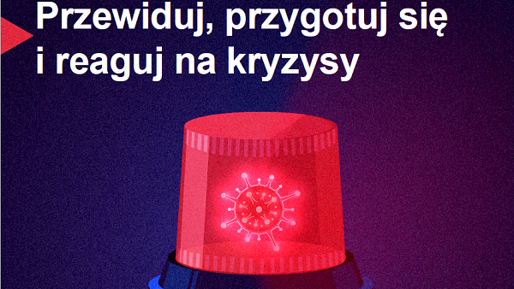
Anticipate, prepare and respond to crises. BET ON OHS
The World Day for Health and Safety at Work is a golden opportunity for summarising the last year's life in the pandemic and drawing conclusions that will help faster and more efficiently respond to difficult and unexpected situations in the future.
For over a year now the SARS-CoV-2-induced pandemic has been setting rules in nearly every aspect of our lives, including work.
The risk of becoming infected with the virus has caused many companies and educational institutions to switch to the remote working mode; our mobility has been restricted, including flights; jobs have been cut in many key industries with some businesses having to close down.
The preventative measures such as limiting contacts and working on a home-office basis have presented employees with new possibilities, but also resulted in potential threats – particularly of psychological and sociological nature.
The International Labour Organisation (ILO) encourages implementation, based on these experiences, of actions that will help better manage work safety, more effectively protect workers' health while ensuring business continuity to enterprises and supporting them in replenishing resources upon recovery from the crisis and facing unexpected challenges or, perhaps, new crises in the future.
The ILO points out that strong and efficient OHS management systems are of paramount importance in critical response and public health protection processes.
Polluted with... noise?
We hear ‘pollution’ and imagine dirty air, contaminated water or soil. However, the term also applies to noise, which is ubiquitous all across Europe and pollutes the environment causing harm to people and wild nature.
It is estimated that 113 million Europeans are exposed to long-term – last the whole day, evening and night - traffic noise at a level of at least 55 decibels. Moreover, 22 million people are exposed to a high level of railway noise, 4 million – to a high level of aviation noise, and nearly a million - to industry-related noise.
Many of those individuals are even unaware of the fact that long-lasting exposure to noise, to which they are accustomed in urban areas, has considerable impact on their health.
The European Environmental Agency (EEA) estimates that this situation causes around 12,000 premature deaths as well as contributing to some 48,000 of new cases of coronary artery disease. 22 million people suffer from persistent irritation with another 6.5 million people - from chronic sleeping disorders.
According to EEA’s information, European states are undertaking multiple measures in order to reduce the levels of noise and to manage it.
Many states, cities and regions have also designated the so-called 'silent zones’ – these include primarily parks and other green areas where local residents can find shelter from the hassle and bustle of the city.
How to work from home efficiently?
It is common knowledge that it is difficult to keep self-discipline and self-organisation when working from home. A little coffee. A snack. Just one TV-series episode. A walk with the dog. Sometimes one gets distracted by domestic noises from tasks requiring concentration. What can one do in order to work efficiently?
Specialists agree here – an effective implementation of any task requires a plan.
When planning, take also into account your so-called ‘chronotype’. It is a pattern of behaviour which takes into account one’s habits in relation to the waking up and bed times as well as the time when one’s frame of mind and psycho-physical fitness are optimal.
‘Lark’ or ‘early bird’ is a morning chronotype. Those who fall in this category typically sleep between 10 PM and 6 AM (or sleep less). They are most active in the morning reaching energy peaks before midday and can do tremendous amounts of work before lunch. They often experience an activity crisis in the afternoon and need a nap in order to regenerate, and can feel exhausted in the evening.
‘Owl’ or ‘night bird’ is an evening chronotype. These individuals go to bed late, but also wake up late. Their rest times fall between 2 and 10 AM (or they sleep longer provided that they are free to choose their activity times: holidays, time off work).
‘Owls’ are most productive at night. The need longer sleep in the morning and take more time to fully wake up.
Wellbeing in the company – what is that?
If you ask people around you what they lack most and what they miss, most will probably answer: a moment of peace, rest and breathing space. Alas, modern times are dominated by hurry and change-chasing. Hence, we may seem to be losing the joy of life while being on the run all the time. The very joy of life.
Wellbeing basically means a positive frame of mind, and the well-being approach assumes just that: one should feel well, live well and enjoy life.
Once all the above spheres have been catered for, one will soon find oneself looking for a good job. Not only one that is well-paid, but also one that caters for our other needs.
Only 15% workers are committed to their work. Aiming to ensure well-being to one’s staff may be an excellent idea as a happier employee is a more committed one, which in turn means higher productivity.
How to care for one’s employee? Let us view an employee as a person who has certain tasks to perform each day. As responsible employers, we will notice that the things that our employees deal with everyday have an impact on them.
Wellbeing at work involves a realisation of what and how we can to in order to replenish the employee’s resources and rid of unnecessary challenges.
Risk of fire? Find out whether such a risk exists
Identification of hazards and risk assessment will allow your company to develop and adjust effective fire safety measures. Only that can give you reassurance that the risk of fire has been brought down to a minimum.
In a company storing, warehousing or using materials classified as dangerous and chemical substances there is a considerable risk of fire or explosion. And this in turn poses a threat to the health and life of the staff.
An employer, in complying with its OHS obligations to ensure safe work conditions, must carry out occupational risk assessment, document the situation, apply necessary preventative measures to mitigate the risk and inform the employees both of the occupational risk they face and of how to protect against workplace hazards.
Fire risk assessment should be carried out by a competent individual.
As a first step, an objective assessment of the danger should be carried out, followed by a determination of the fire risk level.
Depending on the level of fire hazard, adequate fire safety measures should be applied. It should be borne in mind that all fire safety equipment requires periodical checks.
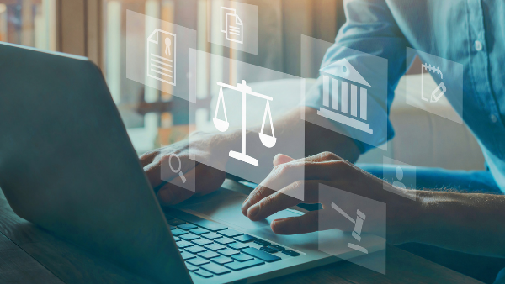
Labour Code – what has changed?
Over the past year, all industries have been dominated by the COVID-19 pandemic and affected by the restrictions imposed. The crisis forced the legislator to implement necessary solutions in the Labour Code so as to enable jobs to be kept and allow workers to work remotely, from home.
Since the beginning of this year, the Ministry have implemented several amendments to the Labour Code. One of them, and one most seriously affecting many areas of the law, is a higher minimum wage. Since 1 January 2021, the lowest gross salary for a full-time job has been PLN 2,800, with the lowest gross hourly rates in civil-law contracts reaching PLN 18.30.
The increase in minimum wages has entailed changes in the levels of other benefits which are determined on the basis of the minimum wage:
- Higher night-work supplement;
- Higher damages for breach of the principle of equality in employment or for mobbing;
- Higher cap on the collective redundancy pay, which cannot exceed a 10-fold of the minimum wage;
- Higher cap on in-company social benefit fund contributions, which is determined with reference to the average wages.
7 rules for lifting heavy items safely
One only has one spine. In jobs requiring lifting and carrying heavy objects it is exposed to defects and injuries. Therefore, it is vital to train one's employees in correct load-handling techniques.
Before you start the lifting process – check the weight of the object. You can do it by pushing it with your hands or leg. If it turns out to be too heavy – ask for help or use auxiliary equipment.

Rules for lifting heavy loads:
- Stand close to the object with your legs apart or with one foot at a slight angle in front of the other so as to ensure body balance both laterally and forward/backward.
- Crouch down in front (as close as possible) of the object; try to position your body such that you can avoid any twisting movements of your trunk.
- Bend your knees, but no more than at right angles. Pull you chin back. Tighten your neck and lean your trunk forward, but do not bend it!
- Tighten your abdominal and back muscles so that the sacral part remains straight.
- Lift the object while straightening your knees, hips and back at the same time - the back must be straight at all times!
- Keep the object as close to your body as possible!
- When lowering an object, act in the same way.
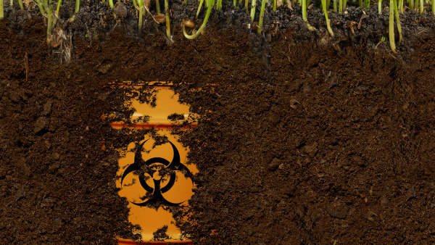
Environmental crime
“Environmental Crime – Contemporary Challenges for Law-Enforcement Agencies and the Environmental Protection Inspectorate” – this is the topic of an online conference organised by the Chief Environmental Protection Inspectorate (GIOŚ) on 15 April 2021. The aim of the debate was to discuss the most important matters involved in combating environmental crime in Poland.
Jacek Ozdoba, Secretary of State at the Ministry of Climate and Environment, pointed out in his opening statement that it was being held with reference to the amendments to the Criminal Code, Misdemeanour Code and other statutes being prepared by the Chief Environmental Inspector.
Prosecutor Ewa Ścierzyńska emphasised that the number of individuals prosecuted in relation to illegal waste handling had increased 15 times - from 44 persons in 2015 to 686 persons in 2020.
Many irregularities in terms of illegal waste handling has been generated by trans-border transportation. In 2020 alone, the State Revenue Administration stopped 239 trans-border waste shipments of a total mass exceeding 8.5 thousand tonnes, in which irregularities had been detected.
The joint efforts of Interpol, State Revenue Administration, Environmental Protection Inspectorate, Police and other law enforcement agencies will not be sufficient to combat environmental crime. A change to the regulations in that respect is also necessary.
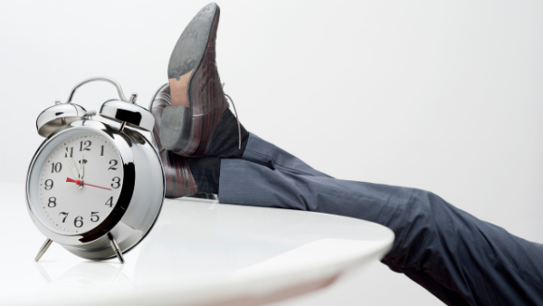
Breaks from work – answer to your body’s natural needs
Breaks from work are necessary. This applies to both physical and mental work. Prolonged fatigue, which is a physiological effect of work, lowers the possibility of it being continued. Efficiency goes down and discouragement grows.
Fatigue develops primarily in the organs engaged in the work performed. Physical work leads mainly to muscle fatigue, using sight – makes eyes sore while mental work tires the brain. This leads to poor concentration, attention and memory disorders, slower perception, longer reaction times, difficulty in decision-making, irritability, discouragement and drowsiness.
Regardless of the type of fatigue, the signals from the body induce breaks from work, or at least a change in the type of work.
Under the Labour Code, each employee who works for more than 6 hours a day is entitled to a 15-minute break counting as working hours. Those using computers at work, provided that such work exceed half of the daily working hour limit, are entitled to an additional 5-minute break, also counting as working hours.
While working remotely, each employee sets up a schedule of breaks, their numbers and duration. As remote work typically involves the use of a computer, it is reasonable to maintain the statutory 5-minute breaks following each hour of work.

