What hazardous factors occur in grocery stores?
Shops are exposed to hazardous, harmful and strenuous factors that can lead to injuries and bodily harm. It is an employer’s duty to identify the hazards occurring in the workplace and take steps to keep to a minimum the risk of their occurring.
Work in a grocery store qualifies as medium hard - the employee performs most of his/her duties in a standing position. The most frequent activities include: reaching, handing, walking, lifting and carrying goods. Constant, monotonous repetition of such activities can lead to work accidents.
Slippery and uneven surfaces, falling objects, sharp tools and edges, limited spaces, as well as moving, spinning equipment parts, plus means of transport, are all examples of mechanical hazardous factors, which can cause injury or bodily harm to the employee.
One should also bear in mind a physical factor, i.e. electricity. It can also pose hazards to humans.
Toxic pesticides and insecticides as well as fruit and vegetable conservatives are also used in shops. All these substances are qualified as chemical hazardous factors, which can affect the staff’s health. Physical hazardous factors, in turn, include: too high or too low temperature, humidity or inadequate lighting.
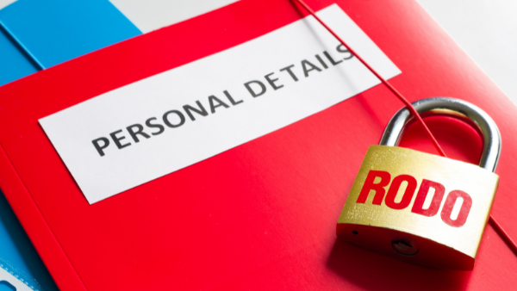
Reporting data protection breach incidents
Data protection breaches can also occur during remote work. In such cases, in order to establish whether or not a breach has occurred, the employer should ensure proper communication to the employees.
A breach occurs where three conditions are met jointly:
- The breach concerns the personal data that are transmitted, stored or otherwise processed by the entity whom the breach concerns;
- The breach results in destruction, loss, modification, unauthorised disclosure of or unauthorised access to the personal data;
- The breach results from a violation of data security rules.
What should an employee do if a data protection breach occurs during his/her remote work? They should report, as soon as they become aware of the incident, that personal data may have been breached.
Here is a possible incident reporting path:
- Notify your line manager with a brief explanation of the situation.
- Report the incident of a template in operation in your organisation (while working remotely, staff should have access to the basic documents used in the organisation).
- Indicate the steps taken in relation to the incident.
- Consult the individual/department designated to handle incident reports.
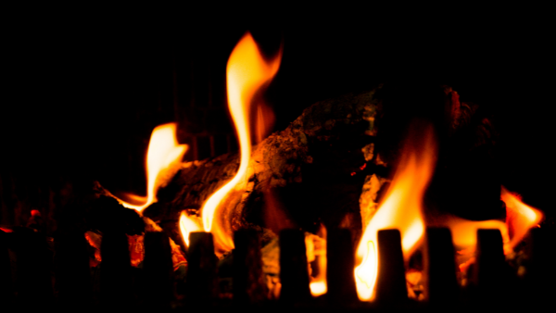
No more subsidies for coal-burning furnaces
Following 1 January 2022, there will be no subsidies for purchasing coal-burning furnaces as part of the ‘Clean Air’ programme. In addition, income thresholds will be increased allowing one to obtain up to PLN 37,000 in non-returnable subsidies.
The Minister of Climate and Environment, Michał Kurtyka, explained in an interview for the PAP (Polish Press Agency) that the decision to withdraw from subsidising coal-burning furnaces in the ‘Clean Air’ programme results from the reforms set down in the National Recovery Plan and the so-called ‘Polish Order’. Another factor is the anti-smog ordinances requiring old coal-burning furnaces to the replaced and restricting the possibilities of using the solid fuel, i.e. coal.
It will still be possible to purchase and install a coal-burning stove as part of the programme until 31 December 2021. During this time, a transition period will be introduced given that the programme allows for a project to be commenced up to 6 months before the date an application for funding is submitted.
Hence, those who file a funding application, purchase and install a coal-burning furnace by 31 December 2021, will have the cost covered by the subsidy.
Coal-burning furnaces will be subsidies on condition that:
- The application for subsidy with respect to a coal-burning furnace is filed by 31 December 2021.
- The furnace is purchased by 31 December 2021.
- The invoice for the furnace is made and the furnace installed by 31 December 2021.
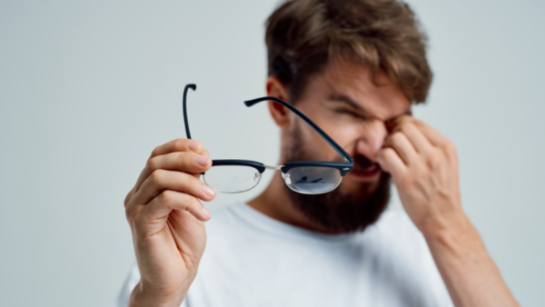
7 rules for taking care of your eyes when working at a computer screen
Long periods of work at a computer screen adversely affects your sight. Eye strain is merely a symptom which can lead to the dry-eye syndrome, early presbyopia or lower sensitivity to contrast. Therefore, it is so important to ensuring breaks and proper screen setup, among other things.
What should I do?
- Take regular, statutory (Dz. U. 1998 nr 148 poz. 973), breaks from work - 5 mins. after every hour. During the breaks do not use a smartphone or other screen equipment.
- The screen should be placed at a distance of 40-75 cm from you face so that its middle be 10-20 degrees below your eye level (such setup decreases the size of the lid slit and reduce the tear film evaporation).
- Work in daylight, and it is not possible - turn on the lights. Just remember that light should not directly fall onto the screen.
- Give up on the air-conditioning, apply artificial tears and drink a lot.
- Ensure proper ambient temperature (approx. 20-22 degrees), cleanliness (no dust) and air humidity (above 40%).
- Use sufficiently large screens, at least 14 inch. Configure all the settings properly, such as brightness, contrast and font type, which will allow you to read easily.
- Use proper corrective glasses with anti-reflex layers.
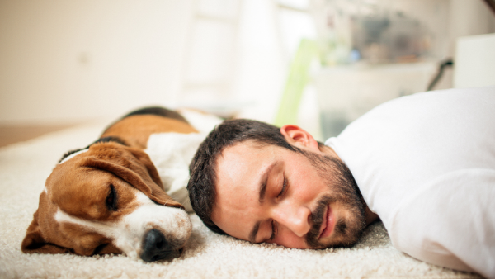
Time for a nap!
Breaks from work is not only a legal requirement, but also a medical indication. Each person’s body simply becomes tired after several hours of work and needs rest. When working very hard, it is worthwhile to dedicate one break from work to a short, 20-minute long nap.
Such rest gives one energy, improves concentration and well-being. During sleep, the information from the short-term memory is transferred to the long-term one and that is why naps aid remembering and learning.
The best time for a nap is in the early afternoon. Particularly, after lunch. According to scientists, it is then that a temporary dip in the body’s activity and readiness for work occur, as well as a greater need for sleep (post-lunch dip – PLD).
No direct relationship of the PLD with the meal times has been detected; however, the lunch itself can increase its effects. It has been observed that the effect does not occur after other meals during the day.
It is also worth noting that such a nap will not interfere with one’s night sleep. However, it should not be extended. Even a 20-minute long sleep brings the expected benefits – longer naps (more than 20 minutes) are often followed by the so-called ‘sleep inertia’, i.e. the feeling of being sleepy, resulting in worse motor skills, cognitive ability, longer reaction times, reduction in attention and concentration, fatigue and irritability.
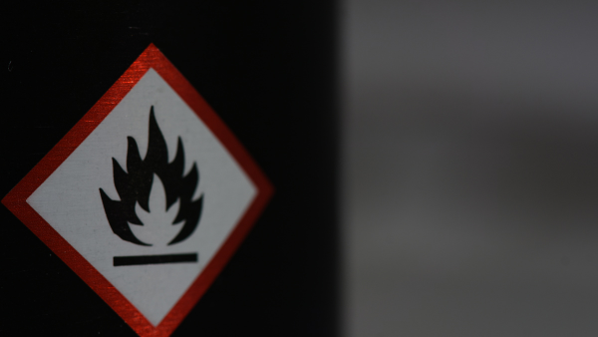
Work in explosion hazard premises
Explosion hazard premises are locations where flammable gases, dusts, vapours or mists occur which can create an explosive mixture. An employer is responsible for ensuring that the technical installations and equipment present on the premises satisfy the safety requirements specified in Polish Norms and other regulations.
Before the workers commence any fire hazardous works, the employer is required to:
- Assess the fire hazard in the area in which the works are to be performed; establish the types of action aiming to prevent fire or explosion from occurring, and familiarise designated individuals with such actions;
- Designated the persons responsible for securing the area of work, for the conduct of the works and for securing the area once the work is over.
Detailed fire safety rules as well as the conditions for obtaining permission to carry them out should be laid down by the employer in a separate manual.
Fire hazardous works may only be carried out by persons who are authorised and hold the necessary qualifications.

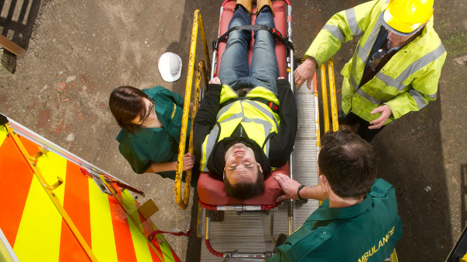
Rules of conduct during a work accident
An accident always means stress. The overwhelming emotions accompanying the event often prevent one from thinking and acting reasonably. However, in such situations the earlier we take proper steps, the greater the chance of mitigating the effects of the injuries or even of the injured person’s survival.

What should an employer do?
- Provide first aid to those injured.
- Take necessary action to eliminate or mitigate the hazard (switch off the machines and equipment).
- Secure the accident site against access from third parties and secure the machines or other technical equipment which have been stopped as a result of the accident against being switched on.
- Maintain the actual position of the machines, equipment and other objects which caused the accident. Based on their location and status it will be possible to recreate the circumstances, the course and causes of the accident.
- Notify the relevant Labour Inspector of a serious accident.
- Conduct a post-accident procedure. This procedure is conducted by the entity for whom the injured person performed work or the ZUS (Social Security Institution), whereas in the case of farmers - the KRUS (Farmers’ Social Security Fund).

The PIP to verify how businesses used the anti-crisis shield measures
According to an announcement of the Chief Labour Inspector (GIP), Katarzyna Łażewska-Hrycko, GIP will broaden the scope of its pandemic-related activities. The PIP (State Labour Inspectorate) will verify, among other things, how employers have managed the anti-crisis shields and whether the aid, whose purpose was to keep jobs, has been used properly.
According to the PIP’s information, the most frequent irregularities occur at micro-businesses.
- These employers fall behind the changes in the law while being focused on the firm's survival, particularly during the difficult times of the pandemic. They can’t afford hiring experts, legal services or employing in-house counsel. However, organisational or economic problems do not release one from one's obligations towards employees. – says Katarzyna Łażewska-Hrycko in an interview for the PB newspaper.
GIP also assures that she wants the PIP to be perceived as an employer’s ally, rather than merely a repressive institution.
Katarzyna Łażewska-Hrycko also announces more promotional and preventive activities. The PIP’s website is to present even more industry-related information, such as that concerning work during the pandemic. Łażewska-Hrycko wants to implement innovative solutions in OHS.
To this end, the PIP are planning on engaging the Central Institute of Work Protection – State Research Institute and the All-Poland Association of OHS Services.
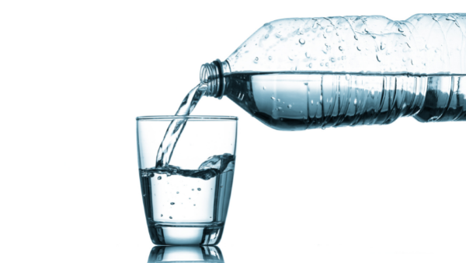
Drinking water – that is what water?
An employer is under an obligation to ensure to all employees access to water that is drinkable, whereas in the summertime, during spells of heat with the outside temperatures exceeding 26 degrees, and indoors – 28 degrees, additionally – proper soft drinks. What is, however, drinkable water?
Tap water. Under a relevant regulation “water is drinkable where it is free from disease-causing micro-organisms and parasites in numbers posing potential threat to human health, any substances in concentrations posing potential threat to human health, and where it does not exhibit any aggressively corrosive properties while at the same time satisfying relevant micro-biological and chemical requirements”.
Thus, it can be assumed that the standard, treated tap water is drinkable.
Bottled water. The problem can also be solved by the employer providing the employees with any amounts of bottled water. It turns out, however, that even here there are regulations laying down specific requirements that natural mineral water, source water and table water should meet, such as:
- micro-biological requirements,
- maximum admissible levels of natural mineral ingredients of such water types,
- conditions for the processes of ingredient removal or carbonation.
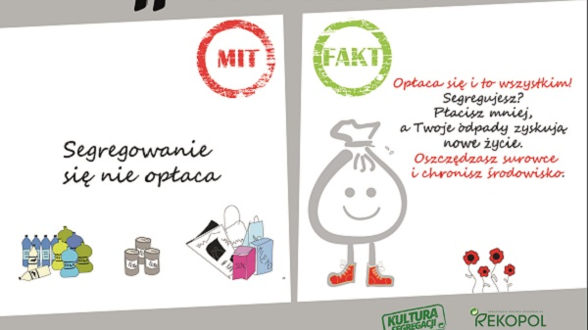
Waste is a raw material!
Sorting waste makes sense. Not only does this simple activity allow one to save (by sorting one pays less for waste disposal), but it also gives waste a second life. For instance, from plastic bottles, the so-called PET, the following can be made: a polar fleece jumper, bathroom rug, pillow stuffing or even a tent. Such waste as: metal, plastic and glass can be processed many times.
9 rules for proper waste sorting:
- Squeeze cans and bottles before throwing them away.
- Take off bottle tops and caps. Throw away glass and juice or milk cartons without plastic or metal tops.
- Check the labelling on the packaging.
- Empty the bottles, jars and cartons. All containers should be thoroughly emptied before being thrown away!
- Unfold cartons before throwing away.
- Discern types of glass. Do not put broken mirrors, glass panes or glasses to the glass waste container. This is another type of glass.
- Do not put into sorted waste containers: butter paper, tissues or paper towels that are very dirty. Also, waste containing glue or fats should not be sorted.
- Used electronic equipment, batteries, car batteries, debris and dangerous waste should be disposed of at PSZOKs (Communal Waste Collection Points).
- Overdue medicines should be disposed of at the chemist’s.

