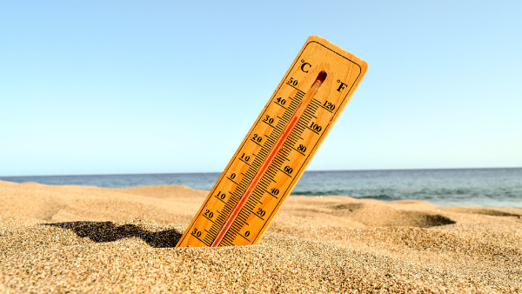
We are reminding employers of their obligations during heat waves!
The times of heat mean arduous and unfavourable work conditions. That is why employers have additional obligations towards their employees under OHS regulations.
Pursuant to section 4 (1) of the regulation of the Council of Ministers on prophylactic meals and refreshments of 28 May 1996, employers are required to provide their employees with sufficient refreshments.
When is this applicable?
- During outdoor works with the temperatures exceeding 25°C,
- During indoor works with the temperatures exceeding 28°C.
This obligation can be satisfied by employers in different ways: one can provide a water dispenser or provide bottled water. It should be remembered that failure to meet the above obligation may attract a penalty imposed by the State Labour Inspectorate.
During heat waves, employers can also reduce the working hours. Employees can also be sent back home, or, where practicable, instructed to work from home. Notably, such decisions result from the employer’s good will, meaning that the employees’ salaries must not be reduced accordingly.
Protect health during heat waves – PIP’s call on employers
The summer months in our country are marked by high temperatures. This often results in heat waves, which are a harmful work factor. With this in mind, the PIP (State Labour Inspectorate) has called upon employers to respect employees’ right to have safe and healthy work conditions.
Refreshments. When the temperatures at work exceed 28°C, or 25°C in the open air, employers must provide their employees with drinks in amounts sufficient to meet the employees’ needs.
Personal hygiene. During works performed in high temperatures causing one’s body and/or clothes to become dirty, each workers should be ensured access to a minimum of 90 l of water for hygienic purposes a day.
Open air. During works performed in open areas, employees should be provided with a rest area that is shaded and roofed. One should also ensure that workers wear hats and airy clothing that ensures UV protection.
Working and clean equipment. The HVAC equipment in the workplace should be kept clean and in working condition. Windows should be protected against excessive sunlight, e.g. by means of Venetian or roller blinds.
Shorter working hours. Employers can also shorten the working hours. Another measure to take is additional breaks.
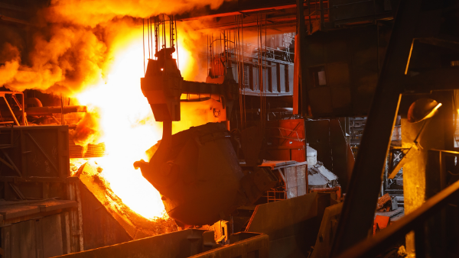
Ways of reducing the thermal load on employees
Prolonged, intensive work in a hot microclimate causes not only perceptible heat stress and tiredness, but also blood circulation disorders. It has also been found that with rising air temperatures and work intensity, the numbers of accidents at work rise, too.
The CIOP-PIB (Central Institute for Work Protection - State Research Institute) reports that approx. 20 thousand people in Poland work in the conditions of a hot microclimate (with the temperatures between 25 ºC and 60 ºC, and relative air humidity of between 10 % and 80 %). This occurs in such industries as: metallurgy, glass, mining, and, during the summer, at works performed in the open air.
Employers are under an obligation, set out in the Labour Code, to take action to liquidate or at least mitigate the hazards caused by dangerous or harmful factors in the workplace. Employees should be informed of the adverse consequences of their prolonged work in a hot environment and ensured access to adequate amounts of refreshments.
What about the types of work where such solutions are impracticable? Then, individual body cooling systems can provide an efficacious solution. These are the so-called cooling systems embedded in clothes. They use: phase-change materials (PCM), ice (as a particular example of a PCM), air or liquids.
NIK: Energy price audit findings
Between 1 January 2016 and 30 June 2020, the NIK (Supreme Auditing Chamber) carried out audits in the Ministry of Climate and Environment, Energy Regulatory Office, Clearing Agent SA and Electricity Distribution Company. The NIK has found unreliable the failure to carry out cyclical analyses of the energy market between 2016-2020.
The audit has found that the Minister responsible for energy matters failed to prevent a sudden jump in electricity prices. This happened despite the consistent EU policy of CO₂ reduction and an awareness of its impact on the Polish energy sector.
CO₂ emission rights continued to rise and, as a result, the prices of fossil fuels were bound to rise accordingly. The act on electricity prices was in force in 2019 only and was an ad-hoc measure only. The act, which according to the NIK aimed to fulfil the Government’s promises to curb electricity prices, was drafted in a hurry.
Consequently, its preparation was in breach of legislative principles, without consultation with the entities subject to the act and with an incomplete assessment of the implications of the act. Nor were the required opinions on compliance with EU law obtained. Although the price stabilisation was only to take effect in 2019, the act was then amended four times, including twice due to a breach of EU law. On expiry of the law, i.e. after 1 January 2020, household electricity prices rose by nearly 20 per cent.
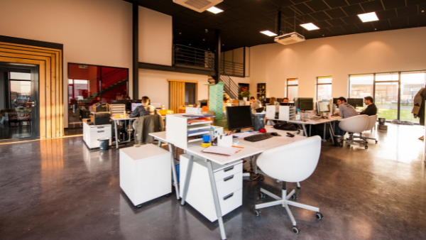
Hazards in office work
During work in the office, although it is deemed ‘easy’, accidents can also happen while performing one’s work duties. It is the employer’s obligation to identify the sources of hazards and, wherever possible, eliminated them.
All hazards can be divided into those that can directly lead to an accident and those that adversely impact an employee’s health due to long-term exposure.
Dangerous factors - physical. Factors leading to accidents in an office include primarily: dangerous flat surfaces (slippery floors, uneven floors, etc.); stairs/doorsteps; unstable ladders; open doors, windows, cabinets, drawers; sharp instruments; electrical appliances, etc.
Chemical factors and dusts. An office worker deals on a daily basis with equipment requiring toners, inks or other types of liquids to operate properly. Sometimes, employees take care of the order in the workplace on their own, which means using the so-called ‘household chemicals’ and detergents. Contact with such substances can lead to various medical conditions.
Arduous factors. Prolonged work at the computer screen can lead to eye strain, headaches or back aches as well as resulting in general exhaustion. Another non-obvious factor posing threat to workers in an office is noise. It is caused, among other things, by people talking or working office equipment.
Staffing - what is that?
A supervisor humiliating, exposing to ridicule, isolating an employee from co-workers is termed mobbing. This concept has been familiar for years now. What, however, does the term ‘staffing’ mean? What does it involve?
However, before moving on to describe the phenomenon, let us recall what mobbing is: it includes any actions taken by a superior which lead to an employee being humiliated or put down.
Staffing is a variety of mobbing where the roles are reversed. It involves an employee, or a group of employees, taking actions affecting a superior aiming at eliminating him or her from the organisation or making them resign from a managerial position.
Staffing can take such forms as:
- ignoring instructions,
- putting down a superior in meetings e.g. with senior managers,
- spreading gossip at work,
- inciting other co-workers against the superior.
The Labour Code only contains a reference to mobbing. Therefore, one would look for proper provisions in vain there. Nevertheless, Art. 24 of the Civil Code expressly states that infringing one’s personal rights is unlawful. Thus, humiliating a superior, slander or other disgraceful action infringe a superior’s personal rights.
Depression at work
Depression is a serious social problem. According to the data from the Institute for Health Metrics and Evaluation, as many as 1 million people suffered from depression in Poland in 2017, with 288 thousand suffering from the bipolar disorder. Those suffering from depression had significantly lower work abilities compared to employees suffering from other medical conditions.
Depression is not a single disease, it is made up of several disorders of various origins and requiring different types of treatment. It consists primarily in mood disorders.
One can speak of the symptoms of depression where the condition lasts for about two weeks.
The findings obtained by the CIOP-PIB are convergent with those of an American study, which stated that “approximately a third of the economic costs of depression include the costs resulting from reduced productivity, inability to work and lower efficiency in those suffering from these problems”.
44.4% of the respondents, i.e. nearly a half, estimated their current work capacity as average or below average. Those with severe depression were more frequently absent from work and less committed to work.
The higher the level of depression, the lower the assessment of one’s current work capacity, the lower the motivation and the greater the absenteeism.
Plastic revolution began on 3 July
Since 3 July, certain plastic materials have been banned from trade. This results from the SUP Directive, which sets out to reduce the impact of certain plastic products on the environment.
A recent research by the World Economic Forum has found that about 8 million tonnes of plastic waste finds its way to the oceans every year. Other sources estimate the value at between 10 and 20 million tonnes! The amount is so great that large patches of waste are forming in the ocean and increasing every year. The waste patch in the Pacific Ocean has even been hailed ‘the eighth continent’.
A measurement of beach littering in the EU has shown that plastics account for 80-85 % of waste in the marine environment. 50% of that is single-use plastic products.
The Directive of the European Parliament and of the Council (EU) 2019/904, the so-called SUP Directive, introduces certain limitations resulting in a ban on marketing certain single-use plastic products.
Hence, according to the Directive, since 3 July it has been prohibited to sell such products as: cotton buds, kitchen utensils (forks, knives, spoons, chopsticks), plates, drinking straws, stirring sticks, balloon sticks as well as expanded polystyrene cups and drink and food containers, from which food is consumed directly without further processing.
How much does a work accident cost?
The costs of a work accident are borne not only by the employer, but also by the injured person’s family and ultimately by the entire society. Therefore, ensuring safe work conditions is a primary obligation of each employer.
The level of costs is dependent primarily on the type of accident itself - the heavier and more serious the accident (fatal, collective), the higher the costs.
The costs of an accident to the injured person and his/her family, as well as to the whole society, will include the expenses incurred for: treatment, medicines, physiotherapy, benefits and compensation.
The costs to the injured person him/herself will include a reduction in or loss of earnings.
For the employer, the costs will above all include the costs of lost working time, ongoing payments, loss of revenue, loss of fixed and working assets.
The data published some time ago by the OIP Warsaw show that in large enterprises the costs of production disruption and repair are higher due to the application of more complex technologies and more expensive technical equipment used.
In terms of post-accident prevention, an employer should develop a consistent safety policy. It is an employer’s obligation to take into account technical matters, the organisation and conditions of work, interpersonal relationships and the impact of work-environmental factors.
Remote work during COVID-19 - privacy obligations towards data subjects
Personal data controllers owe a duty to data subjects to satisfy their requests, e.g. to have their data removed from the data base. How to satisfy such requests while working remotely?
Employees must be aware that despite working remotely they are bound by the same rules under the relevant regulations. The department responsible for answering the requests of data subjects should work flawlessly.
For instance, where an employee is required to respond to a data subject request and has no access to the organisation’s resources (e.g. cannot remove the data in question), because he or she cannot log into the system while working remotely - it should be reported to the employer. The employer, on the other hand, is obliged to be prepared for such situations and provide the employee with access to the relevant data base.
Under the GDPR, a data controller must provide the data subject with information on the actions taken with respect to the request made without delay, not later, however, than within one month of the receipt of the request. If necessary, the deadline can be extended by another two months due to a complicated nature of the request or the number of requests.

