Is demanding proof of vaccination compliant with the GDPR?
The organisers of events or celebrations to which certain restrictions, orders or bans apply in relation to the epidemic state are not entitled to demand that the participants disclose the information on COVID-19 vaccination.
Information concerning vaccination is health data representing a special category of data under Art. 9 (1) GDPR. Its processing is afforded stricter protection.
How can one obtain information on vaccination?
Those required to comply with the limits of participants imposed by those regulations have no right to obtain the information from the participants on whether or not they have been vaccinated.
They have no right to request such information, whereas the person concerned is under no obligation to provide it.
Information on vaccination can only be obtained if the person concerned voluntarily shares it.
It should also be remembered that making copies of documents or declarations collected is in violation of the law. It is sufficient for a data controller to peruse a vaccination certificate and admit the person concerned beyond the limit. Such information cannot be stored.
Take care of your health by taking care of plants – at work and at home
One should take care of one’s own work environment, whether one works in an office, or on a home-office basis. Plants are a good idea as they are not only pleasing to the eye, but also have a positive impact upon human health. How to select them then?
Go for plants that clean the air.
The plants that best support the cleanliness of the air around us include: wingflower, fern, sansevieria, herbalist, ficus benjamina, draecena or aglaonema. These species absorb the greatest amounts of toxic substances.
Select species that fit your workstation
Pay attention to the access of daylight, sunlight intensity, temperature and proximity of heat sources. If your room is smaller, focus on plants that are more compact, whereas if you have a larger space at your disposal, you can afford more expansive species.
It is better to place smaller plants directly on the desk, e.g. snsevieria, aglaonema or wingflower. Larger plants can be placed next to furniture or nearby.
Decide on the amount of time you want to dedicate to the plants
The least demanding plants include sansevierias and draecenas. Ficuses or ferns require somewhat more attention.
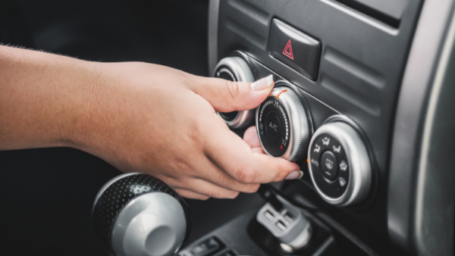
5 rules for safe use of car air-conditioning
Drivers, sales reps and other employees who spend most of their time travelling know very well how much trouble can summer heat cause in the car. The inside of a car parked in direct sunlight can reach as much as 60 degrees Celsius. Thanks God, there’s air-conditioning!
How to use air-conditioning in the care safely? Learn the 5 principles!
- Before you get into the car - open the windows, roof window and doors - ventilate the inside. This will cause the hot air escape the car, and the AC will sooner manage to cool down the cabin.
- Direct the air flow onto the windscreen. Do not direct cold air directly onto your face, neck or feet. Too large temperature differences may affect your health causing a cold, or muscle or joint inflammation.
- Set an optimal temperature. Bear in mind that the temperature differences between the car interior and the outside air should not exceed 10°C.
- Close the windows while using air-conditioning in the car. Open windows will prevent the AC from working properly as the cold air will escape.
- Service regularly (at least once a year) the car AC installation as well as regularly replacing the cabin filter, cleaning and disinfecting the air distribution channels leading to the cabin, evaporators and air inlets.
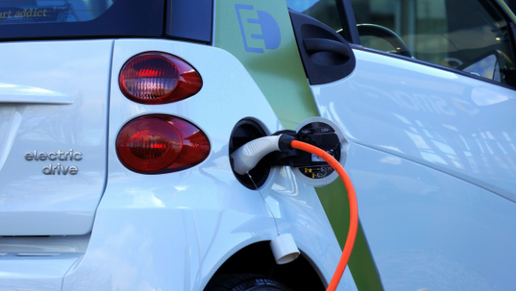
National Environmental Fund to subsidise electric car lease
On 26 July of this year, the National Environmental Protection and Water Management Fund announced the enrolment procedure for banks interested in subsidies to zero-emission (i.e. hydrogen-powered or electric) car lease. This is yet another step in the implementation of the ‘My electric’ programme.
In addition to individuals, enterprises, local governments and institutions will also be eligible for subsidies for purchasing/leasing electric or hydrogen-powered vehicles. The implementation of the programme has been scheduled for the years 2021-2026 and its budget is currently PLN 500 million, including PLN 400 million in lease subsidies.
Michał Kurtyka, Minister of Climate and Environment, stresses that thanks to the solution, the number of electric cars in Poland will triple, which will enable further development of the charging infrastructure and production for the zero-emission car market.
Participation in the ‘My Electric’ programme will be dependent on the conclusion of a financing agreement with the Fund.
The contents of such agreements, similarly to the contents of the agreements concluded between the banks and leasing companies, and the agreements concluded between the banks and the lessees, have been so standardised as to ensure lessees equal access to the subsidies regardless of the choice of the leasing company and of the bank with which the leasing company chooses to cooperate.
Working with a computer – the ‘3B’ principle
Computer work, as any other type of work, can also be strenuous and definitely is tiresome. Sitting in one position for extended periods of time causes back pains while long periods of staring at the screen causes eye fatigue. Thus, in order to mitigate such negative factors involved in computer work, one should remember about the ‘3B’ principle (and breath).
Blink – blinking cleans and moisturises the eyes. Working with a computer involves intensive eye work during which the eye surface can become dry. Frequent blinking and using moisturising eye drops enhances the eye comfort. It is good to learn to blink every time your sight reaches the edge of the screen. It is also helpful to often close your eyelids, which helps your eyes relax.
Break – breaks should be taken frequently with the sight moving to distant objects, e.g. by looking out of the window. Another popular rule is the 20-20-20 principle, i.e. making 20-second breaks every 20 minutes by looking and an object about 20 feet (approx. 6 m) away.
Such 20-second breaks should be treated as extra ones, i.e. in addition to the 5-minute breaks after each hour of work.
Breath - breathing is a spontaneous activity, but dependent to some extent on your will. In stressful situations one often stops breathing, which adversely affects the working of the muscles, including the accommodating ones. By contrast, regular, calm breathing has a relaxing effect. It is useful to do breathing exercises – the instructions can be found in the Internet. Before doing such exercises it is a good idea to ventilate the room, which will increase their efficiency.
A sustainable office enhanced your firm’s positive image
A new generation of procurement department staff poses considerable challenges to manufacturers. They insist that the office equipment meet the sustainable development standards. Hence, suppliers must demonstrate that they take real action to protect the resources, climate, show social responsibility and cares for their workers’ well-being.
One element leading to a sustainable office is the safety of use. What does it mean?
It basically means conformity with environmental protection requirements. Products should be tested in accordance with a number of different eco-labelling systems and should not contain any unnecessary or harmful chemical substances.
Another safety point is ergonomics. From the workers’ well-being point of view, it is crucial to encourage them to move during the day, care for proper acoustics in the working environment and ensure contact with natural plants.
Adjusting the office to the staff’s needs is another element. This means that one should support sustainable development, foster workers’ well-being and crate conditions for successful individuals.
Product quality. Functional, durable, but at the same time environmentally and pocket friendly products will prove their value in the conditions in which they will be used and will serve for many years.
COVID-19 vaccinations – PIP’s position
The State Labour Inspectorate issued a statement on 27 July concerning COVID-19 vaccinations. The PIP emphasises that such vaccinations are of great importance in preventing SARS- CoV-2 infections, but under the current regulations they are voluntary.
The statement reads that the PIP’s position is only based on the official positions of the institutions and authorities authorised to make statements in these matters, in particular the Ministry of Health, Chief Sanitary Inspector and COVID-19 Medical Council to the Prime Minister.
Ambiguous regulations
The PIP remarks that the current situation cannot be assessed unambiguously as under the current regulations “an employer is required to apply any available measures to eliminate or limit the threat to life or health in the workplace”. The available vaccinations limit directly and significantly the risk of the coronavirus spreading.
Employer’s obligations
Employees employed in conditions exposing them to hazardous biological factors must be provided by the employer with all available means to eliminate the exposure, and where it is not possible, to limit the degree of exposure, making a proper use of the latest advances in science and technology.
In conclusion, the PIP stated that vaccinations are important, but each employee has a right to decide whether or not to undergo them.
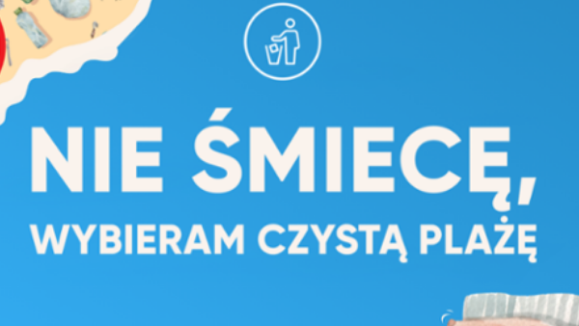
Stricter penalties for beach littering
‘I do not litter, I go for a clean beach’ – that is the name of a campaign organised by the Ministry of Climate and Environment and the Environmental Fund in Gdańsk which sets out to draw the public attention to beach littering. Alas, the amount of waste dropped and the problem of the Baltic Sea, as well as the adjacent beaches and dunes, being polluted is not going down.
Deputy Minister Jacek Ozdoba, during a press conference held on 28 July 2021 in Gdańsk, called upon holiday makers to not drop litter during excursions and while resting on beaches. And further that not only are the aesthetic considerations important here, but that the marine flora and fauna, as well as people, are becoming under threat.
He reminded that littering in public spaces is punishable with relevant penalties – not only fines, but also even imprisonment. Moreover, the Ministry of Climate and Environment have proposed an amendment to the Misdemeanour Code that increases the penalties for littering. The Ministry also wants amendments to the Penal Code with stricter penalties for offences against the environment.
- Hence, the maximum fine for littering beaches, forests, lakeside as well as mountain hiking trails has increased from PLN 500 to PLN 5,000. I would also like to stress here that the penalties for environmental offences have not been updated for many years and their current levels are inadequate to the offences committed – said deputy Minister Jacek Ozdoba.
He added that the draft amendment was entered on the schedule of governmental works last week.
Remote work during COVID-19 – organisational and technological solutions
Introducing remote work should be preceded by a risk analysis with respect to personal data protection as the challenges involved in this form of work include not only IT systems and their necessary adjustments, but also printed document management.
Printed documents. One ought to remember to protect printed documents against access of third parties, such as other family members, children or pets, against flooding, destruction, loss or theft. Such documents can only be destroyed by means of a shredder and filed in a specially dedicated cabinet/place. Never throw printed documents directly to the bin!
Contact with the employee. Naturally, the preferred methods of contact include by email or telephone. We would like to warn you against using non-verified applications, as the GDPR and IT security experts have been holding heated debates as to whether all available tools ensure a proper level of security.
Company equipment. It is worth ensuring that staff use company equipment. One should also ensure VPN logging, install up-to-date antivirus software with firewall, activate a backup function and provide an encrypted hard disk for data storage. In addition, employees can be provided with privacy add-ons. Instruct your staff to lock their computer each time they leave the device. Employees should log in to work by means of private and home networks only, e.g. by smartphone tethering or via a private home router.
Are seasonal workers required to attend initial OHS training?
Seasonal employees must each time be provided initial training. This requirement applies to both those employed on an employment contract and those under a civil-law contract. The employees who were employed, e.g. a year ago may not remember the OHS rules. Besides, the equipment may have changed and so may its operation.
It should be remembered here that the responsibility for occupational health and safety always rests with the employer.
Under the Labour Code and regulation of the Minister of Economy and Labour on the training in occupational health and safety of 27 July 2004, OHS training is mandatory for those employed under an employment contract. A newly employed worker should undergo initial OHS training as early as on the first day at work.
Moreover, prior to starting work, each employee must undergo medical examinations to verify that there are no counter indications to perform a given job. It is the employer’s obligation to refer them to a labour medicine practitioner.
In the case of civil-law contract, the employee must also attend initial OHS training. However, medical examinations will be carried out at his/her own cost. Although, as a rule it is the employer that foots the bill.
Thus, regardless of the type of contract between an employer and employee, the former is always required to communicate the OHS rules and principles of safe machinery operation to its employees.

