Remote work in the amended Labour Code
Remote work will mean work performed entirely or partly in a location specified by a employee or agreed upon with the employer. In principle, this will be the place where an employee lives or another place of his/her choice approved by the employer. This part of the definition is key to distinguishing between remote work and work performed in the traditional way.
On the website of the Government Legislation Centre a new version (the second one already) was published of the draft amendment to the Labour Code, act on professional and social rehabilitation and employment of the disabled and act on the promotion of employment and labour market institutions. The draft sets out to regulate permanently the issue of remote wok in the Labour Code.
The most important assumptions of the draft include: definitions, parties’ mutual arrangements of the employment relationship, rules for the performance of work, employer’s data protection obligations, application for end of remote work and restoration of previous work terms, employer’s obligations and prohibition of employment termination.
According to the proposed definition, remote work may be performed entirely or partly at a location specified by an employee and each time agreed upon with the employer, including the employee’s place of residence, specifically by means of direct remote communications.
The information on COVID-19 vaccination to be no longer employees’ private matter
Under the current legislation, COVID-19 vaccinations are voluntary. The same pertains to the information on the vaccination – an employee may, but is under no obligation to, inform his or her employer of the fact. There is, however, a chance that regulations will come into force which will change the situation.
As of today, there is no obligation for employees, even those who work in conditions of considerable exposure to the coronavirus, to get vaccinated. Similarly, there are no regulations allowing employers to gain access to the information on the vaccination. Such information, representing an individual’s health data, is under special protection.
However, it has been reported lately that works are under way on amendments to the law aiming at allowing employers access to the data on whether or not their employees are vaccinated.
Above all, such information may be used for the purposes of updating occupational risk assessments, i.e. proper anti-virus prevention. Yet, it cannot be excluded that such information will also be used to impose an obligation to wear face masks only on those who have not been vaccinated.
However, a question arises how such regulations will be responded to by the authorities exercising supervision over work conditions, or the Office for Personal Data Protection.
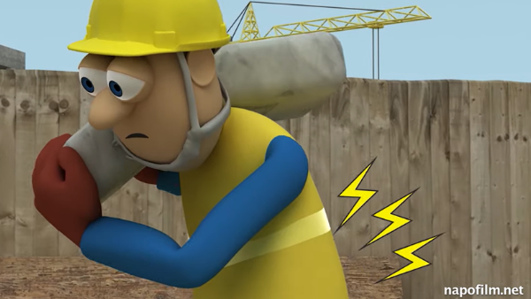
Take care of your spine together with NAPO
The problems relating to the musculoskeletal system disorders in the workplace result above all from risk factors such as: sedentary position, monotonous and repetitive movements, lack of physical activity and lifting heavy loads. The European Agency for Safety and Health at Work is raising people’s awareness, with a series of films featuring a character called NAPO, that these problems can be avoided.
Work-related musculoskeletal disorders (MSDs) are the most frequent health issue in Europe. They often entail symptoms such as: pain in the back and arms.
Musculoskeletal disorders pose problems not only to the employees in question, but also to the enterprises, the economy and the entire society as they cause disabilities, sick leave and early retirement.
The European Agency for Safety and Health at Work has prepared a series of films in which a character called Napo humorously raises the viewers' awareness of work-related musculoskeletal disorders. Early employer intervention, technical and organisational preventive measures as well as ergonomic equipment will not only enhance the work comfort, but they will also protect employees against musculoskeletal disorders.
The films can be viewed here: https://www.napofilm.net/pl/napos-films/napo-lighten-load-2021
Draft EPR law: new obligations for packaging producers?
A draft amendment to the act on packaging and packaging waste management and certain other statutes, which was published on 26 August of this year by the Ministry of Climate, provides for a special packaging fee to borne by producers.
The amendment is in response to the required implementation of EU-imposed regulations, but also aims to regulate the waste management market in respect of packaging in Poland.
The draft introduces a system of extended producer responsibility (EPR) for product packaging. As part of EPR, manufacturers will incur a special packaging charge. Its rates will be specified by the Minister of Climate. They will vary depending on inter alia the type of packaging, recyclability, contents of recycled material taking into account the revenue from recycling, sale of recycled materials and uncollected deposits.
Producers will be able to meet their packaging recycling obligations imposed by the law either themselves or through a producer responsibility organisation.
Such organisations will be required to earmark 95% of the revenue for entities engaged in recycling and packaging waste collection. In this manner they will ensure that the statutory recycling threshold is met.
Physical activity when working from home
During remote work, particularly during a potential lockdown, physical activity is a key factor contributing to the health of workers. Hence, one ought to remember to give oneself a proper dose of exercise.
One could say that working from home makes one lazy. As a result of no longer being forced to move to and from work, we often fall into a routine, which may in time turn into sloth. Such condition is deadly for both our physical and mental health. Therefore, let us not forget to get some exercise. About physical activity. If you cannot work out at the gym, you can at least do a few exercises at home or in the open air (provided no lockdown is imposed).
What you can do:
- regularly get up from your computer station and walk around the flat,
- do a series of general physical exercises, both strengthening and relaxing your muscles (lasting between several to a dozen minutes per series),
- out of doors: walk, do Nordic walking, jog, cycle, use neighbourhood or park health paths or outdoor gyms.
Do exercise as often as possible. Approach them with concentration and care as you take care of your own health.
What are the benefits for employers employing those disabled suffering from depression?
There is a certain degree of synchronisation between depression and disability - if one factor deteriorates or improves – so does so the other. It is worth knowing that an employer employing a disable person with depression may count on various financial as well as non-financial benefits.
- Reduced mandatory PFRON contribution
Employers hiring employees with moderate to severe disability suffering from conditions particularly making work difficult, including those suffering from chronic mental diseases, which typically include depression, can make savings.
They can also obtain reimbursement of costs such as adaptation of newly created or existing workstations for the needs of the disabled. Moreover, employers can have the costs of training for the disabled refunded.
- Subsidies to the remuneration for the disabled
Since 1 April 2020, a monthly subsidy to the remuneration of a disabled employee has been:
- PLN 1,950 – for those with a severe disability,
- PLN 1,200 - for those with a moderate disability,
- PLN 450 - for those with a slight degree of disability.
3W: Woda-Wodór-Węgiel (Water-Hydrogen-Carbon)
Bank Gospodarstwa Krajowego (the BGK) is implementing a new initiative called ‘3W: Woda-Wodór-Węgiel’ (Water-Hydrogen-Carbon) in order to support the worlds of science and business in developing modern technologies to be applied in industry, energy sector and medicine. This is a long-term programme aiming at activating the society, business, world of science and state administration.
The BGK is also planning on creating a 3W Centre, whose aim will be to develop know-how, and, in the long run, enhancing the competitiveness of Polish enterprises engaged in the use of hydrogen, water and innovative carbon-based technologies.
Water, hydrogen and carbon, according to the analyses by the BGK, will have considerable impact on the development of innovative technologies.
Water as the source of life, but also an indispensible raw material used in industry and the energy sector, is of paramount importance for further development of new technologies. Action should be taken in favour of a modern closed-circuit water economy.
Hydrogen stands a chance to become the fuel of the future. Hydrogen valleys, wind farms generating ‘green’ hydrogen, hydrogen-powered buses and trains are not merely the song of the future. They are things happening right now.
We tend to think of carbon primarily as a fuel which upon being burnt pollutes our air. The BGK intends to support the application of non-energy carbon in modern technologies.
Soon, the PIP will stop notifying of inspections
The issue of advance notices to enterprises of imminent PIP inspections has been debatable. Now, a draft amendment to Traders’ Law has found its way to the consultations stage. The proposed regulations are to allow the PIP to carry out inspections without prior notice.
There is an apparent contradiction in the Polish law in this respect: on the one hand, PIP inspectors can conduct audits without notice; on the other hand, they have to notify the audited business of such an audit. It is also not clear, when such audits can be conducted. At any time of night or day, or 7 days after receipt of audit notice?
Two provisions deal with this.
- Art. 23 of the act on PIP provides that labour inspectors are entitled to carry out, without notice and at any time of day and night, audits of compliance with employment laws.
- On the other hand, according to Art. 48 of Traders' Law of 6 March 2018 “the authority shall notify the undertaking of an intention to conduct an audit, and such audit shall be conducted not earlier than after 7 days and not later than within 30 days of service of notice of an intended audit”.
The primary objective of PIP’s actions is achieving an improvement in the state of compliance with employment law at the audited enterprises. Therefore, unexpected audits stand a greater chance of achieving that objective.
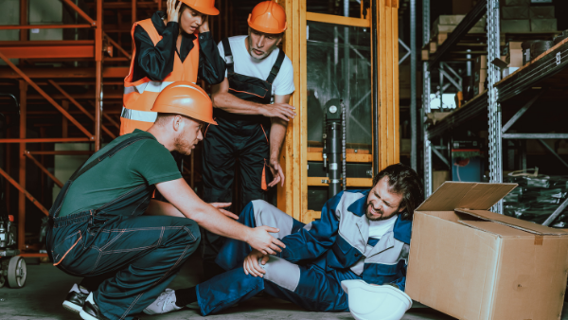
Fewer work accidents in Q1 2021
According to the GUS data, the year-on-year number of those injured in work accidents and the accident rate fell in Q1 2021. During that period, 10,891 persons injured in work accidents were reported, which represents a 23% drop year-on-year.
According to the statistics, the number of those injured per 1,000 workers also fell from 1.04 in the same period of last year to 0.81 in the period in question.

The largest number of accidents in opolskie region.
The greatest accident rate has been reported in the following Voivodships: opolskie (1.02), podlaskie (0.99) and śląskie (0.98), and the lowest in: mazowieckie (0.5), małopolskie (0.56) and podkarpackie (0.62).

Worker misconduct – the most frequent accident cause
Yet another time, the single most frequent cause of work accidents was improper worker behaviour - as many as 60% incidents were caused by this.
Other reasons contributing to less than 10% of all work accidents are: improper condition of material assets, improper wilful employee misconduct, lack or improper handling of material assets by workers.
Work without end
Work without end is a situation experienced by many employees doing their work remotely. Since the outburst of the pandemic, employers have had to face a new challenge – ensure continuity of work in conditions that are safe for their staff. As a result, many work duties have been sent to the so-called ‘home-office’.
The studies carried by CIOP-PIB in April 2020 show that remote work was performed by 7% employees prior to the pandemic, whereas during the pandemic - 59%.
Cyber stress Adapting to the new situation was not easy. Well, it is still not, because a new problem has arisen – a lack of work-life balance. Research has shown that further negative aspects of remote work include:
- having to plan and organise one’s working day;
- exposure to excess digital information (e.g. videoconferences, emails, business phone calls, social media, etc.).
All this may trigger a feeling of ‘being constantly at work’ (‘work without end’), resulting in information overload, overstimulation and feeling overwhelmed. All these factors are sources of stress and tension, described in the literature on the subject as ‘cyber stress’. or ‘techno-stress’.

