Cyber security during online training courses
The outbreak of the pandemic, and hence - the transfer of the entire organisation of work to an online mode, has somewhat disrupted the cycle of statutory training (companies) or education (educational institutions). However, currently everything is going back to ‘normal’. Such as it has become over the last two years - online normal. How to ensure security in this mode?
In Poland during Q3 2020, there were between 800 to more than 950 attempted attacks per educational institution. The data are alarming as it is twice as much as in other sectors. Hackers tried to take advantage of return to school and shift to remote education, among other things.
The most frequent cyber-attack methods and techniques include: fileless attacks, clickjacking, botnet, man in the middle, Denial of Service (DoS), phishing and ransomware.
Regardless of the type of attack, one should secure one’s devices. One solution (being actually a basis for further action) is antivirus software, which protects the ‘entrance’ to the computer. There are many applications of this type available on the market. The choice depends on both the financial resources and actual needs of each user. It should be remembered that computers should have legal software installed - only then will any protection be possible.
Home office ergonomics – basic rules
A workstation should enable one to do both conceptual and interactive work – contact with one‘s colleagues, customers and clients. The aim of any equipment in the workstation is to make one's work duties easier, not more difficult. For this reason, no activities involved in using the equipment should be burdensome for the employee.
In an office space it is much easier to achieve - the employer's financial and spatial capabilities are greater than those of the employee. Nevertheless, one should take them into account in designing one's workplace, including at home.
Separation between the working space and the family life. One should specify a dedicated place of work and ensure that the laptop or PC is not too ‘conspicuous’ when not in use. The impression of permanent readiness for work outside the working hours has an adverse impact on one’s well-being. The best solution is a separate room dedicated for work, such as a study.
Positioning a computer workstation in relation to light sources, specifically windows. An optimal solution is where the desk is so placed that the screen has its side towards the window, to the right of the window for right-handed people and to the left of it for left-handed people. This layout will allow one to avoid covering light when using the keyboard, reading source documents or handwriting using one’s dominant hand.
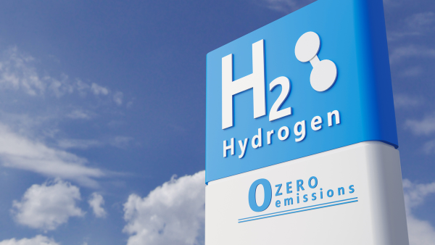
Time for hydrogen – fuel of the 21st century
According to the Teraz Środowisko (Environment Now) portal, on 12 October 2021 an inter-industry agreement is to be signed concerning Poland’s hydrogen economy in the years 2030-2040. Poland stands a chance of becoming a European leader in hydrogen production and use.
The first step involved adopting the so-called ‘Polish Hydrogen Strategy’ (the official strategy document is currently underway). As a result, hydrogen is to find its application in many branches of the Polish economy, such as heating and industry.
After adopting the Polish Hydrogen Strategy and signing the above inter-sector agreement, the next step will involve passing Hydrogen Law. It is to regulate not only the use of hydrogen in means of transport, as currently, but also in installation using this precious gas, e.g. for heating purposes.
In addition to the regulations, the availability of fresh water will be of paramount importance as obtaining hydrogen from sea water requires much greater outlays, and hence is more expensive. And here a problem arises as fresh water is slowly becoming a scarce resource in the entire world due to global warming and climate changes. It is necessary to invest in storing rain water - this concerns both households and the industry at large. Poland is working on water retention systems which should improve the situation.
What workplace factors may have a negative impact on health?
Strenuous (forced and awkward) body position or one causing pain is one of the most frequent factors adversely affecting workers’ physical health, particularly in transportation and warehousing.
In Q2 2020, the Statistical Office in Gdańsk carried out a study showing that 10.7 million people experience factors in the workplace that may have a negative impact on their physical health. This an increase of 7 percentage points compared to the findings of a study carried out in 2013.
The most frequent factors include:
- Strenuous (forced and awkward) body position or one causing pain – 19.3% workers,
- Physical effort involved in transporting heavy loads – 11.3%,
- Activities requiring considerable sight concentration – 8.5%,
- Repetitive hand or arm movements – 8%.
The study shows that men have been more frequently exposed to the inconveniences – 70% of working men have reported the occurrence in the workplace of at least one factor harmful to their health. Women, on the other hand, were mostly exposed to repetitive hand or arm movements (25.5% of women and 23.6% of men) and activities requiring considerable eye concentration (21.3% of women and 19.7% of men).
Employees do not want to return to the offices
As many as 93% of IT specialists go for a flexible work system, and six in ten Poles expect to continue working partly from home – in the hybrid mode, after the pandemic is over. Only 13% of those surveyed would prefer to work in the office only – these are the findings of a study carried out by Inquiry Market Research.
According to the Rzeczpospolita daily, relying on the research of DataArt, a counselling firm, as many as 93% of Polish IT specialists would like to continue working remotely or in a hybrid mode after the pandemic is over, with a mere 7% being ready to work in the office. Moreover, as many as 64% of the group state that they will look for a new employer if the current one requires them to work in the office mostly.
- Employees in the IT sector do not see a point in going back to their offices, as they feel well with the current working mode. Out of those declaring the greatest general work satisfaction 44% work remotely and 43% - in the hybrid mode – says Ryszard Remus, President of the Wrocław office of DataArt.
After over a year of remote or hybrid work, employees notice the resulting benefits. The most frequently mention the following: time savings as a result of no need to commute, and flexibility.
Moreover, remote workers also value the following: freedom in organising one’s working hours, possibility of wearing casual clothes, working in a home environment, which reduces stress.
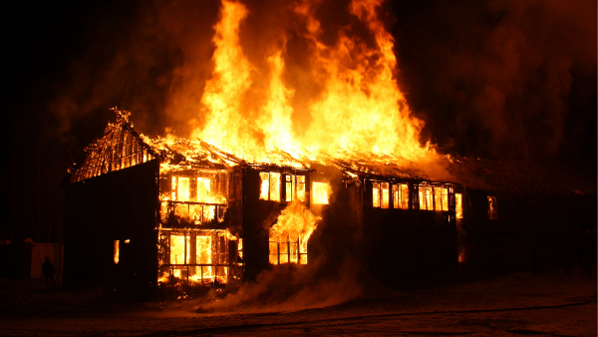
Fire classification – what is it and what for?
Reaction to fire classes are broadly applicable in industry and construction. It concerns construction materials/products, surface covering elements (installations) and elements of a building.
Fire classifications are issued by relevant research units for product or system manufacturers. The class of reaction to fire is established based on a comprehensive assessment of performance of the products in question to fire in conditions corresponding to the various stages in fire development. The following basic classes of reaction to fire are distinguished (from highest to lowest):
A1, A2, B, C, D, E, F. They also specify the flashover time of the product as well as the amount and speed of heat generation.
The fire classification has to basic functions:
- It allows for the materials at issue to be built into the site, through corroboration of their fire performance qualities,
- It provides a point of departure in choosing proper safeguards.
A description of the solution it refers to and to scope of its application (validity) is an essential part of each classification. Therefore, the scope of application of a given construction element or material must be checked and considered as early as at the designing stage, rather than the documents confirming the classification being gathered at the as-built documentation completion stage.
From 2022, work burn-out as occupational disease
From 1 January 2022 on, job burnout will be treated as a disease, for which one can be given a doctor's leave (the L4 form). Until recently a syndrome, yet in 2019 the WHO included job burnout in the International Classification of Diseases (ICD).
A job burnout syndrome is a civilisational disease affecting an increasingly large part of the population. The symptoms affect virtually every aspect of life, significantly affecting the performance of one's professional duties. An employee is distracted, makes mistakes, which can result in serious consequences to the company.
Burnout does not appear suddenly, it is a long-term process. The primary cause of the illness is prolonged stress, excessive exhaustion and setting oneself unrealistic goals. Burnout is diagnosed based on Christina Maslach’s three-dimension theory. According to that theory, the disease consists of three groups of elements:
- Physical ones: feeling of exhaustion or lack of energy,
- Emotional ones: lower mood, negative emotions or indifference in the form of cynical behaviour lacking in empathy,
- Behavioural ones: reduced work efficiency, reduced evaluation of one’s achievements and feeling that what one is doing lacks sense or is not good enough.
How to motivate staff?
Staff’s commitment and pro-active approach has considerable impact on whether the company will turn in a profit, fall into stagnation, or – even worse – go bankrupt. The better an employer cares for the employees, the better they will repay by caring for the clients. How to motivate staff?
On ought to bear in mind that motivation requires an individual approach: some are motivated by money, others – by fringe benefits, while others care for recognition and good word. Motivating is action directed at achieving a goal.
Each company can take steps to support and motivate its employees to act. There are various source of staff motivation. They include pecuniary motivators (salary, bonuses and benefits), developmental motivators (training, conferences, development programmes and promotions), and many others, such as sport vouchers, medical insurance, fruit days, etc.
The most well-known and generally applied is the instrumental theory, commonly known as the ‘stick and carrot’ theory. This approach relies on a conviction that people only work for money, and reward and punishment may be sufficiently motivating through positive or negative feedback.
Another theory is the needs theory based on an assumption that an unsatisfied need may become a source of tension and result in the employee’s imbalance.
In such cases, a good manager will be able, based on the specific need, to define specific goal and outline a path leading to it.
Time for environmental support for multi-family buildings
Smog in not only generated by single-family houses, but also by multi-apartment blocks. The Ministry of Climate and Environment and the National Environmental Protection and Water Management Fund (NFOŚiGW) are working on new programmes addressed at housing communities, but also on extending the 4the edition of the My Electricity programme to cover multi-family buildings.
In October of this year the applications started for a pilot project carried out by the WFOŚiGW in Wrocław. The projects aims to replace 720 inefficient heat sources and thermo-modernise 60 multi-family blocks. The total cost of the project is PLN 20 million. A similar pilot project will be carried out in Zachodniopomorskie Voivodship.
- We will draw conclusions from the pilot projects and implement them to the programme which we intend to launch at the beginning of 2022. The budget of that programme will be approx. PLN 2 billion. We are still working on the financing terms, but it is certain that we will want to reach hundreds of thousands of beneficiaries – stresses Paweł Mirowski, Vice-President of the NFOŚiGW.
The aim is to extend the Clean Air programme to cover multi-family buildings. The programme aims to fight smog and achieve low emissions by eliminating old coal-burning furnaces (the so-called ‘smokers’) and radically thermo-modernising residential buildings. It is one of the largest programmes of this type in Europe, with the budget exceeding PLN 100 billion. As part of the programme, over 300 thousand applications have been made so far for a total financing amount of PLN 5 billion.
Sabbatical leave – what is it?
A sabbatical leave, or a sabbatical, is an additional, longer leave. It is defined as a form of motivation, particularly for experienced employees. This solution is most frequently found in big global corporations.
Sabbatical leave means a long and usually paid break from work with the same salary and position retained. This solution is beneficial for businesses as it allows to keep their best employees in a good shape. And this in turn, translates to the entire company’s performance.
This type of leave has been regulated in the United States, where it is offered by every fifth employer. But also in such countries as Austria, Germany, Italy, Denmark and France.
Whereas in the UK, the entitlement to it may be provided for in an employment contract.
In Poland, the law does not regulate the longer sabbatical leave. The Labour Code only provides for unpaid leave. But it is an entirely different form of leave having a different purpose from the sabbatical. Above all, as the name implies, unpaid leave means that that no salary is paid and its duration is not included in one’s total length of service.
Polish employees struggling with job burnout can only count on medical leave. This, however, carries a risk of losing one’s job - particularly if the absence from work is prolonged.

