Mental safety during online courses
Remote training, which has been operating in a new reality for over 1.5 years now, has revealed the so-called ‘cyber exclusion’, among both teachers and students. The prolonging situation has also disturbed the social relations between the participants in the educational process. And all this affects mental safety.
Isolation, i.e. lack of contacts with others, affects workers’ effectiveness and efficiency, which in turn leads, among other things, to: fatigue, overall discomfort, sleeping disorders, stress demonstrated during online contacts, depression and suicide.
Isolation adversely affects interpersonal relations – both at work and at home. Hence the increasing popularity of ‘well-being’, which, also referred to as ‘cautionary value’ or ‘quality of life’, indicates what one values naturally. Thus, a person's good is what is ultimately good for that person, what is in its own interest.
Chill-out zones are being created in workplaces, which are places of rest during one’s working hours. Such spaces are also conducive to creativity as well as enhancing workers’ efficiency. They are already available at universities. In educational institutions this role is performed by the so-called ‘catering rooms’.
Investing in staff development
People are the single most valuable asset of an enterprise. Taking care of their development will yield intangible benefits for the enterprise – it may translate into increased efficiency and success of the firm. One of the most important duties of HR managers in this respect is identifying talent, properly shaping its development and retaining it.
Modern business is characterised by innovation, in which man is at the forefront. Therefore, its people that each company should take care of. What does it mean?
The measure of a worker’s value is his or her performance as well as the potential being a promise of further development. This potential is actually talent, which is a rare asset and not everyone can be highly talented. For this reason, it is advisable to thoroughly examine the skills and capabilities of those employed at different levels of the organisation's structure and invest in developing the competences, not only of the few 'high fliers', but also of a greater part of the staff.
As various studies show, an increasing number of Polish employers follow the latter approach – treating all employees as a pool of potential talents, provided that people are accurately assigned to their tasks and that their competence development is shaped properly.
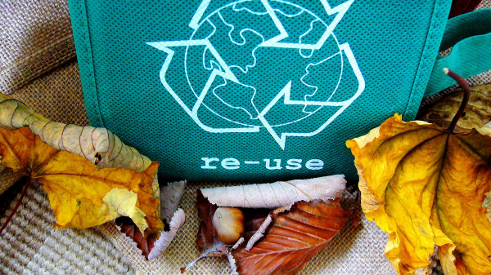
Flexible packaging also fit for recycling
Crisps, chocolate bar and other sweet or salty snack packaging should also be recycled, i.e. thrown away into the yellow waste container. Food producers have launched an initiative setting out to recycle exactly such waste.
Magdalena Dziczek, Board Office Director of EKO-PAK, the Association of Employers in the Packaging and Packaged Product Industry, said, during a press conference, that around 650 thousand items of plastic packaging are marketed each year in Poland for household use. Alas, the level of recycling with respect to such packaging waste is low in Poland.
This is primarily due to the format and small weight of such packaging – it could get lost during the waste collection or sorting processes Moreover, consumer still do not sort it properly. Such packaging waste should be put in the yellow container.
There is one more reason why the recycling level is so low and this is communal services, which are not interested in sorting such packaging for precisely the reasons mentioned above.
ReFlex is a project that aims to support the flexible waste collection and recycling. The initiative is coordinated by the Association of Employers in the Packaging and Packaged Product Industry EKO-PAK with the technical side of the project being managed by Eco Solutions. The project is funded by Nestle Polska and PepsiCo Polska.
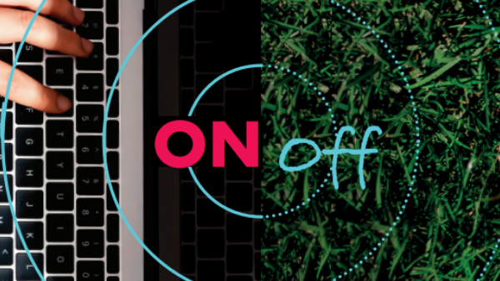
Digital stress being a real threat in a virtual working world
The CIOP-PIB has been carrying out a social information campaign entitled "Information Stress" since September. It sets out to prevent digital stress and maintain a digital balance both at work and after work. SEKA S.A. has joined the campaign as partner in order to promote this important problem area.
Since the outbreak of the SARS-COV-2 virus epidemic and introduction of multiple changes, employers have had to face a considerable problem - ensuring the employees safe conditions of work in the face of a biological threat. Since then, remote work has become a common way of working across the world.
According to CIOP-PIB research, the negative aspects of remote work include stress resulting from a lack of digital balance, both during and after one’s work. Working from home may result in the boundaries being blurred between one’s working life and personal life.
In January 2021, the European Parliament adopted a resolution in order to counteract the lack of digital balance in remote workers. It contains a number of guidelines drawing attention to what digital stress is in workers and to the “right to be offline”.
According to the guidelines, employers should have a right to not engage in work-related duties outside their working hours and to not participate in digital communications by means of tools such as email, telephone, etc.

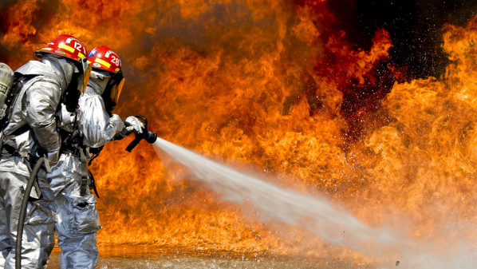
New regulation concerning OHS for PSP fire-fighters
In October 2021, new regulations entered into force concerning the OHS rules for fire-fighters of the State Fire Service (PSP). The regulations aim to adjust the law to the legal and organisational changes involved in the operations of the PSP. It also aims to ensure a proper level of occupational health and safety of the service.
The application of the new regulations is confined to the PSP only. This limitation results from the high requirements with respect to the PSP’s buildings, equipment and rescuers and the specifics of their service.
The requirements have been adjusted to new threats to people, assets and natural environment resulting from the civilisation’s progress. As a result of the latter, fire-fighters have a greater number of task during their rescue actions.
The updated regulations set out detailed OHS rules for fire-fighters, taking into account the following requirements:
- the health and safety of service at the facilities for rescuing and fire-fighting units of the State Fire Service;
- in the area of providing fire-fighters with personal protective equipment,
- in the area of medical support to fire-fighters in rescuing actions, training and drills,
- health and safety in rescue action, training and drills
Remote work and employer’s costs
The works on the amendment to the Labour Code are still underway but they are slowly approaching half-time. Expectedly, a statue will soon see the light of day regulating the matters relating to remote work.
Remote work has hitherto been regulated in the ‘Covid Act’; however, it is far from being complete legislation on the subject merely setting out the basic rules. The draft amendment to the Labour Code is to lay down detailed rules and also address the issue of costs.
According to the assumptions for the draft, employers will be required to cover:
- the costs related to the installation, servicing, maintenance and operation of work tools, including technical equipment, necessary for the performance of remote work,
- costs of electricity as well as those of the necessary access to IT infrastructure,
- costs other than above which are directly involved in the performance of remote work, if the reimbursement of such costs has been agreed upon in an agreement with the trade unions, Work Rules, employer's instruction in respect of remote work or in an agreement with the employee.
The draft also provides for a possibility of payment of a lump sum (instead of covering the costs or payment of an equivalent benefit), whose level is to correspond to the anticipated costs to be borne by the employee in respect of remote work.
Home office ergonomics: desk - worktop
A feature of home office is that the furniture at hand is used for work purposes. Hence, it often happens that the only workstation available for computer work is the kitchen table. How to ensure ergonomics in your home office?
In arranging a working space, make sure that the surface of the worktop (desk or table) allows for a convenient placement of all the necessary computer equipment and other devices, such as: screen, keyboard, mouse, smartphone or documents.
Currently the task is simpler in that LCD screens are nowadays in use, which are flat. And this allows the desk depth to be reduced.
The desktop surface should be large enough to enable the user to change body position. One should also remember to properly place the keyboard, mouse or documents, as their position contributes to the comfort of one’s arms, forearms and wrists.
It is hard to find an adjustable-height desk in a home office. An alternative solution is provided by electronic equipment stands, which when placed on the desktop allow the screen with keyboard, mouse and documents to be raised or lowered.
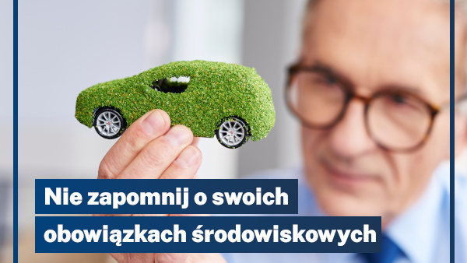
Eco outsourcing – it pays off!
Business owners – do you know your obligations under environmental laws? Are you familiar with the deadlines for statutory reports? What do you know about environmental charges?
Environmental obligations pertain not only to large businesses. The mere fact of owning a car, boiler room or distributing marketing materials entails an obligation to fulfil certain requirements.
The mere number of changes and regulations implemented every year can cause a headache; yet, the consequences of failure to meet the obligations can be really serious. One does not always end up paying a fine, in extreme cases the penalties include closing down a business and even imprisonment. Failure to obtain the permits required may attract fines of up to 500% of the normally paid charges for the ‘use of environment’.
Report filing deadlines:
- 28/29 February – report to the National Emission Balancing and Management Centre (KOBiZE).
- 15 March – aggregate breakdown of data on the waste generated (BDO).
- 31 March – report on the extent of environmental use (Regional Governor’s Office - Urząd Marszałkowski).
We offer our assistance – Environmental protection with SEKA S.A.
Who will the PIP audit in 2022?
The State Labour Inspectorate’s (PIP) plans for auditing, prevention and promotional activities for 2022 are still being developed. However, it is likely that until the COVID-19 epidemic state is revoked it will be necessary to verify the state of compliance in workplaces with the regulations which have seriously affected the entities’ situation on the labour market.
The most important issue is still (until the epidemic state is revoked) auditing compliance with Covid-related restrictions. Many of these regulations concern labour law issues, such as working hours, payment of remunerations and other cash benefits, and vacation rules.
Moreover, the new legislative solutions have covered the broadly understood OHS area. An obligation was imposed on employers to organise work in a manner taking into account the sanitary restrictions and to provide employees with measures protecting them against the coronavirus spreading.
The PIP’s priority as regards OHS and health protection will be: taking auditing and preventive action in the areas of professional activity involving the greatest accident rates and highest degree of occupational hazards; eliminating direct accident hazards and mitigating the impact of dangerous or harmful workplace factors on the workers, and improving the ergonomics; taking into account the new workplace factors, as well as of the dynamically changing legislation.

