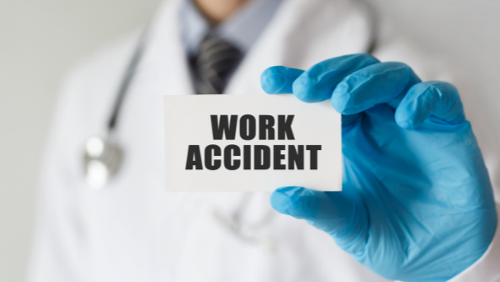
73 per cent of accidents during remote work proved fatal
Accidents while working remotely occur less frequently than during traditional work; however, their results are more tragic. Between March and June 2021, 11 out of 15 recorded accidents turned out fatal.
According to the GUS’s (Central Statistical Office) data, 27 thousand employees had work-related accidents in the first half of 2021 alone. The majority of accidents were recorded in the mining and mineral extraction industries – an average of 6.41 per 1,000 employees suffered an accident. Also those employed in water delivery and healthcare are exposed to accidents. Here the respective accident rates were: 4.98 and 3.36 per 1,000 employees.
The largest number of fatal accidents occurred in industry (20 employees), 19 persons died in construction and 9 in mining.

Remote work is also dangerous
Interestingly, accidents also occurred during remote work, but the death rate here was much higher than in the other industries mentioned above. Between March and June 2021 alone the PIP recorded 15 accidents, of which as many as 11 were fatal. All of them involved medical cases.
The remaining two accidents resulted in serious injuries: injury to the eye as a result of a fall in the toilet and bodily injuries as a result of a car accident on the way to work in order to collect company equipment.
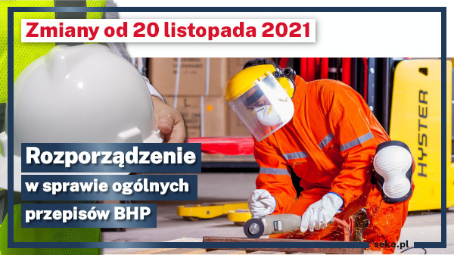
Amendment to the Regulation on the General Provisions on Occupational Health and Safety
On 20 November, a regulation of the Minister of Family and Social Policy amending the regulation on the general provisions on occupational health and safety. The amendments were made in order to adjust Polish law to the EU Commission Directive amending Annexes I, II and III to Council Directive 89/656/EEC.
Most of the changes are merely technical.
In Annex I, in addition to physical, chemical and biological hazards other risks (such as lack of oxygen) have been included. The changes set out to reflect new types of risk occurring in the workplace and to clarify the terminology used in respect of the hazards.
In Annex II, in addition to the types of Personal Protective Equipment (PPE) included in the previous wording of the Annex, the types of risk have been included against which each PPE type is to protect one (e.g. protective equipment in the form of helmet is to protect against injuries caused by falling or thrown out objects).
Annex III has been developed in the form of table.
Risk assessment and provision of adequate PPE still rest with the employer.
New regulations in the act on waste from January 2022
On 23 November 2021, RP President Andrzej Duda signed the act amending the act on waste and certain other statutes of 17.11.2021. The act sets out to implement into the Polish law EU-level regulations and reduce the amount of waste at waste disposal sites. The act is to come into force on 1 January 2022.
Under EU law, EU Member States are required to achieve a 65% level of preparation of household waste for reuse and recycling by 2035. The most important changes introduced by the amendment include:
- Amended definitions of bio-waste, waste management and household waste;
- Added definitions of construction and demolition waste, food waste, earthworks and system of extended producer liability;
- Introduction of a national programme for the prevention of waste generation;
- Introduction of requirements concerning the costs of waste management incurred by those placing products on the market;
- Prohibition to carry to waste disposal sites sorted waste in order to prepare it for reuse or recycling – except for waste generated as a result of further processing of sorted waste.
The new regulations also provide that from 2035 waste disposal sites will not be allowed to keep more than 10 per cent of household waste. This rate will be 30% for the years 2025-2029 and 20% for the years 2030-2034.
Home-office ergonomics: the chair
It is not recommended to use regular chairs, stools or dining or living room furniture when working remotely in front of a computer screen. One should only sit on an ergonomic office chair. What should it be like?
An ergonomic office chair should provide a stable support to the body in a dynamic position, ensuring at the same time comfort even during long work periods, mental satisfaction and proper adjustments to the purposes or types of jobs performed.
The wheels should be adjusted to the type of floor and character of the tasks involved in one’s position.
The chair base should ensure stability – most frequently in the shape of a 5-pointed ‘star’.
The seat height should be adjusted to the knee level of the user. Where the height of the chair prevents the employee from placing their foot flat resting on the floor, the workstation should be equipped with a proper footrest.
The seat should ensure comfortable placement of one’s buttocks and proper positioning of the pelvis.
The back of the chair should provide support to the lumbar part of the back as well as the shoulder girdle and upper back.
Role and image of OHS services - report of the Safe at Work Coalition
The pandemic has affected virtually all industries, in particular – the OHS departments, whose employees stood at the forefront of fight against the epidemic. Therefore, in this year the eighth edition of the work safety report entitled ‘Work Safety in Poland 2021’ focuses on the work of OHS specialists and managers.
According to the report, the scope of OHS services expanded during the pandemic. The respondents admitted that their daily working hours had on occasion extended to 12 hours and their hotline standby duty could even last 24 hours.
Quantitative studies, on the other hand, have shown that OHS services were responsible - in addition to their standard scopes of duty - for enforcing compliance with the social distancing and hand disinfection measures (97%) and carrying out health surveys and temperature-taking (90%).
All respondents declared, however, that the OHS training rate had dropped slightly during the pandemic (98%). Other duties, such as teaching fire-protection courses (99%), and implementing and communicating changes in regulations, have remained at the same level (98%).
There has been a slight drop in activities such as communicating ergonomics to the staff (from 98% to 95%) and technical approval of workstations, equipment and facilities (from 97% to 95%), which may have resulted from an increase popularity of remote work.
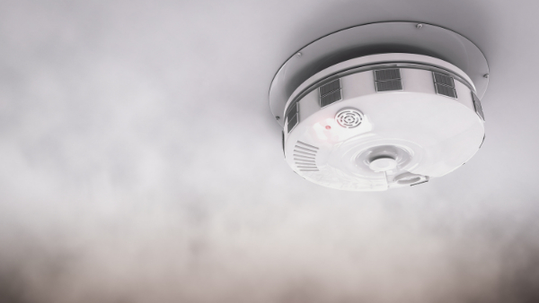
Carbon monoxide – silent killer
In the autumn-winter season, carbon monoxide - commonly known as 'damp' - is one of the most serious threats. Getting intoxicated with this substance is serious as it can be fatal. How to avoid getting damped?
Damp is a highly poisonous, colourless and odour-free gas – carbon monoxide (CO). It is slightly lighter than air, hence it propagates easily. It finds its way to human blood through breathing. Depending on its concentration and time of exposure, various ailments can be experienced: from fatigue to nausea, headaches, dizziness, convulsions, breathing problems, lack of coordination, to irreversible brain tissue and heart damage. Oxygen deficiency in the body leads to loss of consciousness and death.
Carbon dioxide cannot be detected naturally ; therefore one must take all steps to prevent its generation. To this end:
- Regularly maintain heating equipment;
- Ensure that the chimneys are passable;
- Check the air draft;
- Ensure proper ventilation, do not seal or cover ventilation inlets, try and ventilate rooms as frequently as possible;
- Fit CO detectors – these can save your life;
- Do not heat rooms with equipment which is not designed for that purpose;
- Crack open a window while using an open fire;
- Never leave a car engine working in a garage;
- Never belittle potential symptoms of CO intoxication.
The Polish Deal: The adverse consequences of illegal employment will only be borne by the employer
The Polish Deal regulations will enter into force as early as on 1 January 2022. They will introduce, among other things, new tax and social security solutions which aim to limit illegal employment and concealment of the actual levels of salary reportable to relevant authorities.
According to the legislative assumptions, from next year on the consequences of illegal employment will be solely borne by the employers, who will be taxed on the salaries paid for illegal employment or part of legitimate salary paid ‘under the table’. Employers will also be assigned additional revenue equal to a minimum salary for each month of illegal employment, regardless of whether or not the salary was actually paid and in whatever amount.
Dishonest employers will also be required to pay full social insurance and health insurance contributions on the salaries due workers employed illegally or paid ‘under the table’. Moreover, both the salaries paid and the contributions will not be capable of being recorded in the books as tax-deductible costs.
Workers so employed, on the other hand, will not incur any tax-penal liability. They will not pay income tax either on the salaries due on account of illegal employment or on the reduced income.
Penalties for obstructing PIP’s auditing activities
Ever since the State Labour Inspectorate started its operations their audits have been obstructed from time to time. Under the Labour Code, an employer preventing an audit of a workplace may be punished with a fine of between PLN 1,000 and 30,000.
The grounds for PIP’s operations are set out in the act on the State Labour Inspectorate of 13 April 2007. This act vests labour inspectors with a number of privileges, including a right to carry out, without notice and at any time of day or night, audits of compliance with labour law, specifically the state of health and safety.
Obstructing, or even making impossible, auditing activities qualify as misdemeanour or criminal offence – entailing all related consequences.
The Labour Code expressly states that “whoever obstructs the activities of the PIP, in particular by rendering an audit of the workplace impossible or refusing to provide any information necessary to perform its duties - commits a misdemeanour punishable with a fine from PLN 1,000 to PLN 30,000”.
On the other hand, Art. 225 of the Penal Code stipulates “whoever obstructs or renders impossible the activities of those authorised to carry out workplace audits or those appointed to assist the same is punishable with imprisonment of up to three years”.
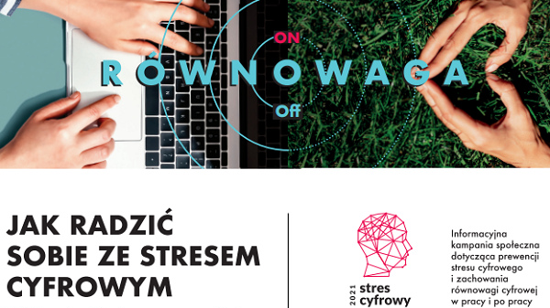
How to cope with digital stress? Guidelines for employees
The CIOP-PIB, as part of its social information campaign entitled 'Information Stress', have come up with a number of important tips for employees. We present them below.
Consider whether or not you have noticed the following symptoms in yourself: less concentration, memory disorders, feeling overworked, or even professional burnout, increased irritability and being confrontational, feeling lonely, disturbed sense of balance between work and private life.
If so, you are likely to be suffering from the current situation – remote work - which is adversely affecting you. You can manage that.
- First of all, do not start your day with the smartphone in hand. Develop your daily ritual, which could look as follows: physical activity, a cup of coffee, a glass of water.
- Make meal breaks at the same time every day. Preferably, have you meals away from your workstation. Remember to be offline during that time.
- Spend breaks from work away from the desk, preferably in an active way. Put down your smartphone.
- Be aware of the time spend browsing the Internet and choose what you want to pay your attention to.
- Set and signal the end of your working day.
- Specify how much time you wish to dedicate to the social media.
- If you feel you need support in controlling and managing your time and limiting you access to certain websites or platforms, use dedicated applications available on the market.
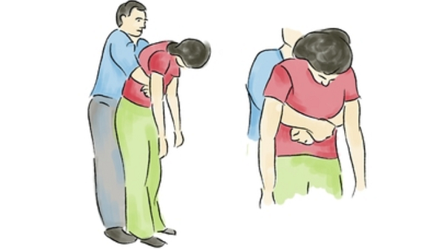
How to provide first aid in a choking incident?
Choking is a situation where a foreign body finds its way to the larynx or trachea rather than the gullet. Where the airways are blocked entirely one loses one’s breath, the heart stops, and, if one does not receive help, one can die. Rapid response in this situation means rescuing life.
Due to many factors, professional medical assistance may reach the injured with considerable delay. During such waiting time, the witnesses, including company staff, must not be passive as for the injured person every minute is invaluable.
If the injured person is able to perform limited breaths in and out, one should hit them forcibly on the back between the shoulder blades (up to 5 times).
If this is to no avail, 5 abdominal thrusts must be given. How to do it:
- Stand behind the choking person;
- Hold the person around the waist with both your arms, above the belly button;
- Perform a sudden, strong thrust pulling inwards and upwards several times in order to exert sudden pressure on the diaphragm;
- When thrusting, additionally place your clenched fists in the injured person’s epigastric fossa.

